RG-RSR77-XA Series
Routers
Datasheet
V1.0

Ruijie Networks Co., Ltd
All rights reserved.

Change History
Note: The change history is for internal reference only. You must delete the change history when this document is released for external users.
Date | Version | Description | Revised
2023-05-26 | V1.0 | First draft.

Product Overview
The RSR77-XA series router is the next-generation high-end distributed router developed by Ruijie Networks for the cloud architecture and cloud service of the enterprise network.
Based on Ruijie-developed RGOS 12.X operating system, the RSR77-XA series multi-service core router features high performance, high reliability, and high security. The RG-RSR77-XA series supports smooth upgrade and capacity expansion, providing strong support for live network services and coping with service development in the next five to ten years.
The chassis uses independent routing switching engines, switch fabric units (SFUs), and line cards, separating management, control, and data planes based on the high-performance multi-core platform and distributed architecture. The RG-RSR77-XA series adopts dual data planes, improving performance and ensuring nonstop services.
Characterized by high availability, high performance, multi-service, and high security, the RG-RSR77-XA series supports enterprise service operation and bearer network construction, enhancing network value and saving network construction cost. With a resilient and scalable architecture, the RG-RSR77-XA series can boost its performance by installing more line cards. What is more, traffic can be load balanced among line cards inside the chassis.
Based on Ruijie-developed RGOS 12.X operating system, the RSR77-XA series provides various features. High-speed forwarding technologies such as the virtual Central Processing Unit (vCPU) and Ruijie Express Forwarding (REF) improve the router's multi-service processing capability. The distributed service line cards of the RG-RSR77-XA series have various types of ports and integrate features including Network Address Translation (NAT), Internet Protocol Flow Information Export (IPFIX), Internet Protocol Version 6 (IPv6), Border Gateway Protocol (BGP), IP Security (IPsec), Multi-Protocol Label Switching Virtual Private Network (MPLS VPN), and Hierarchical Quality of Service (H-QoS), and multicast features.
The RG-RSR77-XA series is available in two models: RG-RSR77XA-08 and RG-RSR77XA-03.
The RG-RSR77-XA series is mainly used as the core or aggregation node on a WAN of the government, finance, carrier, education, or large- and medium-sized enterprise network, egress of a large campus network, and an edge aggregation node of a data center. The RG-RSR77-XA series together with RSR30-XA and RSR20-XA series routers enables one-stop delivery of a WAN solution.

Product Appearance

RG-RSR77-XA-03
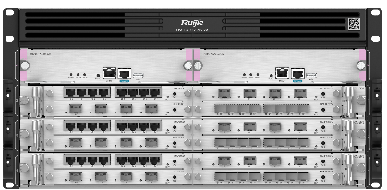
Front View of the RG-RSR77-XA-03

RG-RSR77-XA-08
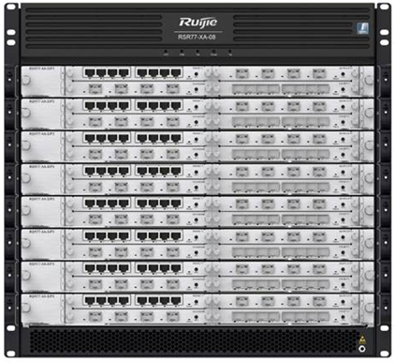
Front View of the RG-RSR77-XA-08

Product Highlights
- Multi-service core router, supporting IP, MPLS, SR, IPsec, L2TP, and SRv6, with no limitations on service provisioning
- Multi-rate interfaces, including E1/CPOS/POS/GE/10GE/40GE/100GE interfaces, meeting requirements of different network layers
- Hardware redundancy to ensure uninterrupted service: Key components such as supervisor modules, switch fabric modules, and power modules use redundancy design, and the RG-RSR77-XA-03 has no switch fabric module and integrates the supervisor module and switch fabric module.
- Y-shaped airflow design with power consumption lower than 0.5 W per Gbps, reducing overall energy consumption

Product Features

Comprehensive Architecture Upgrade
Based on a resilient and scalable platform, the chassis of the RG-RSR77-XA series uses Clos non-blocking switching and advanced distributed multi-service processing architecture and provides 100GE and 40GE ports. The chassis uses independent SFUs and separated routing, service, and forwarding engines, separating management, control, and data planes. This further improves service availability.

Modular Compatibility
The RG-RSR77-XA series leverages the independent carrier card design and comes into two modular models: RG-RSR77-XA-08 and RG-RSR77-XA-03. The two models employ consistent hardware and software platforms with completely compatible line cards, adapting to application requirements at different network layers for constantly developing enterprises.

Energy-Saving Design
The RG-RSR77-XA series incorporates the energy-saving design. The chassis supports highly-efficient modular power modules, which improves the power system efficiency and reduces energy consumption of an equipment room.
The chassis adopts heat dissipation by isolating physical partitions. Intelligent fan modules support partition-based temperature control and multi-level speed regulation, saving energy and reducing noise. All these measures greatly reduce energy consumption of air conditioners.

High-performance and Built-in Services
The distributed line cards of the RG-RSR77-XA series have built-in features including IPv6, BGP, IPsec, MPLS VPN, and QoS. When new service features need to be loaded, there is no need to purchase a software license or add a line card, maximizing user investment.

Powerful Route Processing Capability
The RG-RSR77-XA series supports various dynamic routing protocols to apply to different networks. Furthermore, it supports policy-based routing (PBR) to flexibly control and schedule network traffic, coping with routing demands of finance, government, and enterprise customers.
Based on the high-performance flow table and fast forwarding technologies, the RG-RSR77-XA series uses features such as GR, FRR, and BFD to accelerate convergence of traditional routing protocols, achieving rapid convergence on a large-sized network.

All-round MPLS VPN Functions
The RG-RSR77-XA series supports comprehensive MPLS VPN functions. It can function as the provider (P) or provider edge (PE) device, and delivers fully distributed Layer 2 and Layer 3 VPN services. It provides a high-performance, secure, and hierarchical MPLS VPN solution.
The RG-RSR77-XA series supports distributed multicast VPN and can be enabled with high-performance multicast service on the MPLS VPN network, satisfying multicast service requirements of video conference and remote teaching.
The RG-RSR77-XA series provides fault location, MPLS ping, and MPLS traceroute to help users quickly locate failure points.

Full SRv6 Support
SRv6 supported by the RG-RSR77-XA series can be used with the Network Configuration Protocol (NETCONF), Topology-Independent Loop-free Alternate (TI-LFA), inter-AS E2E, and PCEP. The RG-RSR77-XA series supports BGP for SRv6 policies, Generalized SRv6 (G-SRv6), SRv6 OAM, SRv6 Policy, SRv6-BE, SRv6 GR, Non-Stop Routing (NSR) for SRv6, and Seamless Bidirectional Forwarding Detection (SBFD) for SRv6.

Carrier-Class Reliability
Redundancy of key modules: routing engines, SFUs, power modules in N+M mode, dual startup image files, and dual configuration files.
Hot swapping of key components: routing engines, carrier cards, line cards, power modules, and fan modules

Flexible Device Management
The RG-RSR77-XA series supports user-based hierarchical management and password protection, and applies the multi-core CPU technology to separate the control plane from the forwarding plane, allowing device management in any environment. It authenticates login users and grants users of different levels with different administrative permissions, ensuring device security.

Product Specifications

Hardware Specifications
Hardware Specifications | RG-RSR77-XA-03 | RG-RSR77-XA-08
Interface Specifications
Power module | 4 (N+N redundancy)
Fan module | 1 | 2
Fixed management port | 1 x console port, 1 x MGMT port, and 1 x USB port | 1 x console port, 1 x MGMT port, and 1 x USB port
Supervisor module slot | 2 | 2
Switch fabric module | 2 x integrated switch fabric modules | 4 x independent switch fabric modules
Service module slot | 3 | 8
Line card slot | 12 | 32
System Specifications
Packet forwarding rate | 25,000 Mpps | 35,000 Mpps
System Switching capacity | 150 Tbps | 180 Tbps
ARP table size | 40,000 | 40,000
Number of IPv4 unicast routes | 500,000 | 500,000
Number of IPv4 multicast routes | 2,048 | 2,048
Number of IPv6 unicast routes | 1,000,000 | 1,000,000
Number of IPv6 multicast routes | 1,024 | 1,024
Number of ACEs | Ingress: 16,000  Egress: 16,000 | Ingress: 16,000  Egress: 16,000
Dimensions and Weight
Dimensions (W x D x H) | 442 mm x 560 mm x 220 mm (17.40 in. x 22.05 in. x 8.66 in.), 5 RU | 442 mm x 560 mm x 442 mm (17.40 in. x 22.05 in. x 17.40 in.), 10 RU
Weight (empty chassis and fan modules) | 12.5 kg (27.56 lbs) | 43.55 kg (96.01 lbs)
CPU and Storage
CPU | FT2000/D2000 | FT2000/D2000
Storage | Flash: 16 GB  SDRAM: 8 GB | Flash: 16 GB  SDRAM: 8 GB
Power and Consumption
Maximum power consumption | 40 W | 60 W
Maximum output power | RG-PA460-RI: 90 V AC to 290 V AC, 460 W | RG-PA1600I:  90 V AC to 180 V AC, 200 W  180 V AC to 264 V AC, 1600 W  HDC:  192 V DC to 216 V DC, 1200 W  216 V DC to 290 V DC, 1600 W  RG-PD600I: 600 W
Rated input voltage | - AC: 100 V AC to 120 V AC, 200 V AC to 240 V AC, 50 Hz to 60Hz | - AC: 100 V AC to 120 V AC, 200 V AC to 240 V AC, 50 Hz to 60 Hz  - DC: –48 V DC
Maximum input voltage | - AC: 90 V AC to 290 V AC, 45 Hz to 65 Hz | - AC: 90 V AC to 264 V AC, 47 Hz to 63 Hz  - DC: –40 V DC to –75 V DC
Environment and Reliability
MTBF | 216,000 hours | 342,000 hours
Primary airflow | Fans drawing air for forced convection | Fans drawing air for forced convection
Operating temperature | 0°C to 45°C (32°F to 113°F)
Storage temperature | –40°C to +70°C (–40°F to +158°F)
Operating humidity | 10% to 90% RH (non-condensing)
Operating noise | Ambient temperature ≤ 70 dB  Maximum noise < 77 dB | 35°C (95°F): 60 dB  50°C (122°F): 75 dB

Software Specifications
RG-RSR77-XA Series
Model | Description
Ethernet switching | Jumbo frame length: 1,578 bytes
Ethernet switching | 802.3az EEE
Ethernet switching | LLDP/LLDP-MED
IP service | Static and dynamic ARP
IP service | DHCP server, DHCP relay, and DHCP client
IP service | FTP, TFTP, FTPv6, and TFTPv6
IP service | NTP, SNTP, and NTPv6
IP service | NAT
IP service | Strict and loose RPF  uRPF ignoring default routes
IP service | ND
IP service | FTP, TFTP, FTPv6, and TFTPv6
IP service | DNS
IP service | IPv4/IPv6 VRF
IP service | DHCP server, DHCPv6 client, and DHCPv6 relay
IP service | ND and ND snooping
IP service | IPv6 GRE tunnel
IP routing | IPv4 and IPv6 static routing, and static blackhole routes
IP routing | RIP v1/v2 and RIPng
IP routing | OSPFv2 and OSPFv3
IP routing | IS-ISv4 and IS-ISv6
IP routing | BGP and BGP4+
IP routing | Routing policies
IP routing | BGP4, BGP4+, and MP-BGP
IP routing | IPv4 VRRP v2/v3 and IPv6 VRRP v3
IP routing | IPv4 and IPv6 PBR
Multicast | IGMP v1/v2/v3
Multicast | Static multicast routing
Multicast | PIM-DM, PIM-SM, PIM-SSM, PIM-SSMv6, PIM-SMv6, and other multicast routing protocols
Multicast | MSDP for inter-domain multicast
Multicast | MLDv1/v2
MPLS/SR | Basic MPLS functions
MPLS/SR | MPLS forwarding
MPLS/SR | 6PE/6VPE interconnection with IPv4/IPv6 MPLS backbone network
MPLS/SR | MPLS MIB (RFC 1273, 4265, 4382)
MPLS/SR | L3VPN
MPLS/SR | LSP
MPLS/SR | LDP
ACL and QoS | Standard IP ACLs
ACL and QoS | Extended IP ACLs
ACL and QoS | Extended MAC ACLs
ACL and QoS | IPv6 ACLs
ACL and QoS | Applying ACLs to interfaces
ACL and QoS | MPLS QoS
ACL and QoS | HQoS
Security | Multiple AAA modes
Security | RADIUS authentication, authorization, and accounting
Security | TACACS+
Security | Attack defense
Security | Password security
Security | RNFP
Security | CPP
Security | FPM
Security | PKI
Security | IPsec VPN
Security | VPDN
Security | SSHv1 and SSHv2
Security | Global IP-MAC binding
Security | Login authentication and password security
Reliability | BFD
Reliability | GR
Reliability | DLDP
Reliability | ECMP
Reliability | NSR
Reliability | Hot swapping
NMS and maintenance | SPAN and ERSPAN
NMS and maintenance | SNMP v1/v2/v3
NMS and maintenance | System operation logging
NMS and maintenance | IPFIX
NMS and maintenance | Command line configuration through console, AUX Modem, Telnet, and SSH
NMS and maintenance | RMON (1, 2, 3, 9)
NMS and maintenance | NETCONF
NMS and maintenance | CWMP
NMS and maintenance | gRPC
Note: The item marked with the asterisk (*) will be available in the future.

Protocol Compliance
RG-RSR77-XA Series
Organization | Standards and Protocol
IETF | RFC 1157 A Simple Network Management Protocol (SNMP)  RFC 1305 Network Time Protocol Version 3 (NTP)  RFC 1349 Internet Protocol (IP)  RFC 1350 TFTP Protocol (revision 2)  RFC 1519 CIDR  RFC 1591 Domain Name System Structure and Delegation  RFC 1643 Ethernet Interface MIB  RFC 1757 Remote Network Monitoring (RMON)  RFC 1812 Requirements for IP Version 4 Router  RFC 1901 Introduction to Community-based SNMPv2  RFC 1902-1907 SNMP v2  RFC 1918 Address Allocation for Private Internet  RFC 2131 Dynamic Host Configuration Protocol (DHCP)  RFC 2132 DHCP Options and BOOTP Vendor Extensions  RFC 2571 SNMP Management Frameworks  RFC 2863 The Interfaces Group MIB  RFC 2925 Definitions of Managed Objects for Remote Ping, Traceroute, and Lookup Operations (Ping only)  RFC 3046 DHCP Option82  RFC 3417 (SNMP Transport Mappings)  RFC 3418 Management Information Base (MIB) for the Simple Network Management Protocol (SNMP)  RFC 4022 MIB for TCP  RFC 768 User Datagram Protocol (UDP)  RFC 783 TFTP Protocol (revision 2)  RFC 792 Internet Control Message Protocol (ICMP)  RFC 793 Transmission Control Protocol (TCP)  RFC 813 Window and Acknowledgement Strategy in TCP  RFC 815 IP datagram reassembly algorithms  RFC 826 Ethernet Address Resolution Protocol (ARP)  RFC 854 Telnet Protocol  RFC 959 File Transfer Protocol (FTP)  RFC 1058 Routing Information Protocol (RIP)  RFC 1583 OSPF Version 2  RFC 1981 Path MTU Discovery for IP version 6  RFC 1997 BGP Communities Attribute  RFC 2236 IGMP  RFC 2328 OSPF Version 2  RFC 2385 Protection of BGP Sessions via the TCP MD5 Signature Option  RFC 2439 BGP Route Flap Damping  RFC 2460 Internet Protocol, Version 6 (IPv6)  RFC 2461 Neighbor Discovery for IP Version 6 (IPv6)  RFC 2462 IPv6 Stateless Address Auto configuration  RFC 2463 Internet Control Message Protocol for IPv6 (ICMPv6)  RFC 2545 Use of BGP 4 Multiprotocol Extensions for IPv6 Inter Domain Routing  RFC 2711 IPv6 Router Alert Option  RFC 2787 Definitions of Managed Objects for the Virtual Router Redundancy Protocol  RFC 2918 Route Refresh Capability for BGP 4  RFC 2934 Protocol Independent Multicast MIB for IPv4  RFC 3065 Autonomous System Confederation for BGP  RFC 3101 OSPF Not so stubby area option  RFC 3137 OSPF Stub Router Advertisement sFlow  RFC 3509 Alternative Implementations of OSPF Area Border Routers  RFC 3513 IP Version 6 Addressing Architecture  RFC 3623 Graceful OSPF Restart  RFC 3768 VRRP  RFC 3810 Multicast Listener Discovery Version 2 (MLDv2) for IPv6  RFC 3973 PIM Dense Mode  RFC 4271 A Border Gateway Protocol 4 (BGP 4)  RFC 4273 Definitions of Managed Objects for BGP 4  RFC 4360 BGP Extended Communities Attribute  RFC 4456 BGP Route Reflection: An Alternative to Full Mesh Internal BGP (IBGP)  RFC 4486 Subcodes for BGP Cease Notification Message  RFC 4552 Authentication/Confidentiality for OSPFv3  RFC 4724 Graceful Restart Mechanism for BGP  RFC 4750 OSPFv2 MIB partial support no SetMIB  RFC 4760 Multiprotocol Extensions for BGP 4  RFC 4940 IANA Considerations for OSPF  RFC 5065 Autonomous System Confederation for BGP  RFC 5187 OSPFv3 Graceful Restart  RFC 5340 OSPFv3 for IPv6  RFC 5492 Capabilities Advertisement with BGP 4
IEEE | IEEE 802.2 Logical Link Control  IEEE 802.1ab Link Layer Discovery Protocol  IEEE 802.1ad Provider Bridges  IEEE 802.1ax/IEEE802.3ad Link Aggregation  IEEE 802.1D Media Access Control (MAC) Bridges  IEEE 802.1Q Virtual Bridged Local Area Networks (VLAN)  IEEE 802.3ad Link Aggregation Control Protocol (LACP)  IEEE Std 802.3x Full Duplex and flow control

Typical Applications

E-government Network
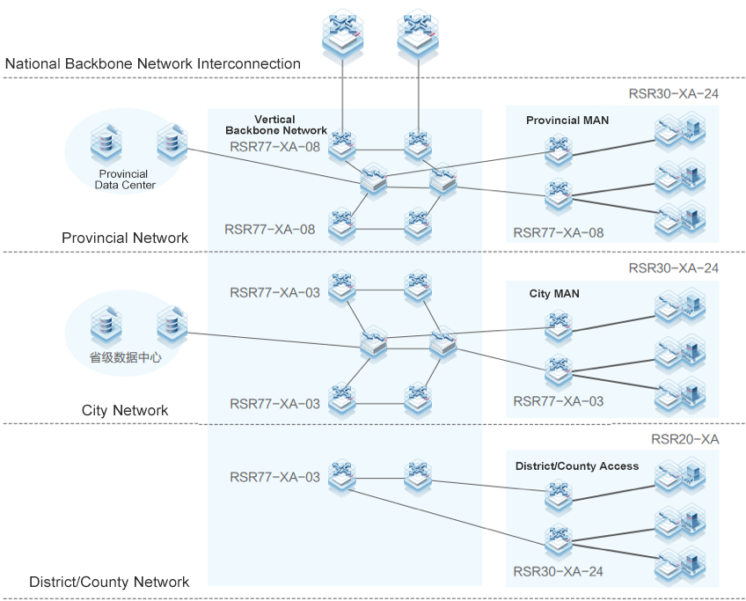
Characteristics:
The RG-RSR77-XA series core router supports the MPLS VPN solution for the government industry. It caters to application requirements of e-government intranet and internet.

Financial Backbone Network
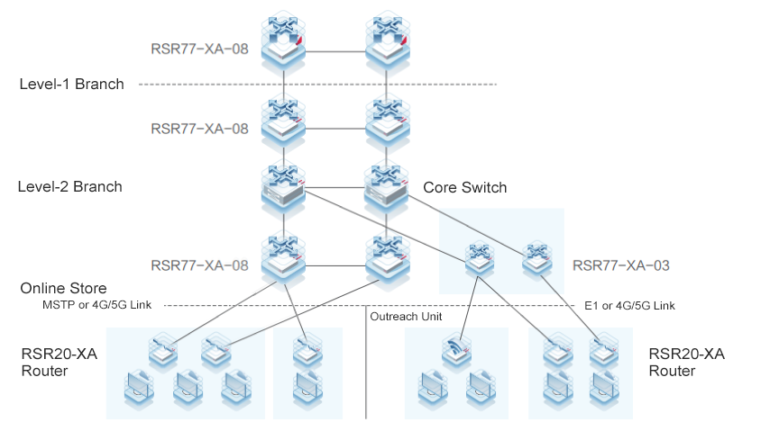
Characteristics:
The RG-RSR77-XA series core router can aggregate services of a large number of branches and delivers high performance even in the case of multi-service. It copes with service requirements of backbone networks of banking, insurance, postal savings bank, and other financial subsectors.

Ordering Guide
Perform the following steps to configure an RSR77-XA series router:
- Select the chassis and supervisor engine based on the specific product model.
- Select switch fabric modules based on service requirements.
- Select power modules based on power supply requirements. At least one power module is required.
- Select line cards and function modules based on service requirements.

Ordering Information

Chassis and Supervisor Engines
Model | Description
RG-RSR77-XA-03 | RG-RSR77-XA-03 chassis
RG-RSR77-XA-08 | RG-RSR77-XA-08 chassis
RSR77-XA-03-CM | RG-RSR77-XA-03 routing switching engine
RSR77-XA-08-CM | RG-RSR77-XA-08 routing engine
RSR77-XA-08-DSF | RG-RSR77-XA-08 switch fabric module (40 Gbps supported by a single switch fabric module)
RSR77-XA-08-DSF II | RG-RSR77-XA-08 switch fabric module (200 Gbps supported by a single switch fabric module)

Power Modules
Model | Description
RG-PA1600I | RG-RSR77-XA-08, 1600 W AC power module
RG-PA460-RI | RG-RSR77-XA-03, 460 W AC power module
RG-PD600I | RG-RSR77-XA-08, 600 W DC power module

SIP Carrier Card
Model | Description
RSR77-XA-SIP3 | NM/DNM carrier card (four NM modules or two DNM modules supported by each RSR77-XA-SIP3)

NM Line Card
Model | Description
NM-2XS-KA | 2-port 10GE Ethernet interface module, requiring additional SFP+ modules
NM-4XS-KB | 4-port 10GE Ethernet interface module, requiring additional SFP+ modules
NM-8SFP-G | 8-port 1GE Ethernet optical interface module, requiring additional SFP modules
NM-8GT-G | 8-port 1GE Ethernet electrical interface module
NM-8E1/CE1 | 8-port E1/CE1 interface module, requiring adapters and adapter cables
Note: The item marked with the asterisk (*) will be available in the future.

Warranty
For more information about warranty terms and period, contact your local sales agency:
- Warranty terms: https://www.ruijienetworks.com/support/servicepolicy
- Warranty period: https://www.ruijienetworks.com/support/servicepolicy/Service-Support-Summany/
Note: The warranty terms are subject to the terms of different countries and distributors.

More Information
For more information about Ruijie Networks, visit the official Ruijie website or contact your local sales agency:
- Ruijie Networks official website: https://www.ruijienetworks.com/
- Online support: https://www.ruijienetworks.com/support
- Hotline support: https://www.ruijienetworks.com/support/hotline
- Email support: service_rj@ruijienetworks.com

