RG-RSR20-XA Series
Multi-service Access Routers
Datasheet
V1.0

Ruijie Networks Co., Ltd
All rights reserved.

Change History
Note: The change history is for internal reference only. You must delete the change history when this document is released for external users.
Date | Version | Description | Revised
2023-05-26 | V1.0 | First draft.

Product Overview
The RG-RSR20-XA series multi-service access router is the next-generation fixed access router innovatively launched by Ruijie Network to cope with enterprise network cloud architecture and cloud service demands.
It integrates routing, switching, security, and other access network applications, while comprehensively improving the performance, port density, rate, reliability, and other aspects. It can provide a low-cost integrated solution for enterprise edge networks, satisfying diversified application needs and trends of future service expansion.
It comes with a built-in stateful firewall function, providing excellent capabilities to defend against traffic attacks. It also boasts a wide range of software features, including Multiprotocol Label Switching (MPLS), Virtual Private Network (VPN), multicast, IPv6, and Network Address Translation (NAT). Additionally, it offers rich backup solutions and QoS/HQoS features, without the need for separate software licenses or service cards, saving investment costs.
It supports the next-generation expansion module HSIC card. The HSIC card supports up to 10 Gbps bus bandwidth, and various types of HSIC cards are available to support more combined applications. The HSIC module is hot-swappable, which is only available on a high-end router. The line card can be added or replaced online without affecting forwarding of other services. The router also supports power module redundancy, which enhances device reliability.
The RG-RSR20-XA series is available in three models: RG-RSR20-XA-24, RG-RSR20-XA-36, and RG-RSR20-XA-54.
It is suitable for small- and medium-sized branch scenarios of finance, government, and enterprise customers, providing an ideal choice for the low-cost and multi-service access needs of this scenario.

Product Appearance

RG-RSR20-XA-24
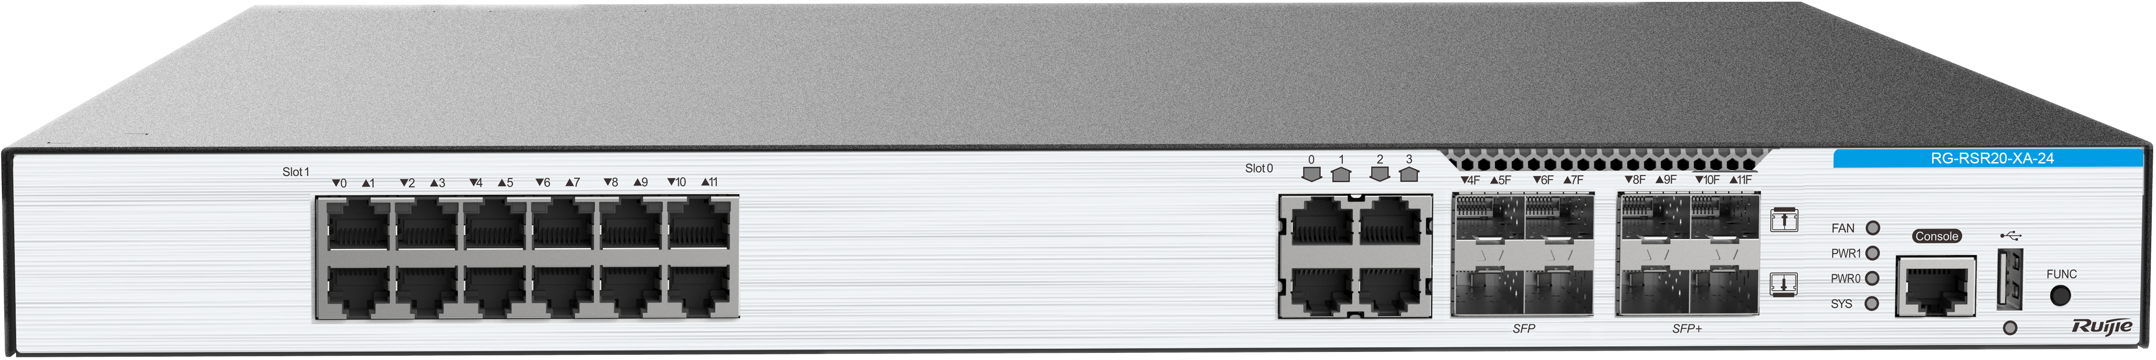
Front View of the RG-RSR20-XA-24

RG-RSR20-XA-36
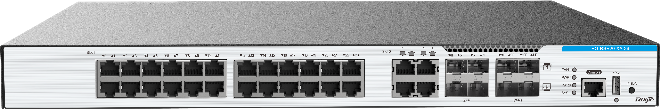
Front View of the RG-RSR20-XA-36

RG-RSR20-XA-54
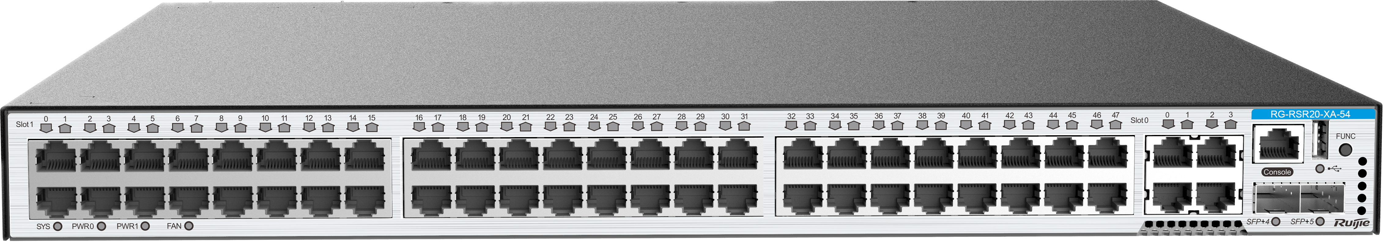
Front View of the RG-RSR20-XA-54
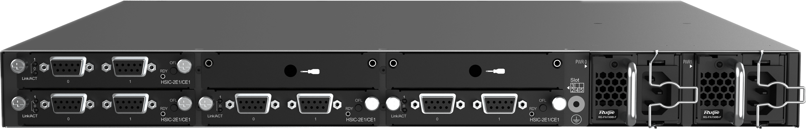
Rear View of the RG-RSR20-XA-54

Product Highlights
Full-Featured Service Router in Diverse Scenarios
- Routing, switching, security (IPsec), egress (NAT), and 4G/5G
- E1/POS/GE/10GE rates
Carrier-Class Reliability
- BOOT dual planes, ensuring stable operation with 99.999% uptime
- Redundancy of key components such as fan modules and power modules

Product Features

Multi-service Integration and All-in-One

Advanced Hardware Architecture
Multi-core processor and distributed hardware architecture, meeting diversified network access needs
Distributed hardware architecture that separates the control plane from the forwarding plane, and delivers excellent forwarding performance and reliability

Powerful Routing Capabilities
IPv4/IPv6 static routing and dynamic routing protocols including the Open Shortest Path First (OSPF), Routing Information Protocol (RIP), Intermediate System to Intermediate System (IS-IS), and Border Gateway Protocol (BGP), adapting to different networking requirements of various industries
Policy-based routing (PBR) used to flexibly control and schedule network traffic, satisfying routing requirements of finance, government, and enterprise networks
High-performance flow table, fast forwarding technologies, and functions such as Graceful Restart (GR), Fast Reroute (FRR), and Bidirectional Forwarding Detection (BFD), realizing fast convergence of traditional routing protocols on large-sized networks

Comprehensive Switching Characteristics
Layer 2 Ethernet interfaces extended to integrate functions of a switch and a router, reducing the investment in network construction and maintenance costs
Layer 2 Ethernet interfaces that support complete switching features and provide 1000M line-speed forwarding

Rich VPN Features
Internet Protocol Security (IPsec), Generic Routing Encapsulation (GRE), Dynamic Multipoint Virtual Private Network (DMVPN), and other VPN applications
Multiprotocol Label Switching (MPLS) L2VPN/L3VPN applications
Layer 2 Tunneling Protocol (L2TP) or Point to Point Tunneling Protocol (PPTP) for Virtual Private Dialup Network (VPDN) applications, and L2TP/PPTP pass-through for Network Address Translation (NAT) applications

Various Security Features
Built-in encryption engine, substantially improving encryption and decryption performance
Rich security features, including the firewall, IPsec VPN, Secure Shell (SSH), intrusion defense, DDoS defense, attack defense, anti-ARP spoofing, DHCP snooping, and digital certificate
Authentication, Authorization, and Accounting (AAA), and RADIUS and TACACS+ authentication
802.1X authentication, MAC address authentication, web authentication, and other access authentication modes

All-round MPLS Functions
All-round MPLS protocols including MPLS L2VPN and L3VPN, providing a high-performance, secure, and hierarchical MPLS VPN solution
Distributed multicast VPN, enabling high-performance multicast services on an MPLS VPN network to cope with multicast services such as video conferencing and distance learning
MPLS Label Distribution Protocol (LDP) FRR for fast label switched path (LSP) switching

Complete IPv6 Solutions
IPv4/IPv6 dual stack, and multiple IPv6 routing technologies such as static routing, Equal-cost Multi-path Routing (ECMP), PBR, OSPFv3, RIPng, BGP4+, and IS-ISv6, supporting future deployment of large-scale IPv6 networks
Rich IPv4-to-IPv6 transition solutions, such as dual-stack, manual tunnels, ISATAP tunnels, and 6to4 tunnels, allowing transition from an IPv4 network to an IPv6 network
A variety of IPv6-related technologies such as address auto-configuration, Internet Control Message Protocol Version 6 (ICMPv6), ICMPv6 redirection, ACL for IPv6, and TCP/UDP for IPv6
Video features and optimization
Diverse multicast functions including Internet Group Management Protocol (IGMP), Protocol Independent Multicast - Dense Mode (PIM-DM), Distance Vector Multicast Routing Protocol (DVMRP), and PIM Sparse Mode (PIM-SM) to meet video application requirements

Sound HQoS/QoS Policies
5-level Hierarchical QoS (HQoS): HQoS enables the router to process data flows on a network based on the combination of user services, users, user groups, and interfaces, to achieve multi-level QoS. Underlying user service-level QoS ensures the SLA between multiple service flows of a single user, user-level QoS ensures the SLA between multiple users within a group, user group-level and interface-level QoS achieve SLAs between user groups and on an interface respectively. HQoS realizes E2E service quality guarantee in a centralized manner. It also improves the QoS accuracy on a data aggregation device and enhances the quality of services for network-wide users.
QoS traffic queue scheduling policies such as Priority Queuing (PQ), Custom Queuing (CQ), First In First Out (FIFO), Weighted Fair Queuing (WFQ), Class-based WFQ (CBWFQ) , Low Latency Queuing (LLQ), and Real-time Transport Protocol Priority Queuing (RTPQ), and HQoS multi-level queue scheduling technologies such as flow queue (FQ), user queue (UQ), user group queue (GQ), virtual output queue (VoQ), destination interface/destination device class queue (CQ), and low priority queue (LPQ)

Ease of Use and Management
Command line interface (CLI), web, Simple Network Management Protocol (SNMP), CPE WAN Management Protocol (CWMP), and other modes
Onboarding through Zero Touch Provisioning (ZTP), and onsite configuration import and software upgrade through the USB flash drive and wizard, avoiding complex CLI operations, simplifying device deployment, and greatly improving deployment efficiency

High Reliability
BFD, BFD for static routes, and BFD for RIP/OSPF/BGP/IS-IS, achieving FRR and millisecond-level switching
Hot swapping of line cards: Services are not affected when line cards are added or replaced online, which improves the device reliability.
The RG-RSR20-XA series supports dual power module redundancy to enhance reliability.

Product Specifications

Hardware Specifications
Hardware Specifications | RG-RSR20-XA-24 | RG-RSR20-XA-36 | RG-RSR20-XA-54
Interface Specifications
Fixed WAN port | 4 x 10GE optical ports  4 x 1GE optical ports  4 x 1GE electrical ports | 4 x 10GE optical ports  4 x 1GE optical ports  4 x 1GE electrical ports | 2 x 10GE optical ports  4 x 1GE electrical ports
Fixed LAN port (LAN/WAN port switching) | 12 x 1GE electrical ports | 24 x 1GE electrical ports | 48 x 1GE electrical ports
Power modules | 2 (1+1 redundancy) | 2 (1+1 redundancy) | 2 (1+1 redundancy)
Fixed management ports | 1 x console port and 1 x USB 2.0 port
Expansion slot | 4
System Specifications
Packet forwarding rate | 9 Mpps to 40 Mpps
System switching capacity | 120 Gbps
Number of MAC addresses | Number of global MAC addresses: 10,000  Number of static MAC addresses: 4,000
ARP table size | 24,000
Number of IPv4 unicast routes | 100,000
Number of IPv4 multicast routes | 2,048
Number of IPv6 multicast routes | 1,024
Number of ACEs | Ingress: 4,000  Egress: 4,000
Dimensions and Weight
Dimensions (W x D x H) | 440 mm x 420 mm x 44 mm (17.32 inch. x 16.56 in. x 1.73 in.), 1 RU
Weight (Full configuration) | < 7.8 kg (17.20 lbs) (excluding packaging)
CPU and Storage
CPU | FT2000_V2
Storage | 4 GB DDR4  8 GB eMMC
Power and Consumption
Maximum power consumption | < 150 W
Maximum output power | RG-PA150IB-F: 150 W @ 10 A power cord
Rated input voltage | RG-PA150IB-F: 100 V AC to 240 V AC, 50 Hz to 60 Hz
Maximum input voltage | RG-PA150IB-F: 90 V AC to 264 V AC, 50 Hz to 60 Hz
Environment and Reliability
MTBF | > 100,000 hours
Operating temperature | 0°C to 50°C (32°F to 122°F)
Storage temperature | –40°C to +70°C (–40°F to +158°F)
Operating humidity | 10% to 90% RH (non-condensing)
Storage humidity | 5% to 95% RH (non-condensing)
Interface surge protection | 6 kV
Operating altitude | 0–3000 m (0–9,842.52 ft.)

Software Specifications
RG-RSR20-XA Series
Model | Description
Ethernet switching | Jumbo frame length: 1,578 bytes
Ethernet switching | Number of created VLANs: 4,088
Ethernet switching | Voice VLAN
Ethernet switching | MAC address-based and interface-based VLAN assignment
Ethernet switching | STP (IEEE 802.1.d), RSTP (IEEE 802.1w), and MSTP (IEEE 802.1s)
Ethernet switching | LLDP/LLDP-MED
IP service | DHCP server, DHCP relay, DHCP client, and DHCP snooping
IP service | Static and dynamic NAT, static and dynamic NAPT, and VPN NAT
IP service | DNS
IP service | DHCPv6 client, DHCPv6 relay, and DHCPv6 snooping
IP service | Neighbor Discovery (ND)
IP service | IPv6 GRE tunnel
IP routing | IPv4/IPv6 static routing
IP routing | RIP v1/v2 and RIPng
IP routing | OSPFv2 and OSPFv3
IP routing | GR
IP routing | IS-ISv4 and IS-ISv6
IP routing | BGP and BGP4+
IP routing | Routing policies
IP routing | IPv4/IPv6 VRF
IP routing | IPv4 and IPv6 PBR
Multicast | IGMPv1/v2/v3
Multicast | Static multicast routing
Multicast | PIM-DM, PIM-SM, PIM-SSM, and other multicast routing protocols
Multicast | PIM-SSM for IPv4 and IPv6
Multicast | MSDP for inter-domain multicast
Multicast | MLDv1/v2
Multicast | PIM-SMv6
MPLS | MPLS forwarding  Two MPLS VPN modes: inter-AS Option B and Option C  MPLS L3VPN
MPLS | 6PE/6VPE interconnection with IPv4/IPv6 MPLS backbone network
MPLS | MPLS MIB (RFC 1273, 4265, 4382)
ACL and QoS | Standard IP ACLs
ACL and QoS | Extended IP ACLs
ACL and QoS | Extended MAC ACLs
ACL and QoS | Expert-level ACLs (ACLs based on source and destination IP addresses and ports, and specified protocol)
ACL and QoS | IPv6 ACLs
ACL and QoS | HQoS (traffic shaping on interfaces)
Security | Multiple AAA modes
Security | RADIUS authentication and authorization
Security | TACACS+
Security | IEEE802.1X authentication, MAC address bypass (MAB) authentication, and interface-based and MAC address-based 802.1X authentication
Security | MAC address allowlist, and bindings of VLAN IDs, interface numbers, and MAC addresses
Security | SSHv1 and SSHv2
Security | ICMP (interface discards ICMP traffic of which the rate exceeds the threshold)
Security | Port security
Security | L2TP, IPsec, and GRE  uRPF  Login authentication and password security
Security | CPP
Security | Strict and loose RPF  uRPF ignoring default routes
Reliability | RLDP, Layer 2 link connectivity detection, unidirectional link detection, and VLAN-based loop control
Reliability | DLDP
Reliability | IPv4 VRRP v2/v3 and IPv6 VRRP
Reliability | ECMP
Reliability | BFD
Reliability | GR for OSPF/IS-IS/BGP  BFD for VRRP, OSPF, BGP4, IS-IS, IS-ISv6, MPLS, and static routing
SDN technology | NETCONF
NMS and maintenance | SPAN and ERSPAN
NMS and maintenance | NTP and SNTP
NMS and maintenance | NTP server and NTP client
NMS and maintenance | FTP and TFTP
NMS and maintenance | SNMP v1/v2/v3
NMS and maintenance | System operation logging
NMS and maintenance | Port mirroring
NMS and maintenance | Command line through console, AUX Modem, Telnet, and SSH
NMS and maintenance | RMON (1, 2, 3, 9)
NMS and maintenance | CWMP
NMS and maintenance | gRPC
Note: The item marked with the asterisk (*) will be available in the future.

Protocol Compliance
RG-RSR20-XA Series
Organization | Standards and Protocol
IETF | RFC 1058 Routing Information Protocol (RIP)  RFC 1157 A Simple Network Management Protocol (SNMP)  RFC 1305 Network Time Protocol Version 3 (NTP)  RFC 1349 Internet Protocol (IP)  RFC 1350 TFTP Protocol (revision 2)  RFC 1519 CIDR  RFC 1583 OSPF Version 2  RFC 1591 Domain Name System Structure and Delegation  RFC 1643 Ethernet Interface MIB  RFC 1757 Remote Network Monitoring (RMON)  RFC 1812 Requirements for IP Version 4 Router  RFC 1901 Introduction to Community-based SNMPv2  RFC 1902-1907 SNMP v2  RFC 1918 Address Allocation for Private Internet  RFC 1981 Path MTU Discovery for IP version 6  RFC 1997 BGP Communities Attribute  RFC 2131 Dynamic Host Configuration Protocol (DHCP)  RFC 2132 DHCP Options and BOOTP Vendor Extensions  RFC 2236 IGMP  RFC 2328 OSPF Version 2  RFC 2385 Protection of BGP Sessions via the TCP MD5 Signature Option  RFC 2439 BGP Route Flap Damping  RFC 2460 Internet Protocol, Version 6 (IPv6)  RFC 2461 Neighbor Discovery for IP Version 6 (IPv6)  RFC 2462 IPv6 Stateless Address Auto configuration  RFC 2463 Internet Control Message Protocol for IPv6 (ICMPv6)  RFC 2545 Use of BGP 4 Multiprotocol Extensions for IPv6 Inter Domain Routing  RFC 2571 SNMP Management Frameworks  RFC 2711 IPv6 Router Alert Option  RFC 2787 Definitions of Managed Objects for the Virtual Router Redundancy Protocol  RFC 2863 The Interfaces Group MIB  RFC 2918 Route Refresh Capability for BGP 4  RFC 2925 Definitions of Managed Objects for Remote Ping, Traceroute, and Lookup Operations (Ping only)  RFC 2934 Protocol Independent Multicast MIB for IPv4  RFC 3046 DHCP Option82  RFC 3065 Autonomous System Confederation for BGP  RFC 3101 OSPF Not so stubby area option  RFC 3137 OSPF Stub Router Advertisement sFlow  RFC 3417 (SNMP Transport Mappings)  RFC 3418 Management Information Base (MIB) for the Simple Network Management Protocol (SNMP)  RFC 3509 Alternative Implementations of OSPF Area Border Routers  RFC 3513 IP Version 6 Addressing Architecture  RFC 3623 Graceful OSPF Restart  RFC 3768 VRRP  RFC 3810 Multicast Listener Discovery Version 2 (MLDv2) for IPv6  RFC 3973 PIM Dense Mode  RFC 4022 MIB for TCP  RFC 4271 A Border Gateway Protocol 4 (BGP 4)  RFC 4273 Definitions of Managed Objects for BGP 4  RFC 4360 BGP Extended Communities Attribute  RFC 4456 BGP Route Reflection: An Alternative to Full Mesh Internal BGP (IBGP)  RFC 4486 Subcodes for BGP Cease Notification Message  RFC 4552 Authentication/Confidentiality for OSPFv3  RFC 4724 Graceful Restart Mechanism for BGP  RFC 4750 OSPFv2 MIB partial support no SetMIB  RFC 4760 Multiprotocol Extensions for BGP 4  RFC 4940 IANA Considerations for OSPF  RFC 5065 Autonomous System Confederation for BGP  RFC 5187 OSPFv3 Graceful Restart  RFC 5340 OSPFv3 for IPv6  RFC 5492 Capabilities Advertisement with BGP 4  RFC 6620 FCFS SAVI  RFC 768 User Datagram Protocol (UDP)  RFC 783 TFTP Protocol (revision 2)  RFC 792 Internet Control Message Protocol (ICMP)  RFC 793 Transmission Control Protocol (TCP)  RFC 813 Window and Acknowledgement Strategy in TCP  RFC 815 IP datagram reassembly algorithms  RFC 826 Ethernet Address Resolution Protocol (ARP)  RFC 854 Telnet Protocol  RFC 959 File Transfer Protocol (FTP)  RFC 4251 The Secure Shell (SSH) Protocol  RFC 4252 SSHv6 Authentication  RFC 4253 SSHv6 Transport Layer  RFC 4254 SSHv6 Connection  RFC 4291 IP Version 6 Addressing Architecture  RFC 4292 IP Forwarding Table MIB  RFC 4293 Management Information Base for the Internet Protocol (IP)  RFC 4443 ICMPv6  RFC 4861 IPv6 Neighbor Discovery  RFC 5424 Syslog Protocol  RFC 5798 VRRP  RFC 5905 Network Time Protocol Version 4: Protocol and Algorithms  RFC 6241 Network Configuration Protocol (NETCONF)
IEEE | IEEE 802.2 Logical Link Control  IEEE 802.1AB 2005  IEEE 802.1ab Link Layer Discovery Protocol  IEEE 802.1ad Provider Bridges  IEEE 802.1ax/IEEE802.3ad Link Aggregation  IEEE 802.1D Media Access Control (MAC) Bridges  IEEE 802.1D Spanning Tree Protocol  IEEE 802.1Q Virtual Bridged Local Area NetworksVLAN  IEEE 802.1s Multiple Spanning Tree Protocol  IEEE 802.1w Rapid Spanning Tree Protocol  IEEE 802.1x Port based network access control protocol  IEEE Std 802.3ab 1000BASE-T  IEEE 802.3ad Link Aggregation Control Protocol (LACP)  IEEE Std 802.3ae 10GE WEN/LAN Standard  IEEE Std 802.3x Full Duplex and flow control  IEEE Std 802.3z Gigabit Ethernet Standard

Typical Applications

Financial Branch Network Access
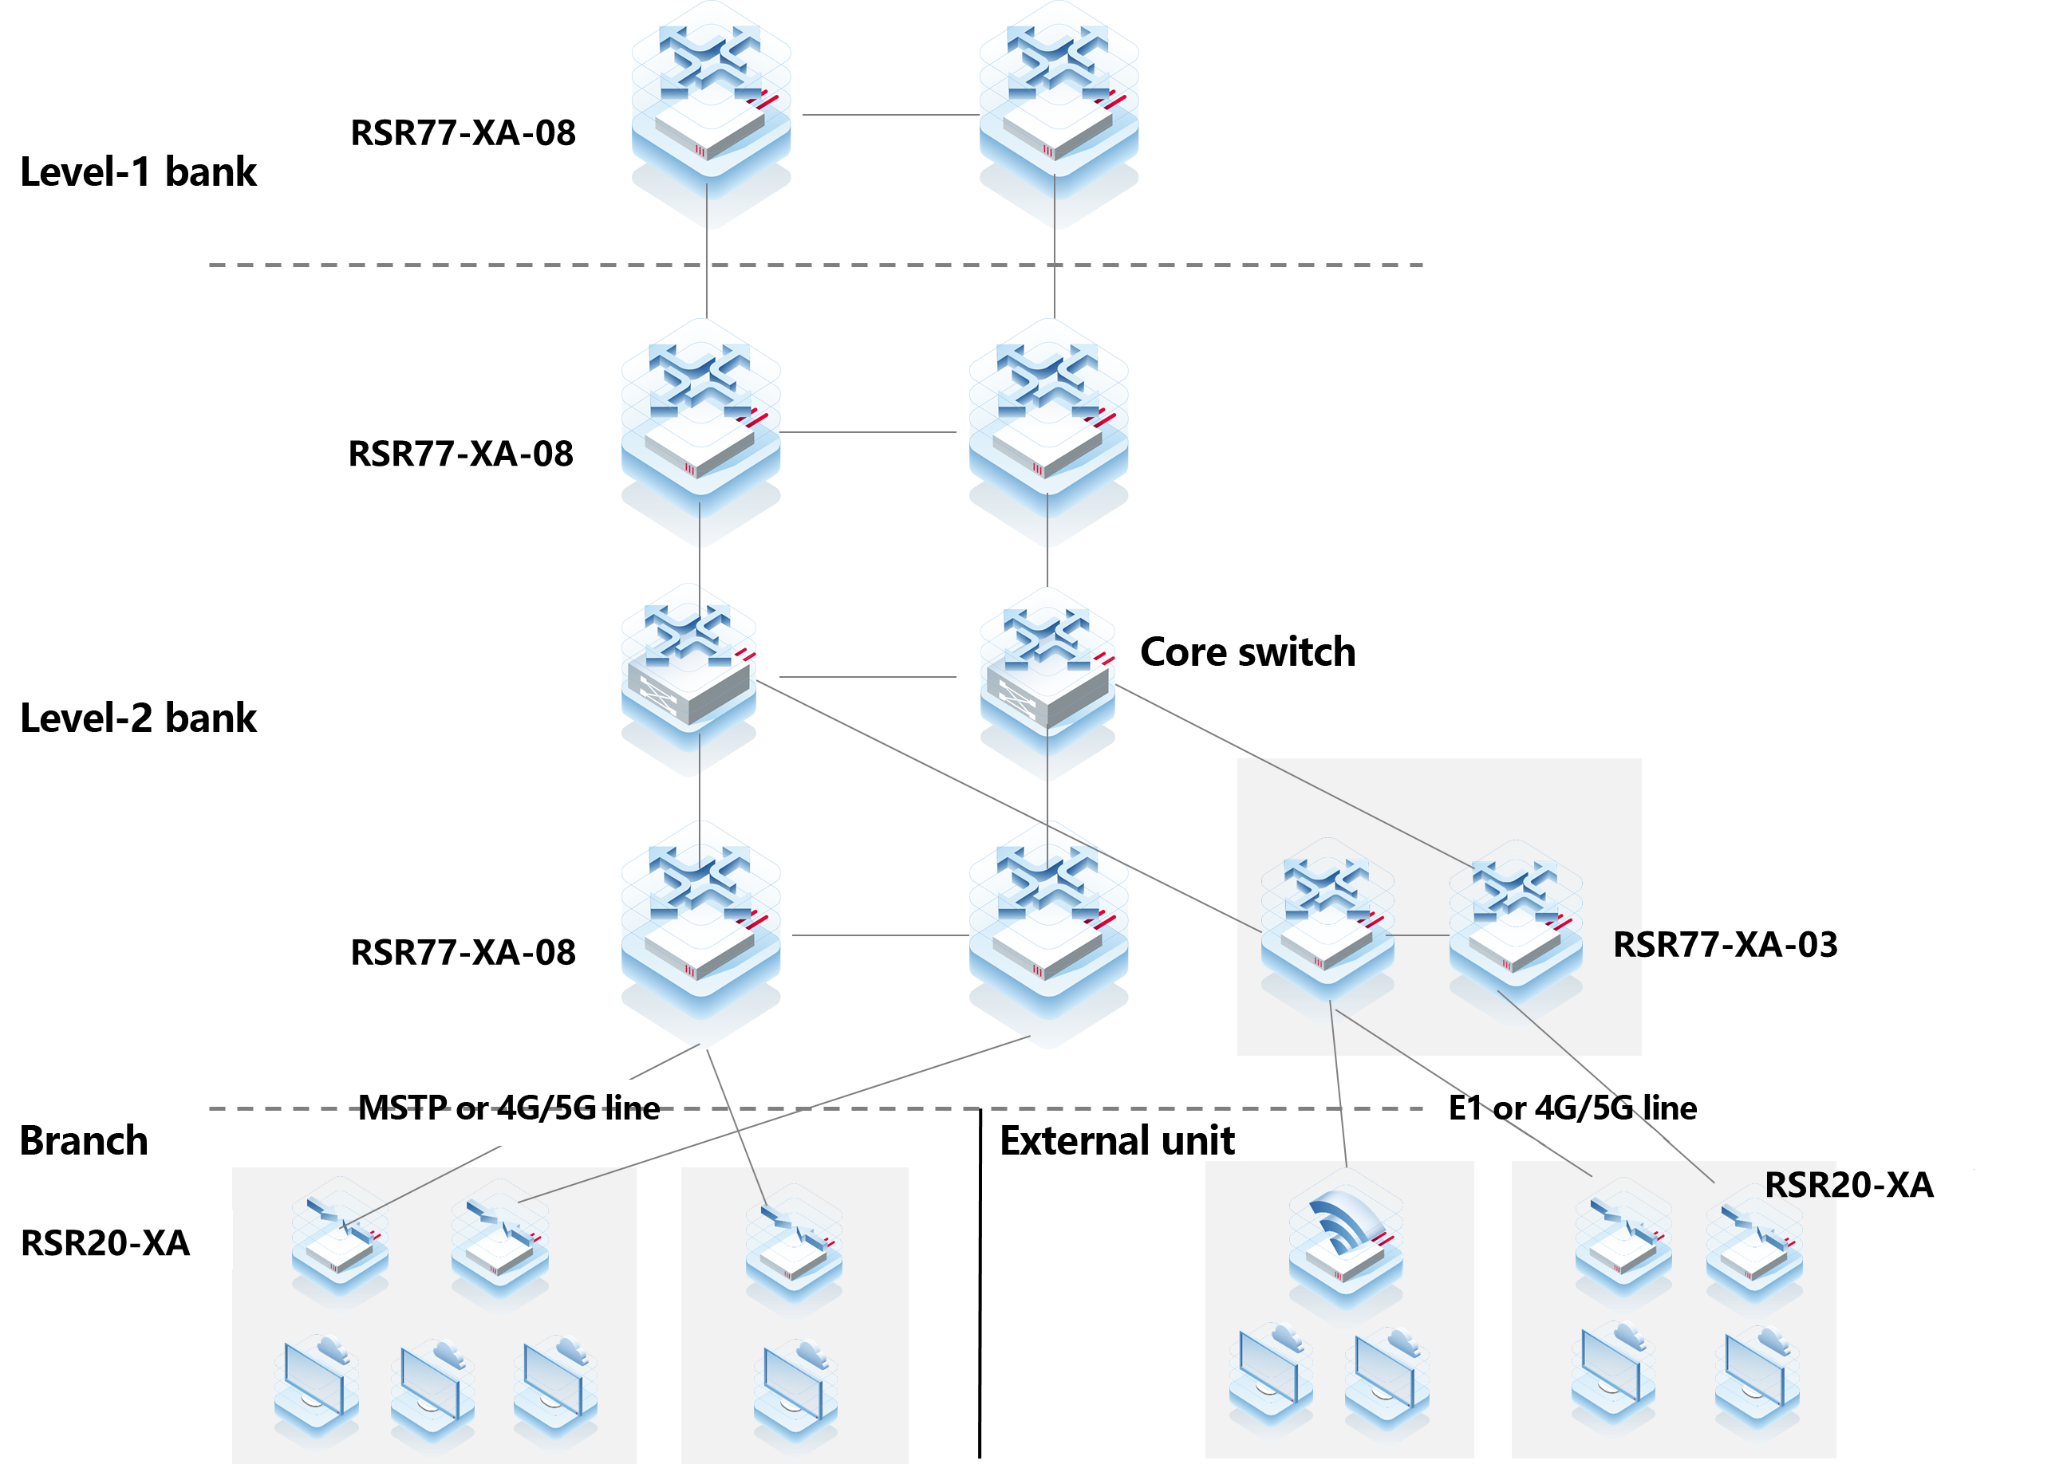
Networking:
The RSR77XA series high-end routers are used in the provincial level-1 and level-2 banks, and the RSR20-XA routers are deployed on a branch network to meet multi-service access requirements.
The RG-RSR20-XA series supports MSTP, 4G/5G, E1, Ethernet, and other access modes.

Enterprise Branch Interconnection
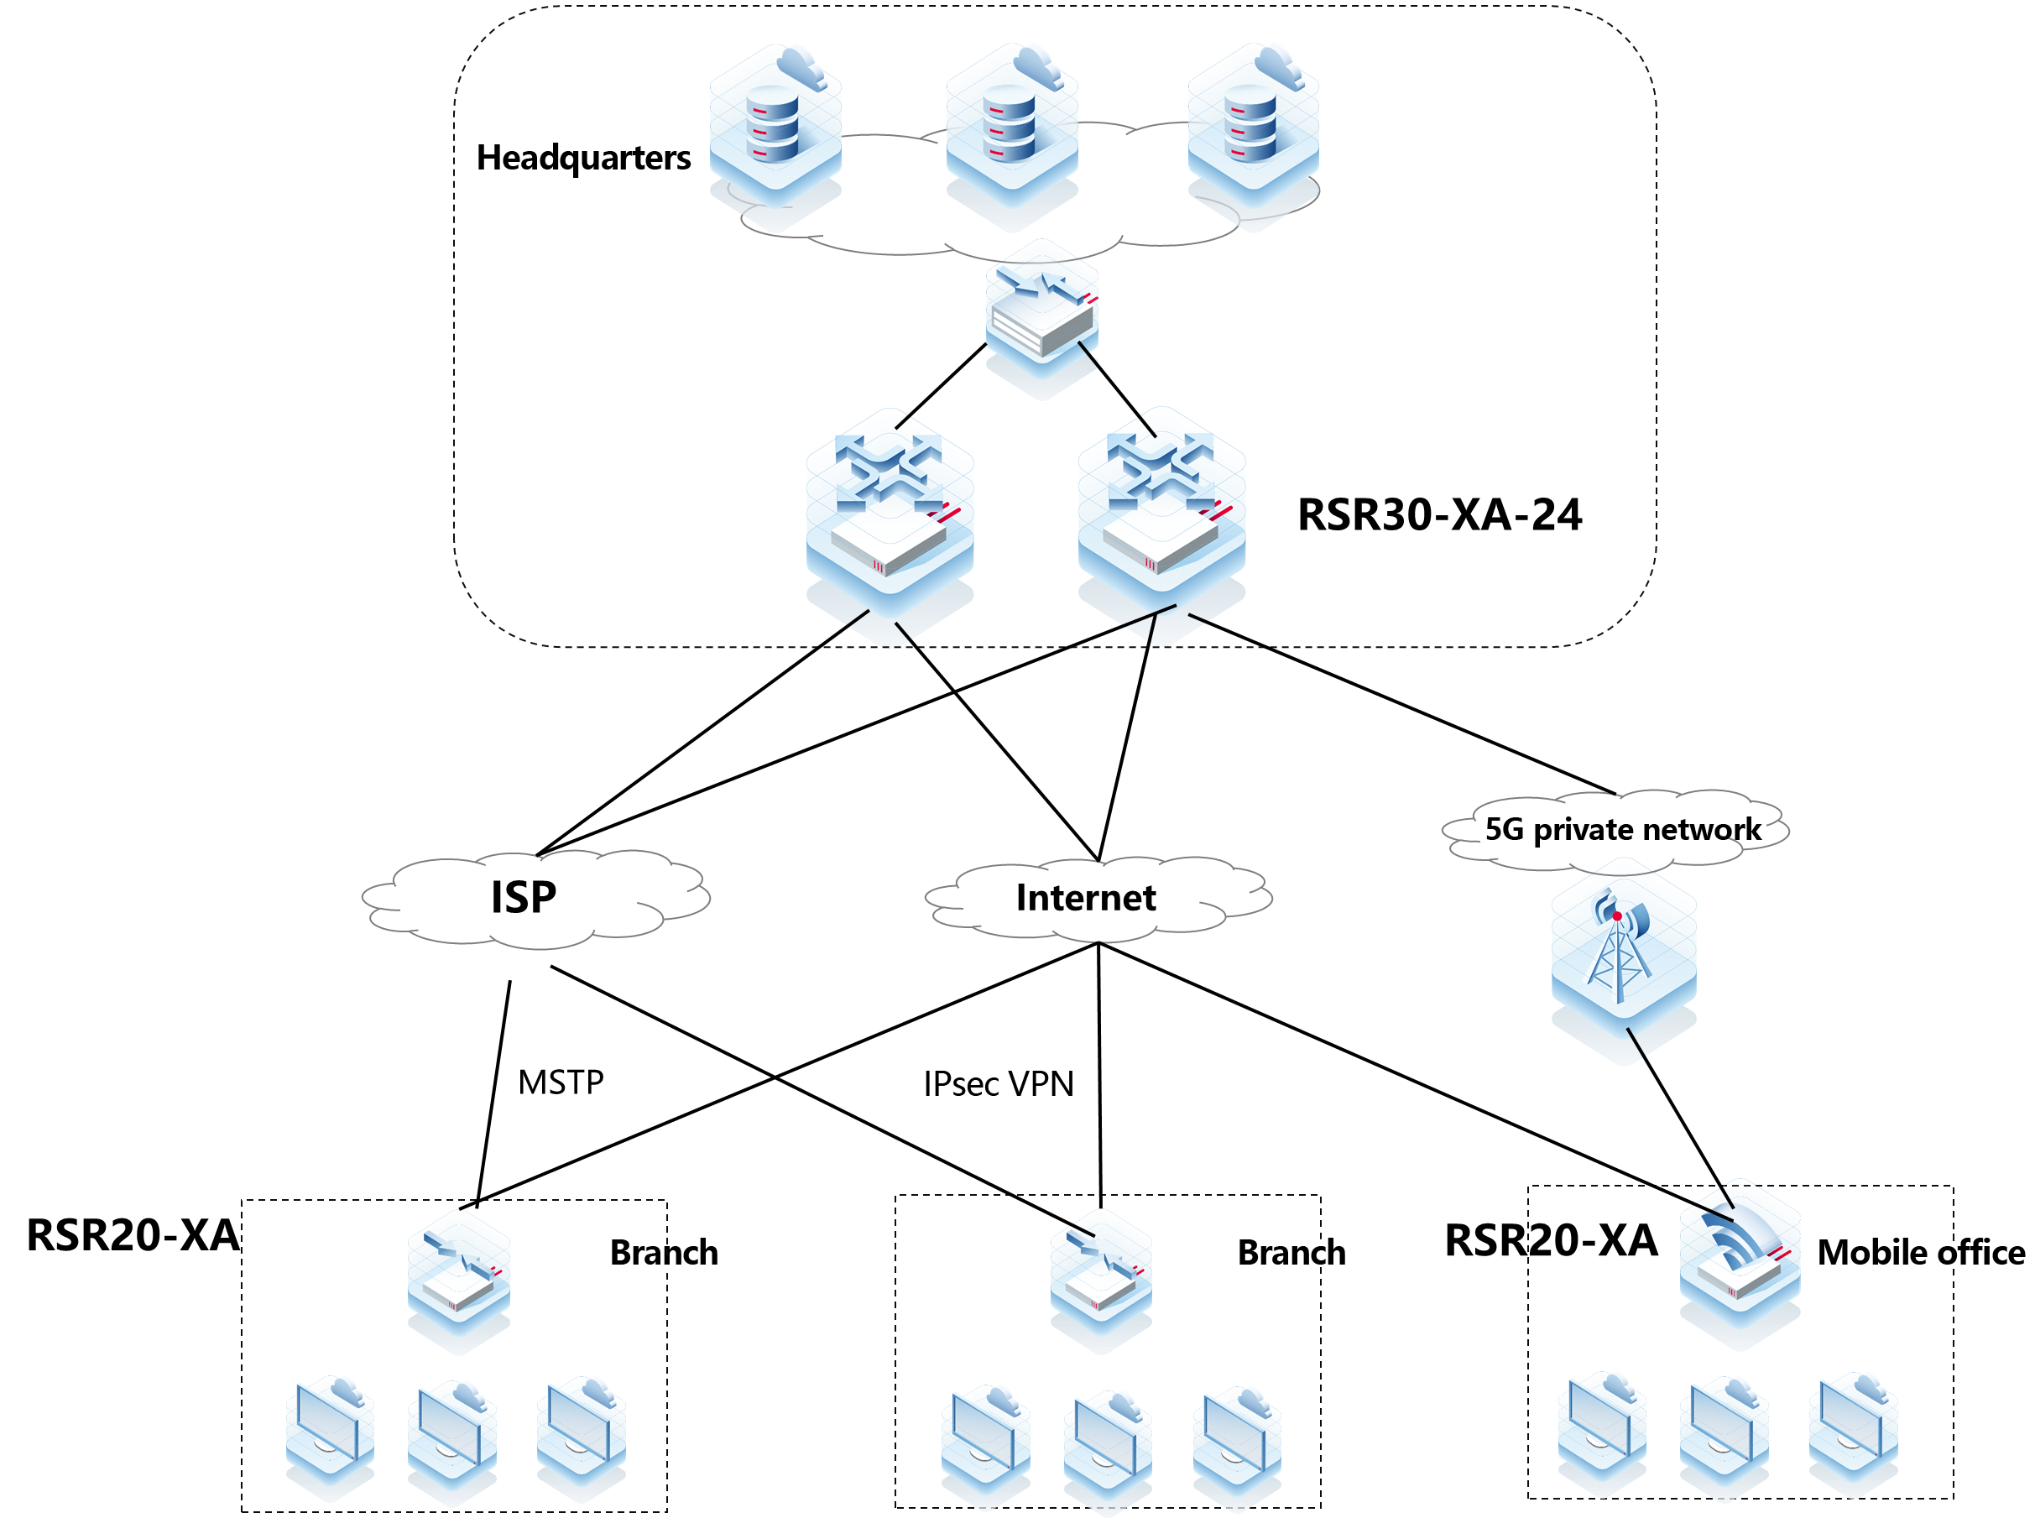
Networking:
The RSR30-XA series routers are deployed in the headquarters, and the RSR20-XA series routers are deployed in branches.
The RG-RSR20-XA series supports MSTP, GE, E1, 4G/5G, and other access modes.
It supports IPsec VPN, AAA, digital certificates, and other technologies.

Ordering Guide
Perform the following steps to configure an RG-RSR20-XA:
- Select the chassis based on the specific product model.
- Select a power module according to power supply requirements of the device. At least one power module is required.
- Select line cards as needed.
- Select accessories such as optical modules, antennas, cables, and adapters according to interface types.
Models marked with asterisks (*) in the ordering information are available later.

Ordering Information

Chassis
Model | Description
RG-RSR20-XA-24 | RG-RSR20-XA-24 chassis, 12 x fixed WAN ports (4 x 10GE optical ports, 4 x 1GE optical ports, and 4 x 1GE electrical ports) and 12 x 1GE electrical LAN ports (LAN/WAN port switching), 4 x Expansion slots, 1 x USB 2.0 port, 1 x console port
RG-RSR20-XA-36 | RG-RSR20-XA-36 chassis, 12 x fixed WAN ports (4 x 10GE optical ports, 4 x 1GE optical ports, and 4 x 1GE electrical ports) and 24 x 1GE electrical LAN ports (LAN/WAN port switching), 4 x Expansion slots, 1 x USB 2.0 port, 1 x console port
RG-RSR20-XA-54 | RG-RSR20-XA-54 chassis, 6 x fixed WAN ports (2 x 10GE optical ports and 4 x 1GE electrical ports) and 48 x 1GE electrical LAN ports (LAN/WAN port switching), 4 x Expansion slots, 1 x USB 2.0 port, 1 x console port

Power Modules
Model | Description
RG-PA150IB-F | 150 W AC power module

Line Card
Model | Description
HSIC-2E1/CE1 | 2-port E1/CE1 module (the cable needs to be purchased separately)
HSIC-4G-LTE | 1-port full-mode 4G and encryption module (the antenna needs to be purchased separately)
*HSIC-5G-NR | 1-port full-mode 5G and encryption module (the antenna needs to be purchased separately)
*HSIC-1POS-STM1 | 1-port OC-3c/STM-1c POS interface card (the optical module needs to be purchased separately)
Note: The item marked with the asterisk (*) will be available in the future.

Warranty
For more information about warranty terms and period, contact your local sales agency:
- Warranty terms: https://www.ruijienetworks.com/support/servicepolicy
- Warranty period: https://www.ruijienetworks.com/support/servicepolicy/Service-Support-Summany/
Note: The warranty terms are subject to the terms of different countries and distributors.

More Information
For more information about Ruijie Networks, visit the official Ruijie website or contact your local sales agency:
- Ruijie Networks official website: https://www.ruijienetworks.com/
- Online support: https://www.ruijienetworks.com/support
- Hotline support: https://www.ruijienetworks.com/support/hotline
- Email support: service_rj@ruijienetworks.com

