RG-IS5200 Series
Industrial Ethernet Switches
Datasheet
V1.7

Ruijie Networks Co, Ltd.
All rights reserved.

Change History
Note: The change history is for internal reference only. The change history must be deleted when this document is released for external users.
Date | Version | Change History | Revised By
2024-09-26 | V1.0 | 初始版本 | 汤润涵
2024-11-27 | V1.1 | 产品补齐 | 汤润涵/王莹
2025-02-10 | V1.2 | 修订Maximum power consumption、IP rating，补充Safety regulation、EMC regulation | 王莹
2025-02-19 | V1.3 | 修订产品亮点内容，纠正部分描述错误，增加PoE-REP、IS52-shield产品图片 | 汤润涵
2025-04-02 | V1.4 | 订购信息补充说明 | 王莹
2025-06-05 | V1.5 | 修订湿度信息内容、网站超链接 | 汤润涵
2025-07-25 | V1.6 | 补充VSU数量的规格 | 曹玉萍
2025-12-26 | V1.7 | 补充软件规格 | 王莹

Product Overview
The Ruijie RG-IS5200 series is the next-generation industrial Ethernet switch designed for harsh industrial environments. It offers flexible full-gigabit access as well as 10GE uplink ports, supporting a wide operating temperature range and surge protection. Compared with commercial switches, the RG-IS5200 series meets higher design and component standards, providing robust protections like fanless heat dissipation, resistance to vibration, extreme temperatures, dust, and lightning. The RG-IS5200 series also supports long-distance Power over Ethernet (PoE) power supplies, making it ideal for safe city solutions, intelligent transportation, and outdoor video surveillance.
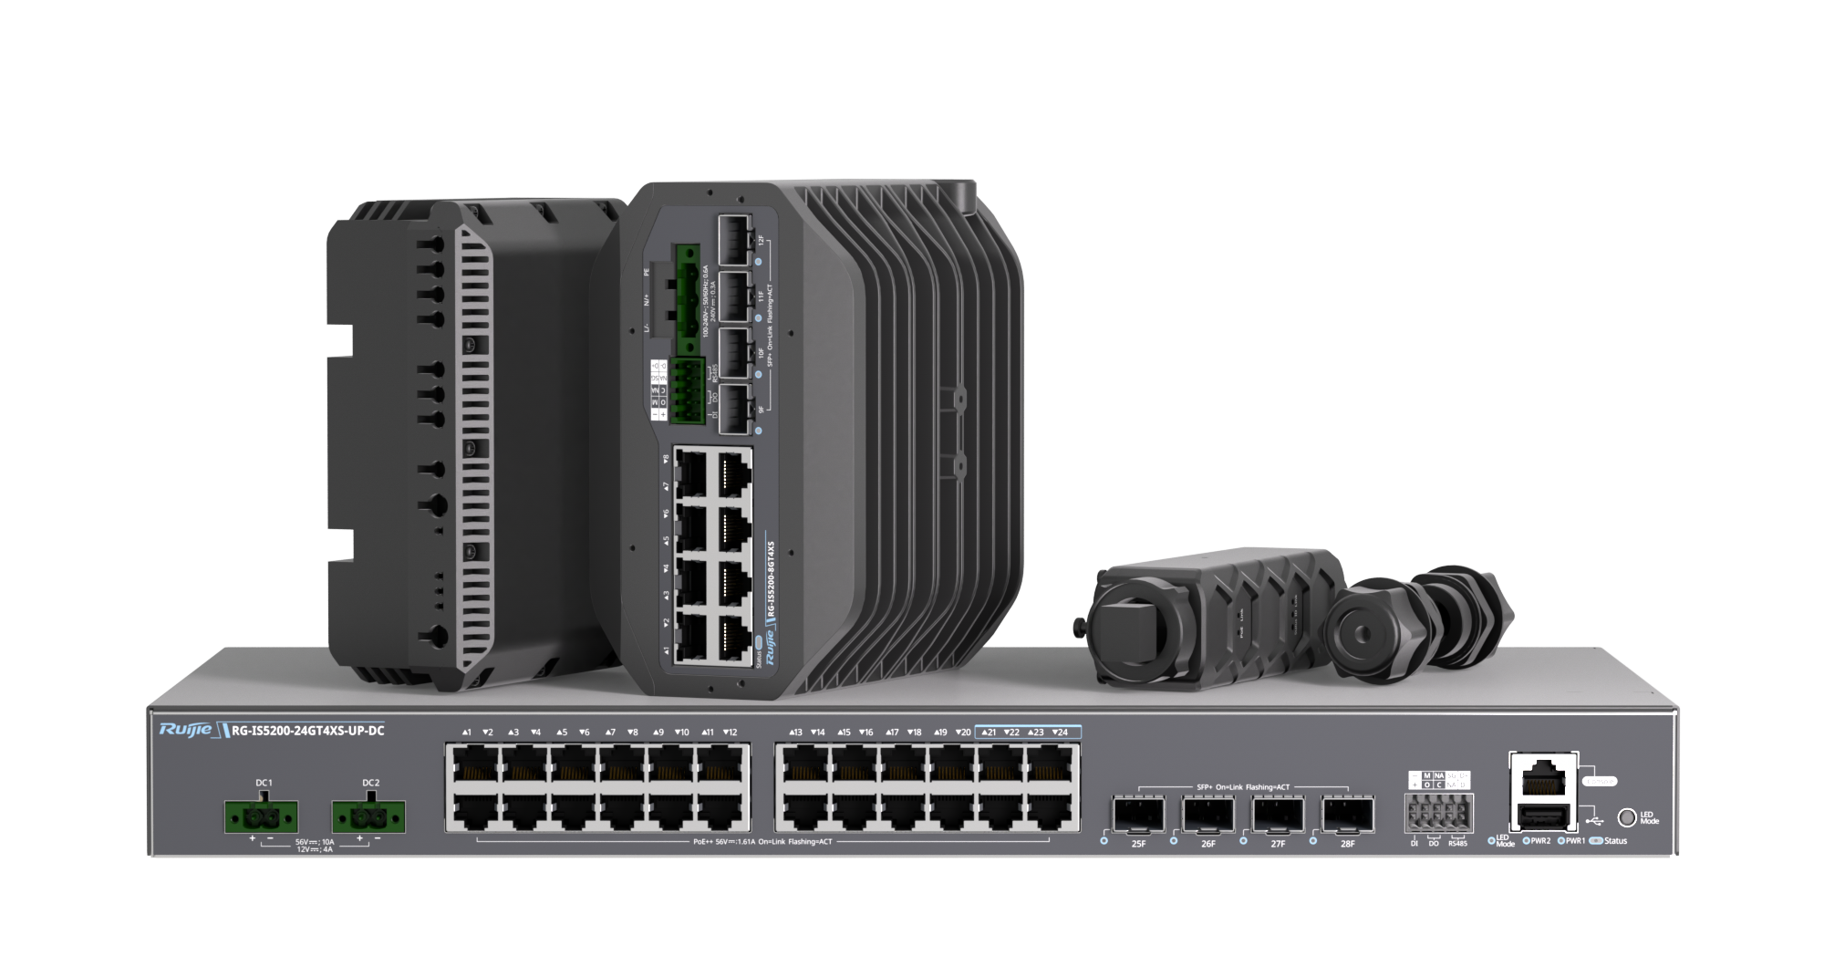

Product Appearance

RG-IS5200-8GT4XS
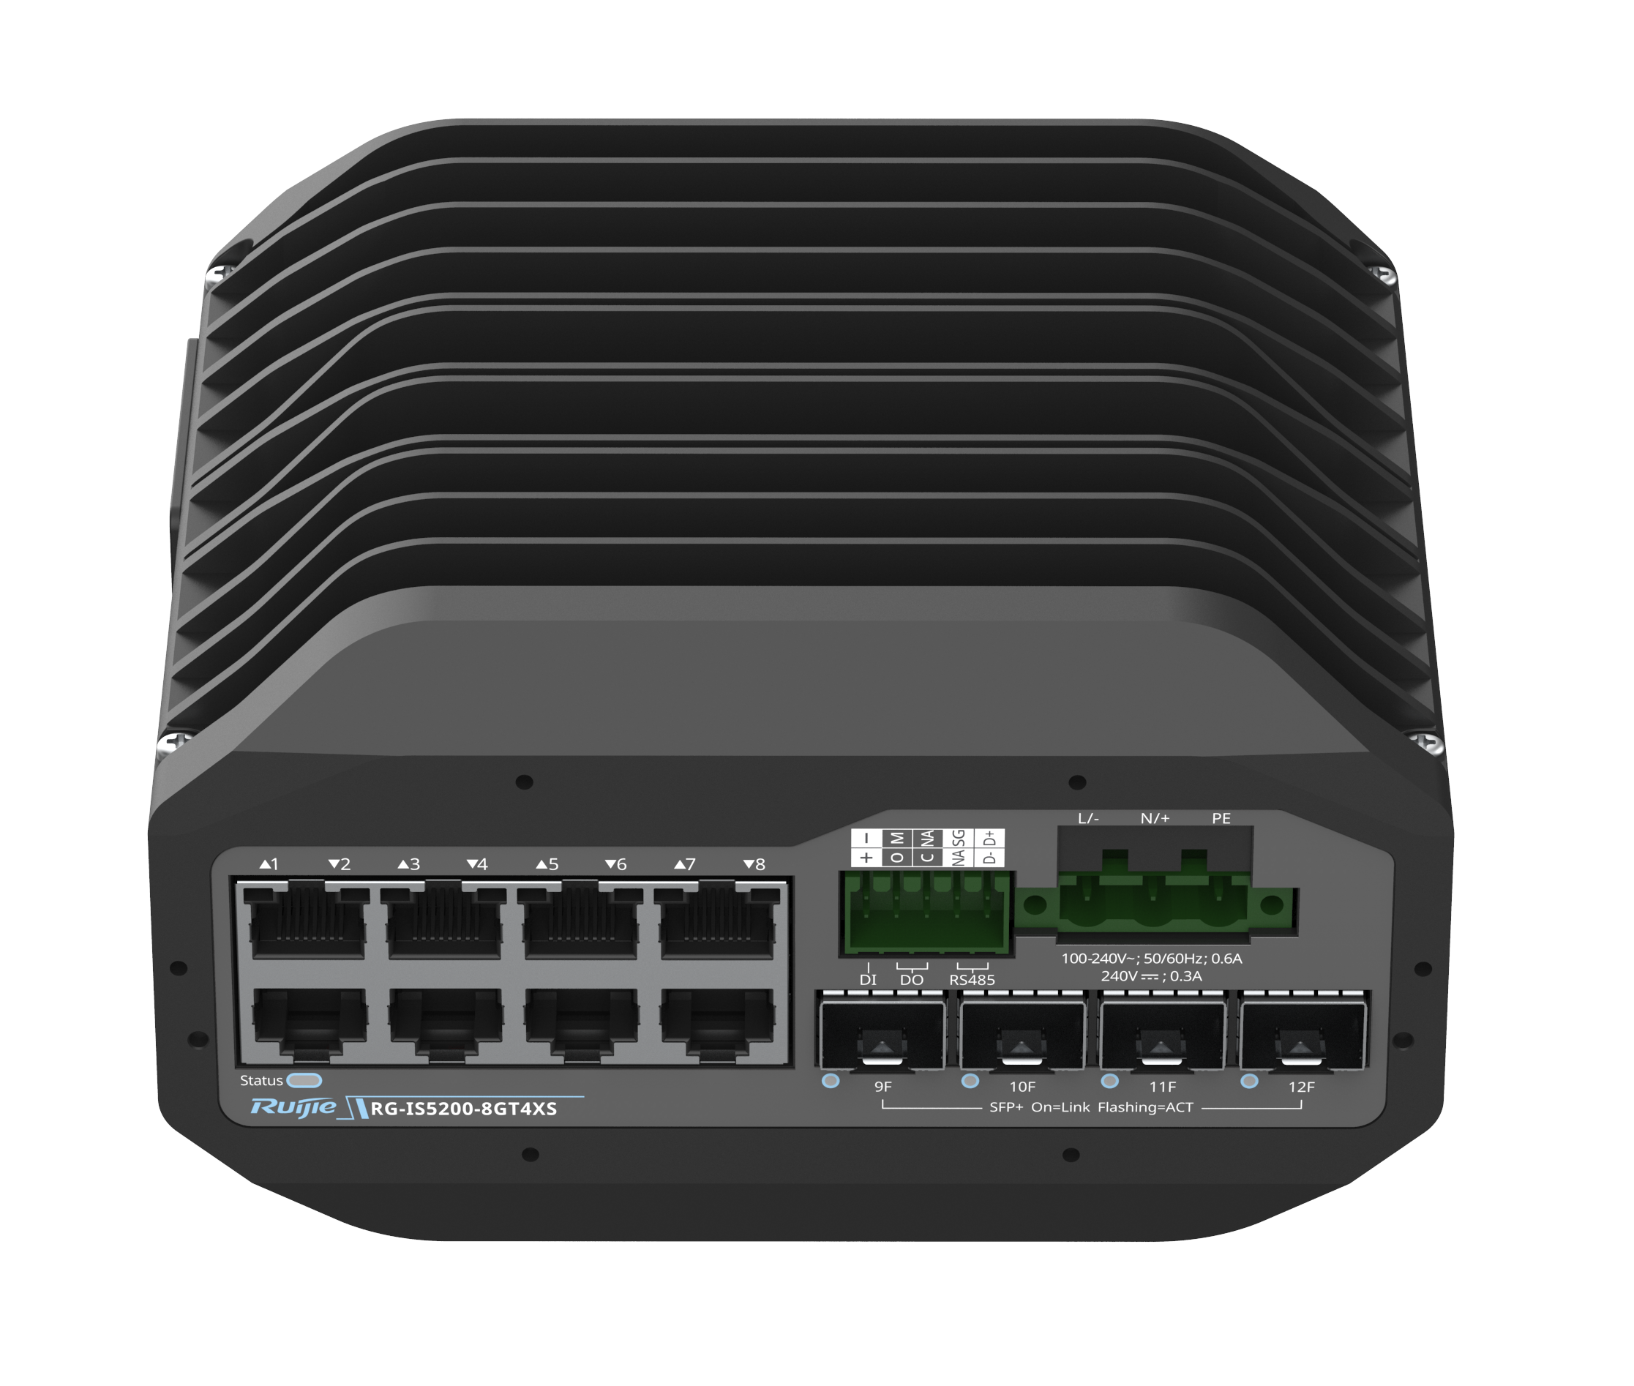
RG-IS5200-8GT4XS

RG-IS5200-8GT4XS-DC
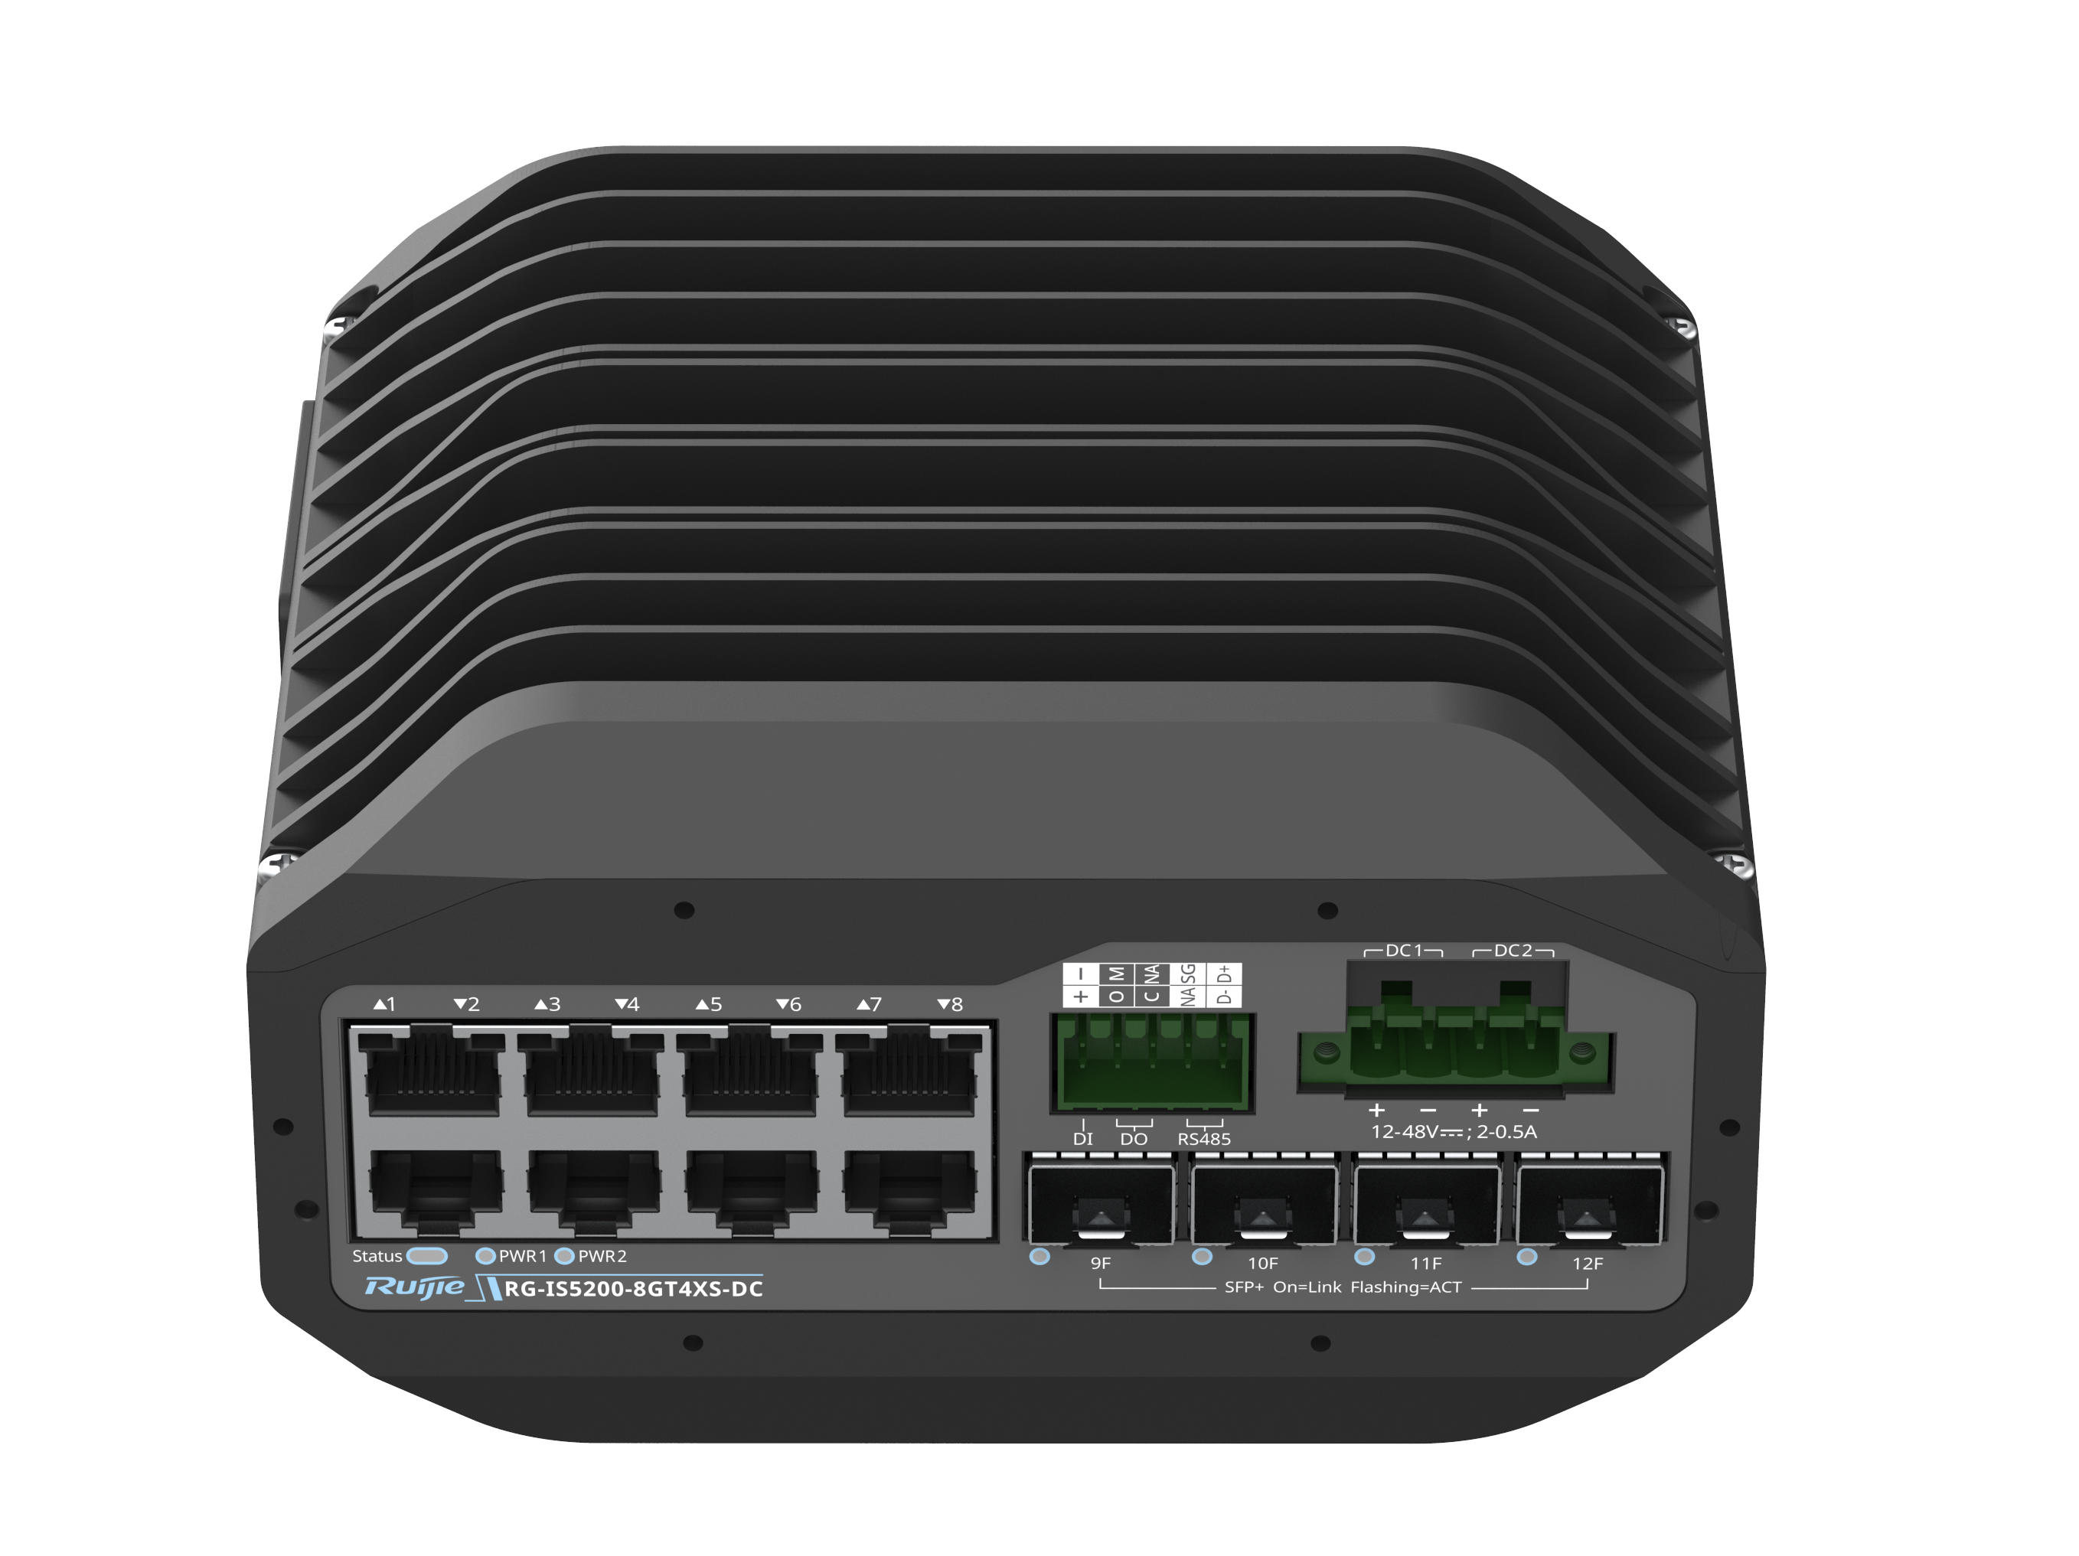
RG-IS5200-8GT4XS-DC

RG-IS5200-8GT4XS-UP-DC
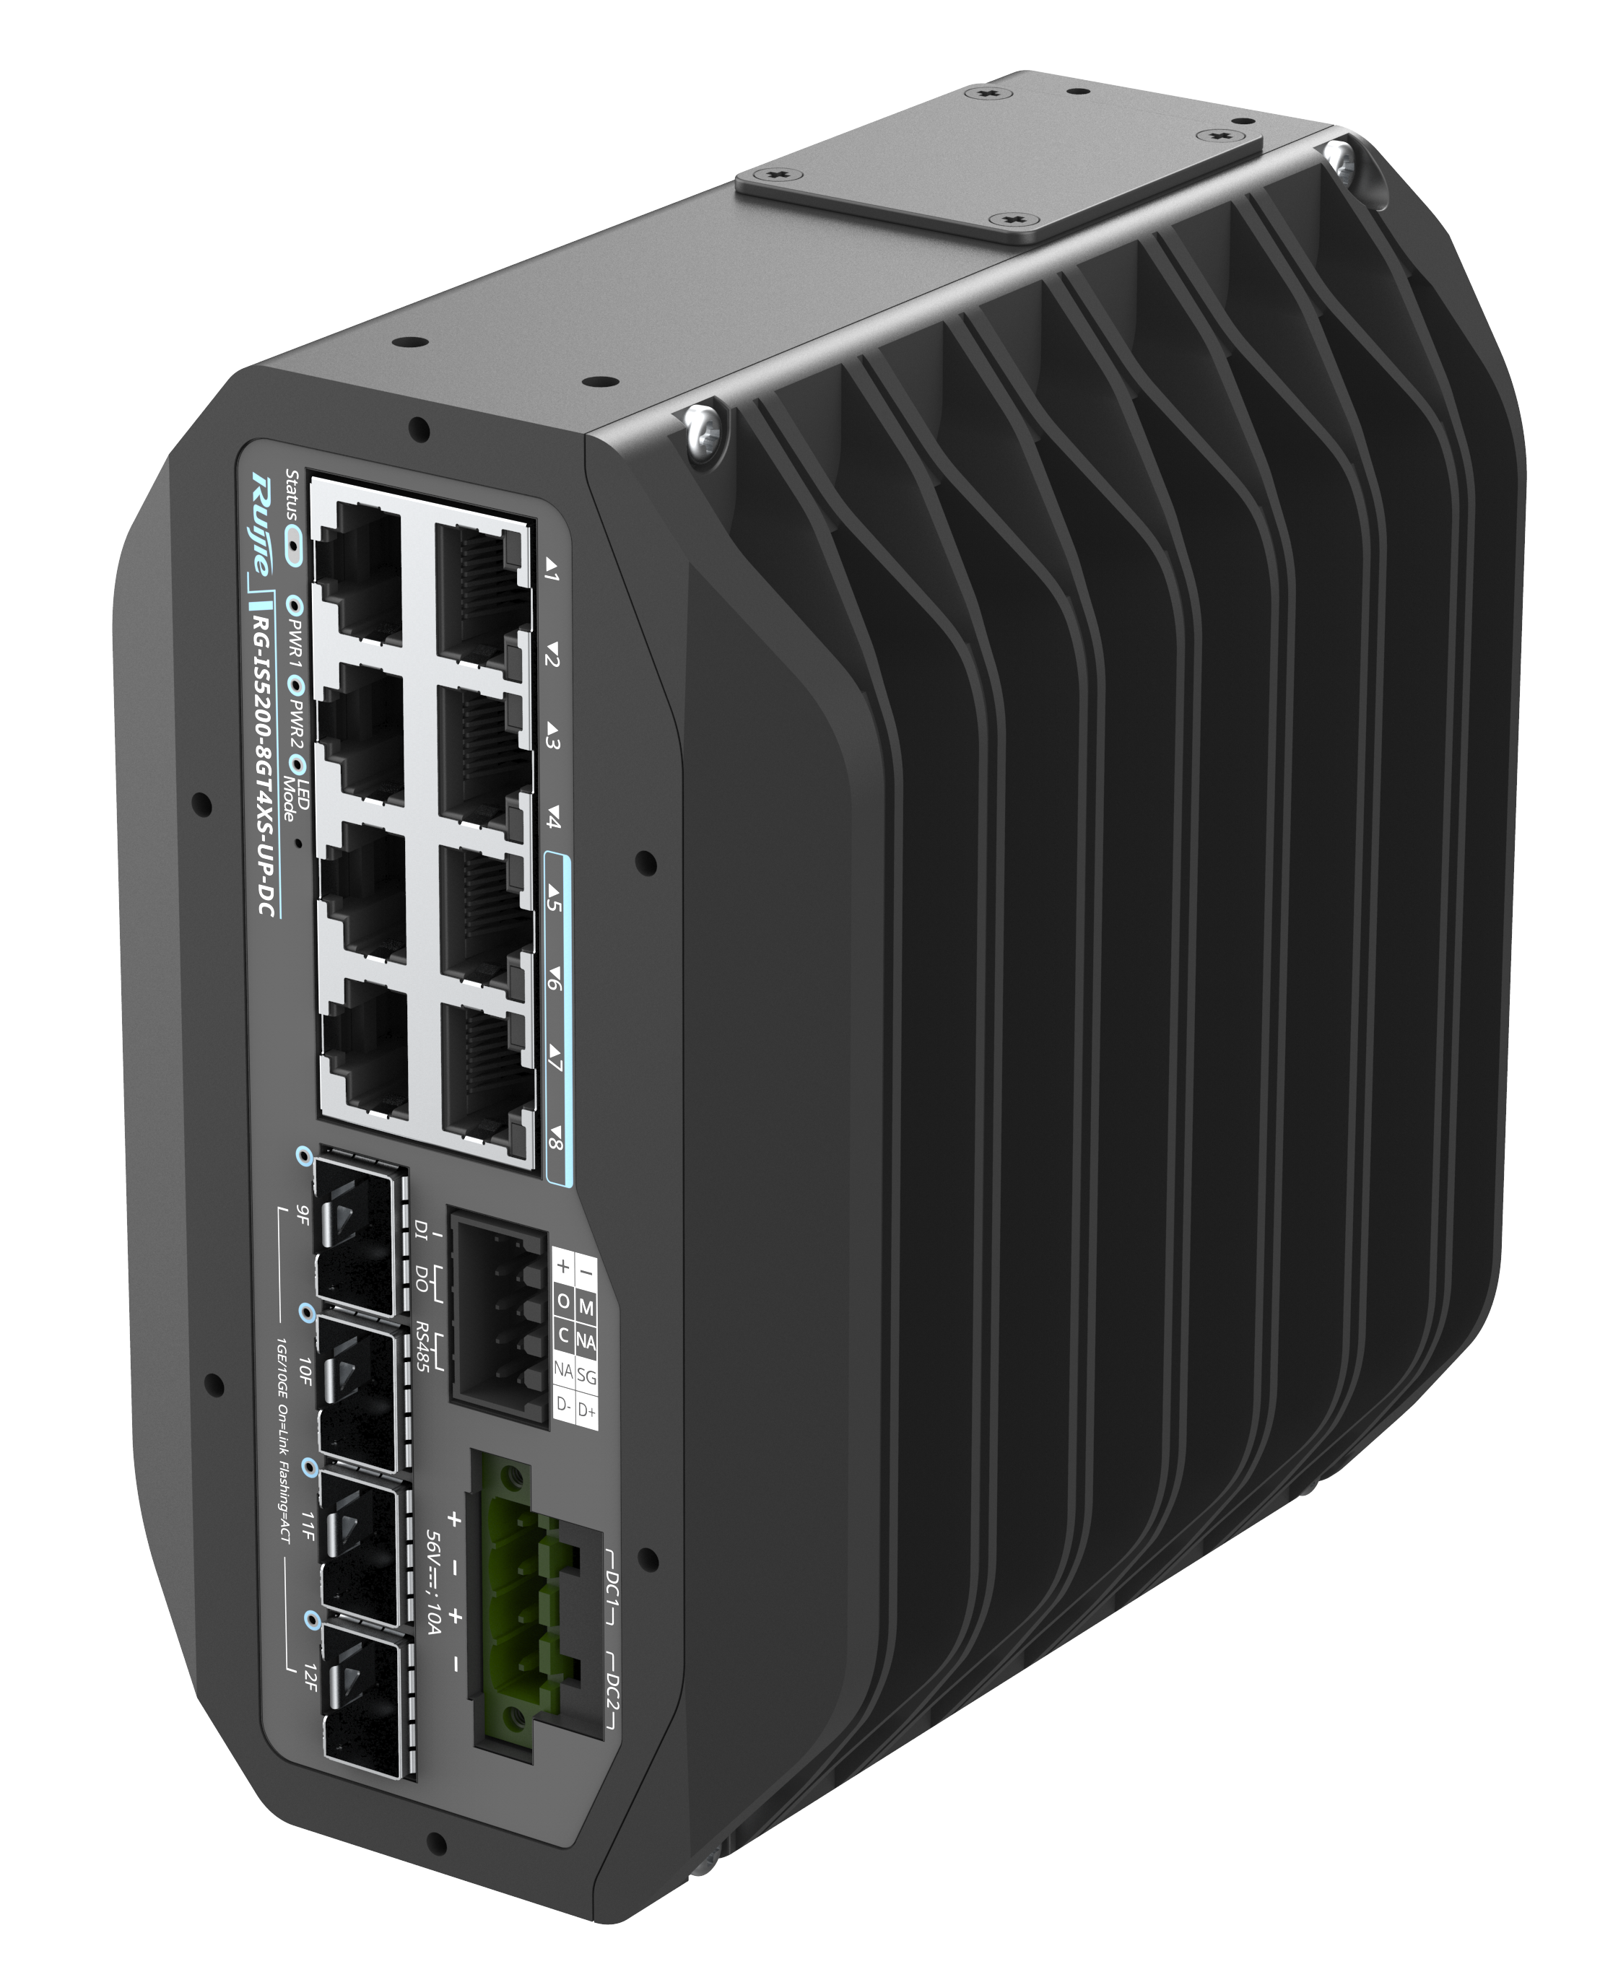
RG-IS5200-8GT4XS-UP-DC

RG-IS5200-24GT4XS-UP-DC
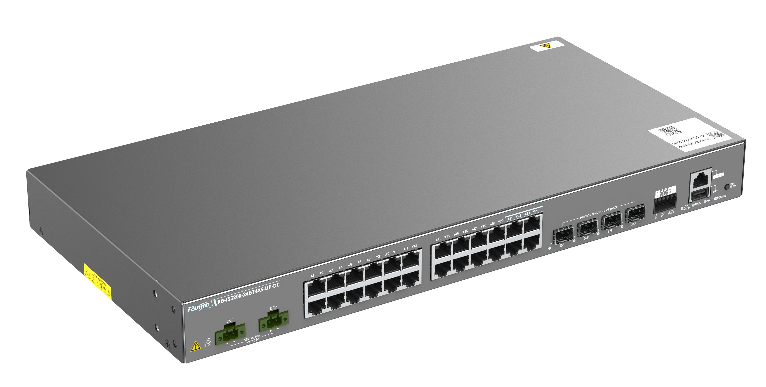
RG-IS5200-24GT4XS-UP-DC

PoE-REP
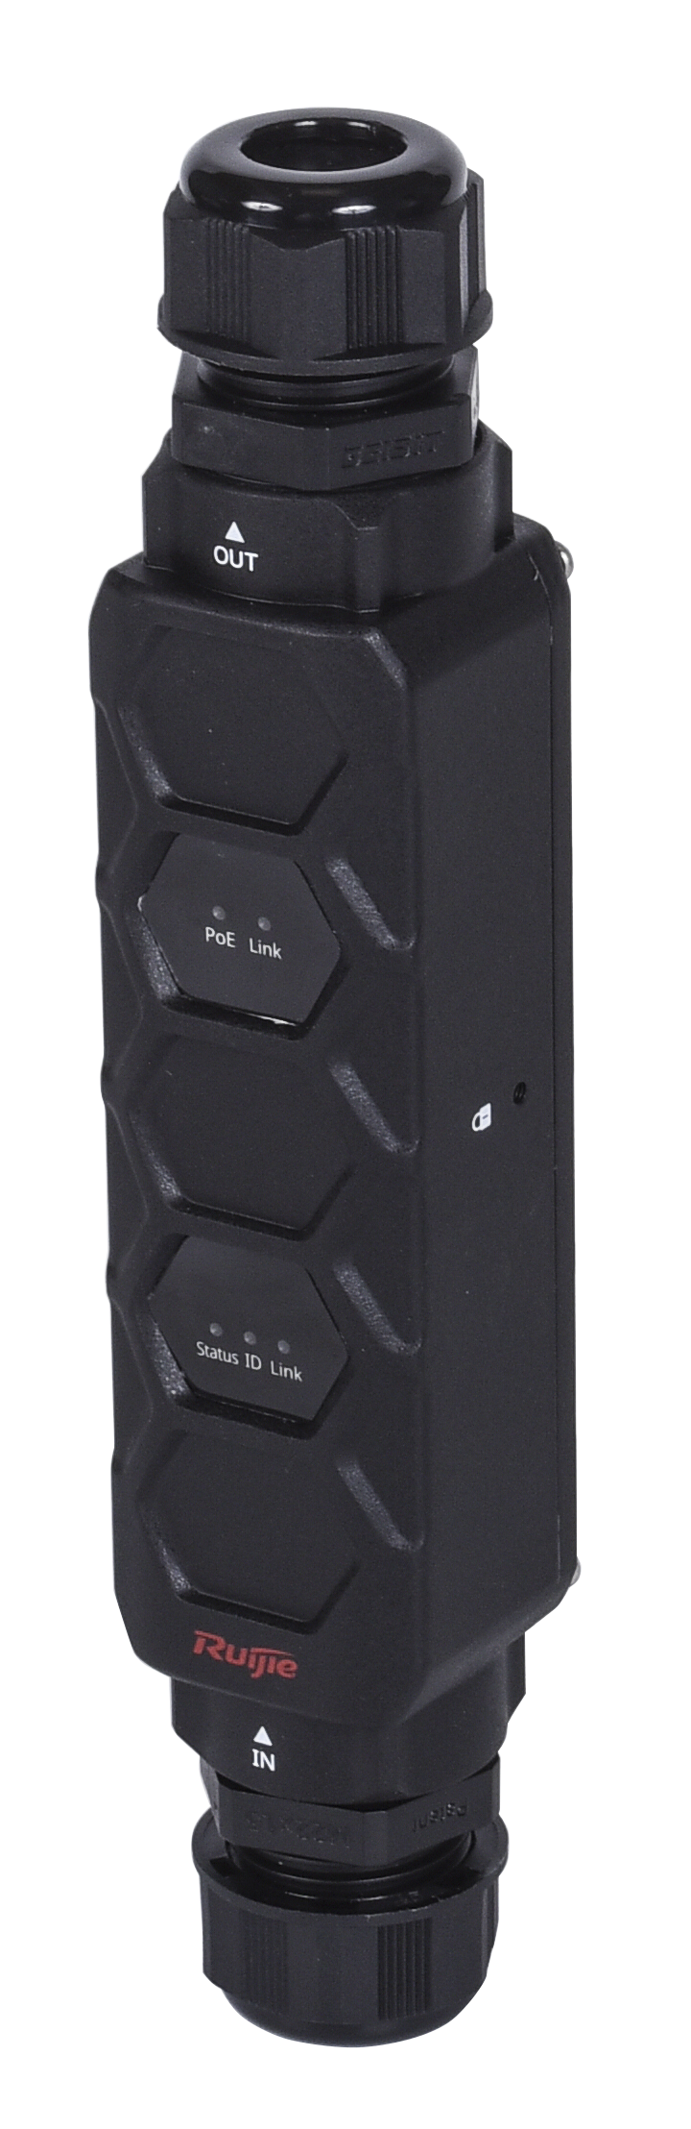
PoE-REP

IS52-shield
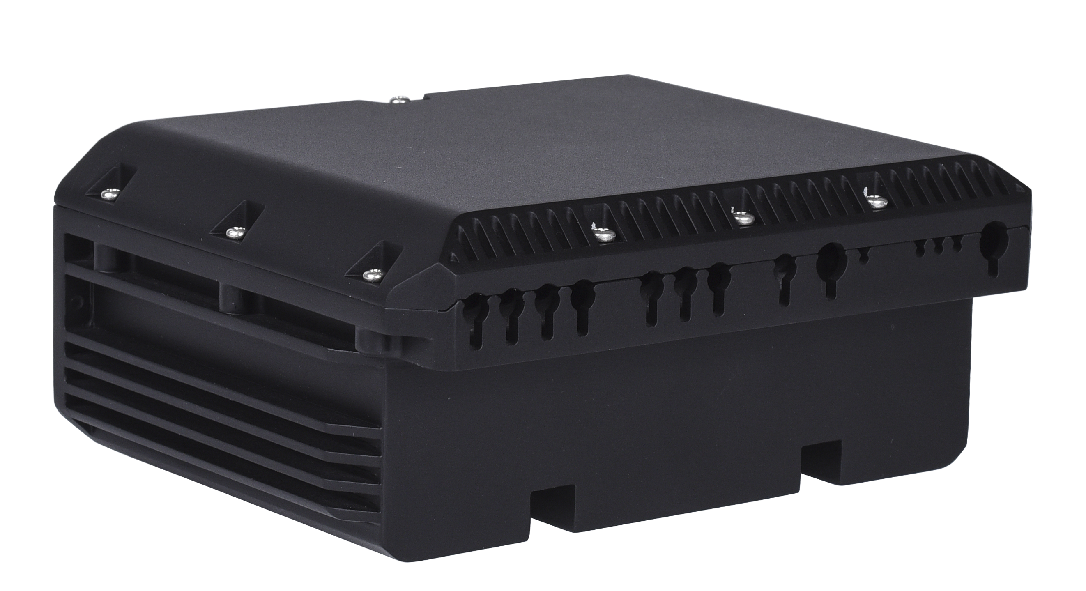
IS52-shield

Product Highlights
- Diverse Ports Options: Full 8GE or 24GE downlink, 4 x 10GE uplink ports, various connection options including RS-232 (console port), RS-485, DIDO, and USB port.
- Ultra-wide Voltage Range Power supply: 9.6 V DC to 60 V DC, 90 V AC to 264 V AC, 240 HV DC, with dual DC power modules (1+1) and hardware-based dual-boot backup.
- Wide Operating Temperature: –40°C to +75°C (–40°F to +167°F).
- Industrial Hardware Protections: Waterproof, dustproof, salt-air proof, and surge protection, as well as loop prevention and leading eco-friendly nano coatings. When the IS52-shield protection enclosure is installed, the IP rating reaches IP55. adapting to more harsh environments.
- Various Software Protocols: Static routing, Routing Information Protocol (RIP), Open Shortest Path First (OSPF), and Virtual Switching Unit (VSU).
- Long-distance PoE: PoE repeater, 1000M over 200 m (656.17 ft.), 100M over 400 m (1,312.33 ft.), all PoE ports supporting 90 W of power supply.
- Flexible Mounting: Flexible mounting options including DIN rail mounting, mounting in a 19-inch rack.

Product Features

High-Quality Hardware Design, Stable Performance
The RG-IS5200 series industrial Ethernet switch features high-quality hardware design, adhering to industrial-grade standards. It utilizes industrial-grade components, power modules, and an aluminum alloy housing to ensure superior industrial-grade quality. The switch employs a fanless heat dissipation design, supporting a wide operating temperature range from –40°C to +75°C (–40°F to +167°F). With the high-quality components, the switch achieves the IP55 protection level, offers a surge protection capability of at least 10 kV, and features a shock and vibration-resistant power design. This ensures stable and reliable operation even in harsh environments.

High Reliability
The RG-IS5200 series industrial Ethernet switch supports STP (IEEE 802.1D), RSTP (IEEE 802.1w), and MSTP (IEEE 802.1s) to achieve fast convergence, improve fault tolerance, and ensure stable network operation and load balancing. It effectively utilizes network channels to improve utilization of redundant links.
Virtual Router Redundancy Protocol (VRRP) ensures network stability for the switch.
With Rapid Link Detection Protocol (RLDP), the RG-IS5200 series can quickly detect link connectivity and unidirectional optical links. Through loop detection on a port, the RG-IS5200 series can prevent network failures caused by loops due to unauthorized connections between the port and hubs.
The RG-IS5200 series supports the Ethernet Ring Protection Switching (ERPS) technology, which is a Layer 2 link redundancy protocol designed for the core Ethernet. The networking method provides high redundancy and reliability, in the event of a node failure in a ring network, data can be forwarded from the other end. Therefore, loop elimination and service recovery time of ERPS is faster than that of STP. ERPS implements link restoration within milliseconds.
With Bidirectional Forwarding Detection (BFD), the RG-IS5200 series can detect links within milliseconds, and quickly converge routing and other services through association with upper-layer routing protocols, ensuring service continuity.

VSU
The RG-IS5200 series supports VSU that enables multiple physical devices to be connected through aggregate links and virtualized into one logical device. By using the same IP address, Telnet process, and CLI for management, along with automatic version check and configuration, network administrators can manage only one logical device, thereby enhancing O&M efficiency.
Simplified management: You can manage multiple switches in a unified manner without the need to connect to each switch for separate management.
Simplified network topology: A VSU serves as a switch on a network and connects to peripheral devices through aggregate links. Therefore, no Layer 2 loop occurs and MSTP configuration is not required. Various control protocols can run on the VSU.
Fault rectification within milliseconds: A VSU connects to peripheral devices through aggregate links. If one device or member link in the VSU malfunctions, data and services can be switched to another member link within only 50 ms to 200 ms.
High scalability: Devices can be added to or removed from a virtualized network, without affecting normal operation of other devices.
Increase in return on investment (ROI): Aggregate links are used for connecting the VSU to peripheral devices, implementing link redundancy and load balancing. All network devices and bandwidth resources are fully leveraged. Any type of 10GE ports can be used to establish a VSU over any data transmission cable, without requiring additional cable or expansion card configurations. There are no limitations on the port or cable types used, which maximizes user investment protection.

Flexible Networking and Easy Management
The RG-IS5200 series allows you to configure the switch using the traditional CLI or the web graphical user interface (GUI). You do not need to understand complex command lines or terminal simulation programs, which enables simple and fast configuration and simplifies deployment.
Syslog facilitates unified collection, maintenance, analysis, fault location, and backup of various log information, and helps you conduct network maintenance and management.
The RG-IS5200 series supports routine network diagnostics and maintenance based on SNMP, Remote Network Monitoring (RMON), Syslog, and USB-based backup log and configuration. Network administrators can perform management and maintenance through CLI, web GUI, or Telnet.

Flexible Connections
- One-level repeater for a longer transmission distance, with a transmission rate of 1000M over a maximum transmission distance of 200 m (656.17 ft.), or of 100M over a maximum transmission distance of 400 m (1,312.34 ft.).
- PoE models support 90 W of power supply, supporting more diverse terminals.
- 4 x 10GE uplinks as standard.
- Flexible mounting methods.

Product Specifications

Hardware Specifications

Port Specifications
Port Specifications | RG-IS5200-8GT4XS | RG-IS5200- 8GT4XS-DC | RG-IS5200-8GT4XS-UP-DC | RG-IS5200-24GT4XS-UP-DC
Fixed ports | 8x10/100/1000BASE-T ports  4 x 1GE/10GE SFP+ ports | 8 x 10/100/1000BASE-T ports  4 x 1GE/10GE SFP+ ports | 8 x 10/100/1000BASE-T ports, supporting PoE/PoE+/PoE++  4 x 1GE/10GE SFP+ ports | 24 x 10/100/1000BASE-T ports, supporting PoE/PoE+/PoE++  4 x 1GE/10GE SFP+ ports
Fixed management port | 1 x RJ45 console port
RS-485 Port | 1 x RS-485 port, supporting Modbus
DIDO | 1 x DI, 1 x DO
USB | 1 x USB 2.0 port

Port Specifications | PoE-REP
Fixed ports | 1 x 100/1000 BASE-T/LRE100-4 IN port, 1 x 10/100/1000BASE-T OUT port

System Specifications

System Specifications | RG-IS5200-8GT4XS | RG-IS5200- 8GT4XS-DC | RG-IS5200-8GT4XS-UP-DC | RG-IS5200-24GT4XS-UP-DC
Packet forwarding rate | 72Mpps | 72Mpps | 72Mpps | 96 Mpps
Switching capacity | 96 Gbps | 96 Gbps | 96 Gbps | 128 Gbps
CPU | Two-core CPU, ARM Cortex™ A55, each core with the clock speed of 1.0GHz
BootROM | 16 MB (2 flash chips for 1+1 boot redundancy)
Flash memory | 512 MB
Memory | 1GB DDR4

System Specifications | PoE-REP
Switching capacity | 4Gbps

Dimensions and Weight
Dimensions and Weight | RG-IS5200-8GT4XS | RG-IS5200- 8GT4XS-DC | RG-IS5200-8GT4XS-UP-DC | RG-IS5200-24GT4XS-UP-DC
Unit dimensions (W x D x H) | 150mm x 133mm x 86mm |  |  | 442mm x 220mm x 43.6mm
Unit weight | 1.49kg | 1.5kg | 1.53kg | 2.85kg
installation method | Desktop mounting, DIN rail mounting, and wall mounting |  |  | Desktop mounting, rack mounting, and wall mounting

Dimensions and Weight | PoE-REP
Unit dimensions (W x D x H) | 35 mm x 35 mm x 187 mm (1.38 in. x 1.38 in. x 7.36 in., with waterproof plugs)  35 mm x 35 mm x 131 mm (1.38 in. x 1.38 in. x 5.16 in., without waterproof plugs)

Power supply and Consumption
Power supply and Consumption | RG-IS5200-8GT4XS | RG-IS5200- 8GT4XS-DC
Power Supply | 1 x fixed power supply | IPA60：60W(12V5A) or external DC power supply
Power connector type | Terminal block
Power module redundancy | Not Supported | 1+1 redundancy
Power input | AC input：  - Rated voltage：100V~240V AC，50/60Hz  - Maximum voltage：90V~264V AC，50/60Hz  - Rated current：0.6A  HVDC input：  - Rated voltage：240V DC  - Maximum voltage：204V~288V DC  - Rated current：0.3A | Dual redundant DC (DC1/DC2) input:  - Rated voltage: 12 V DC to 48 V DC  - Maximum voltage: 9.6 V DC to 60 V DC  - Rated current: 2 A to 0.5 A
Maximum power consumption | 110 V AC：16.7W  220 V AC：16.8W  240 V AC：16.8W | 12 V DC: 19.8W  48 V DC: 17.5W
Leakage current | ≤3.5mA | N/A
Energy saving | Energy Efficient Ethernet (EEE)

Power supply and Consumption | RG-IS5200-8GT4XS-UP-DC | RG-IS5200-24GT4XS-UP-DC
Power Supply | IPA240-P: 240 W (56 V/4.4 A) or external DC power supply | IPA60: 60 W (12 V/5 A), IPA240-P: 240 W (56 V/4.4 A) or external DC power supply
Power connector type | Terminal block
Power module redundancy | 1+1 redundancy
Power input | Dual redundant DC (DC1/DC2) input:  - Rated voltage: 56 V DC  - Maximum voltage：  PoE only: 48 V DC  PoE/PoE+/PoE++: 54 V DC to 57 V DC  - Rated current: 10 A | Dual redundant DC (DC1/DC2) input:  - Rated voltage: 56V DC or 12V DC  PoE not supported: 12 V DC  PoE only: 48 V DC  PoE/PoE+/PoE++: 54 V DC to 57 V DC  - Maximum voltage: 9.6 V DC to 60 V DC  - Rated current: 10A (56V DC) or 3A (12V DC)
Maximum power consumption | 23.8W (Without PoE)  503.8W (full PoE load) | 12V DC input: 36.8W  56V DC input:  - 35.5W (Without PoE)  - 515.5W (full PoE load)
PoE port | Ports 1 to 8 support PoE/PoE+/PoE++ (IEEE802.3af/at/bt) power supply | Ports 1 to 24 support PoE/PoE+/PoE++ (IEEE802.3af/at/bt) power supply
PoE power cable pairs | Four pairs (1-2, 3-6, 4-5, and 7-8 pairs)
PoE output power | PoE budget: 480 W  Maximum power output per PoE port: 15.4 W (PoE), 30 W (PoE+), 90 W (PoE++)  Note:  - The maximum number of powered devices supported by the switch is determined by the available power of the switch and the actual power consumption of each device.  - By default, the maximum PoE output power of the switch is 210 W. | PoE budget: 480 W  Maximum power output per PoE port: 15.4 W (PoE), 30 W (PoE+), 90 W (PoE++)  Note:  - The maximum number of powered devices supported by the switch is determined by the available power of the switch and the actual power consumption of each device.  - By default, the maximum PoE output power of the switch is 200 W.
PoE distance | PoE-REP not used: 100 m (328.08 ft.)  PoE-REP used:  Ports 1 to 4: 200 m (100 m [328.08 ft.] + 100 m [328.08 ft.] = 200 m [656.16 ft.])  Maximum output power of PoE-REP: 60 W  Ports 5 to 8:  - 200 m (100 m [328.08 ft.] + 100 m [328.08 ft.] = 200 m [656.16 ft.]). Maximum output power of PoE-REP: 60 W  - 400 m (300 m [984.25 ft.] + 100 m [328.08 ft.] = 400 m [1,312.33 ft.]) (Distance from RG-IS5200 to PoE-REP + Distance from PoE-REP to powered devices). Maximum output power of PoE-REP: 30 W | PoE-REP not used: 100 m (328.08 ft.)  PoE-REP used:  Ports 1 to 20: 200 m (100 m [328.08 ft.] + 100 m [328.08 ft.] = 200 m [656.16 ft.])  Maximum output power of PoE-REP: 60 W  Ports 21 to 24:  - 200 m (100 m [328.08 ft.] + 100 m [328.08 ft.] = 200 m [656.16 ft.]). Maximum output power of PoE-REP: 60 W  - 400 m (300 m [984.25 ft.] + 100 m [328.08 ft.] = 400 m [1,312.33 ft.]) (Distance from RG-IS5200 to PoE-REP + Distance from PoE-REP to powered devices). Maximum output power of PoE-REP: 30 W
Energy saving | Energy Efficient Ethernet (EEE)

Power supply and Consumption | PoE-REP
PoE Powered (Input) | Support PoE/PoE+/PoE++ (IEEE802.3af/at/bt)
PoE power (output) | Support PoE/PoE+/PoE++ (IEEE802.3af/at/bt) (limited to 100 m)

Environment and Reliability
Environment and Reliability | RG-IS5200-8GT4XS | RG-IS5200- 8GT4XS-DC | RG-IS5200-8GT4XS-UP-DC | RG-IS5200-24GT4XS-UP-DC
Operating temperature | Operating temperature: (at an altitude below 1,800 m [5,905.51 ft.], with industrial optical transceivers installed)  - –40°C to +65°C (–40°F to +149°F) (installed in an enclosed cabinet)  - –40°C to +70°C (–40°F to +158°F) (installed in a ventilated cabinet with a minimum air velocity of 80 Line Feet Minute [LFM])  - –40°C to +75°C (–40°F to +167°F) (installed in a fan-equipped cabinet with a minimum air velocity of 200 LFM)  Note: At an altitude between 1,800 m (5,905.51 ft.) and 5,000 m (16,404.20 ft.), every time the altitude increases by 220 m (721.78 ft.), the maximum temperature decreases by 1°C (1.8°F).  Storage temperature: –40°C to +85°C (–40℉ to +185℉) |  | Operating temperature: (at an altitude below 1,800 m [5,905.51 ft.], with industrial optical transceivers installed)  - –40°C to +60°C (–40°F to +140°F) (installed in an enclosed cabinet)  - –40°C to +70°C (–40°F to +158°F) (installed in a ventilated cabinet with a minimum air velocity of 80 Line Feet Minute [LFM])  - –40°C to +75°C (–40°F to +167°F) (installed in a fan-equipped cabinet with a minimum air velocity of 200 LFM)  Note: At an altitude between 1,800 m (5,905.51 ft.) and 5,000 m (16,404.20 ft.), every time the altitude increases by 220 m (721.78 ft.), the maximum temperature decreases by 1°C (1.8°F).  Storage temperature: –40°C to +85°C (–40℉ to +185℉) | Operating temperature: (at an altitude below 1,800 m [5,905.51 ft.], with industrial optical transceivers installed)  - –40°C to +65°C (–40°F to +149°F) (installed in an enclosed cabinet)  - –40°C to +70°C (–40°F to +158°F) (installed in a ventilated cabinet with a minimum air velocity of 80 Line Feet Minute [LFM])  - –40°C to +75°C (–40°F to +167°F) (installed in a fan-equipped cabinet with a minimum air velocity of 200 LFM)  Note: At an altitude between 1,800 m (5,905.51 ft.) and 5,000 m (16,404.20 ft.), every time the altitude increases by 220 m (721.78 ft.), the maximum temperature decreases by 1°C (1.8°F).  Storage temperature: –40°C to +85°C (–40℉ to +185℉)
Humidity | Operating humidity: 5% to 95% RH, Non-condensing  Storage humidity: 5% to 95% RH
Altitude | Storage altitude: 0 m to 5,000 m (0 ft. to 16,404.20 ft.)  Operating altitude: 0 m to 5,000 m (0 ft. to 16,404.20 ft.)
Mean time between failures (MTBF) | Below 40°C (104°F): at least 300,000 hours (about 34 years)
Fan | Fanless design, natural cooling
Temperature monitoring | Temperature monitoring, over-temperature alarming  If the ambient temperature exceeds a certain value, the device will be reset.
IP rating | IP41 by default. When the IS52-shield protection enclosure is installed, the IP rating reaches IP55.  Note:  Without any protection enclosure, the front panel of the switch should not be installed upward to meet the IP41 protection requirements. |  |  | IP40  Note: For bare metal servers, the front panel port should not be installed upward to meet IP40 requirements.
ESD | ESD contact/air discharge: 6 kV/8 kV  ESD susceptibility contact/air discharge: 8 kV/15 kV
Surge protection | AC power port：  Common mode: 6 kV/Differential mode: 6 kV, 1.2/50, criterion B  Service ports:  - Common mode: 10 kV (1.2/50), criterion R  - Common mode: 6 kV (1.2/50), criterion B  - Differential mode: 500 V (between positive and negative ends, 1.2/50, criterion R)  DI/DO/RS-485 port:  - Common mode: 4 kV (1.2/50), criterion B  - Differential mode: 1 kV (1.2/50), criterion B | AC power port (power adapter)：  Common mode: 6 kV/Differential mode: 6 kV, 1.2/50, criterion B  Service ports:  - Common mode: 10 kV (1.2/50), criterion R  - Common mode: 6 kV (1.2/50), criterion B  - Differential mode: 500 V (between positive and negative ends, 1.2/50, criterion R)  DI/DO/RS-485 port:  - Common mode: 4 kV (1.2/50), criterion B  - Differential mode: 1 kV (1.2/50), criterion B
Conducted immunity | Performance criterion: A  Spectrum scanning range: 0.15 MHz to 80 MHz  Modulation: 80% AM, 1 kHz sine wave  AC power port: 3 V  Service port: 3 V  DI/DO/RS-485 port: 3 V | Performance criterion: A  Spectrum scanning range: 0.15 MHz to 80 MHz  Modulation: 80% AM, 1 kHz sine wave  AC power port: 3 V  Service port: 3 V  DI/DO/RS-485 port: 3 V
Power frequency magnetic field immunity | Continuous magnetic field: 30 A/m  Short-term magnetic field: 300 A/m
Voltage dip | AC power port：  ● 70% voltage remained for 25 cycles (criterion B).  ● 0% voltage remained for 0.5 cycle (criterion B).  ● 0% voltage remained for 1 cycle (criterion B).  ● 0% voltage remained for 250 cycles (criterion C) | AC power port (power adapter):  ● 70% voltage remained for 25 cycles (criterion B).  ● 0% voltage remained for 0.5 cycle (criterion B).  ● 0% voltage remained for 1 cycle (criterion B).  ● 0% voltage remained for 250 cycles (criterion C)
Vibration | Based on IEC 61000-3-2 and GB 17625.1, the switch meets the requirements of category A equipment.
Shock | IEC61000-3-3，GB17625.2  European Limits

Environment and Reliability | PoE-REP
Operating temperature | Operating temperature:  –40°C to +65°C (–40°F to +149°F) (installed in an enclosed cabinet)  - –40°C to +65°C (–40°F to +149°F) (installed in an enclosed cabinet)  - –40°C to +70°C (–40°F to +158°F) (installed in a ventilated cabinet with a minimum air velocity of 80 Line Feet Minute [LFM])  - –40°C to +75°C (–40°F to +167°F) (installed in a fan-equipped cabinet with a minimum air velocity of 200 LFM)  Storage temperature: –40°C to +85°C (–40℉ to +185℉)
Humidity | Operating humidity: 5% to 90% RH  Storage humidity: 5% to 95% RH
IP rating | IP56 (standard waterproof cap)
Surge protection | 10 kV

Certifications and regulatory compliance
Environment and Reliability | RG-IS5200-8GT4XS | RG-IS5200- 8GT4XS-DC | RG-IS5200-8GT4XS-UP-DC | RG-IS5200-24GT4XS-UP-DC
Safety regulation | EN 62368-1, BS EN 62368-1, IEC 62368-1
EMC regulation | EN 55032, EN 55035, EN 300386, BS EN 55032, BS EN 55035

Software Specifications

Performance and Capacity
Performance and Capacity | RG-IS5200 Series
Maximum number of VSU members | 8
VSU bandwidth | 40 Gbps
Maximum number of SVIs | 990
Maximum number of MAC address entries | 16000
Maximum number of ARP address entries | 4000
Maximum number of ND entries | 4000
Maximum number of IPv4 unicast routes | 6000
Maximum number of IPv6 unicast routes | 2000
Maximum number of IPv4 multicast routes | 1000
Maximum number of IPv6 multicast routes | 750
Maximum number of IGMP groups | 1000
Maximum number of MLD groups | 2000
Maximum number of VRF instances | 255
Maximum number of ACEs | In: 1750, Out: 800

Function
RG-IS5200 Series
Feature | Description
Ethernet switching | Jumbo frame (maximum length: 9,216 bytes)
Ethernet switching | IEEE 802.3az EEE
Ethernet switching | IEEE 802.1Q (4K VLANs)
Ethernet switching | Voice VLAN
Ethernet switching | Super-VLAN and private VLAN
Ethernet switching | MAC address-based VLAN, interface-based VLAN, protocol-based VLAN, and IP subnet-based VLAN
Ethernet switching | GVRP
Ethernet switching | Basic QinQ  Selective QinQ
Ethernet switching | STP, RSTP, and MSTP
Ethernet switching | ERPS (G.8032)
Ethernet switching | LLDP/LLDP-MED
IP service | ARP
IP service | DHCP client, DHCP relay, and DHCP server
IP service | DHCP snooping
IP service | DNS
IP service | DHCPv6 client, DHCPv6 relay, and DHCPv6 server
IP service | DHCPv6 snooping
IP service | ND and ND snooping
IP routing | Static routing
IP routing | RIP and RIPng
IP routing | OSPFv2 and OSPFv3
ACL and QoS | Standard IP ACLs  Extended IP ACLs  Extended MAC ACLs  Time-based ACLs  Expert-level ACLs  ACL80
ACL and QoS | ACL redirection
ACL and QoS | Traffic rate limiting on an interface
ACL and QoS | Congestion management: RR, SP, WRR, DRR, WFQ, SP+WRR, SP+DRR, and SP+WFQ
ACL and QoS | Congestion prevention: tail drop
ACL and QoS | 802.1p/DSCP/ToS traffic classification  Eight priority queues per interface
Security | Multiple AAA modes
Security | RADIUS and TACACS+
Security | Interface-based and MAC address-based 802.1X authentication
Security | Web authentication
Security | HTTPS
Security | SSHv1 and SSHv2
Security | Global IP-MAC binding
Security | Port isolation and port security
Security | IP source guard
Security | CPP and NFPP
Reliability | REUP, RLDP, and DLDP
Reliability | IPv4 VRRP v2/v3 and IPv6 VRRP
Reliability | BFD
Reliability | Link tracing, fault notification, and remote loopback based on 802.3ah (EFM)
Reliability | Dual-boot redundancy
Reliability | Fan speed adjustment  Fan fault alarming
Virtualization | VSU
Network management and monitoring | SPAN, RSPAN
Network management and monitoring | sFlow
Network management and monitoring | NTP and SNTP
Network management and monitoring | FTP and TFTP
Network management and monitoring | SNMPv1/v2/v3
Network management and monitoring | RMON (groups 1, 2, 3, and 9)
Network management and monitoring | CWMP (TR-069)
Network management and monitoring | gRPC

Protocol Compliance
RG-IS5200 Series
Organization | Standards and Protocol
IETF | RFC 1157 A Simple Network Management Protocol (SNMP)  RFC 1305 Network Time Protocol Version 3 (NTP)  RFC 1349 Internet Protocol (IP)  RFC 1350 TFTP Protocol (revision 2)  RFC 1519 CIDR  RFC 1591 Domain Name System Structure and Delegation  RFC 1643 Ethernet Interface MIB  RFC 1757 Remote Network Monitoring (RMON)  RFC 1812 Requirements for IP Version 4 Router  RFC 1901 Introduction to Community-based SNMPv2  RFC 1902-1907 SNMPv2  RFC 1918 Address Allocation for Private Internet  RFC 2131 Dynamic Host Configuration Protocol (DHCP)  RFC 2132 DHCP Options and BOOTP Vendor Extensions  RFC 2571 SNMP Management Frameworks  RFC 2863 The Interfaces Group MIB  RFC 2925 Definitions of Managed Objects for Remote Ping, Traceroute, and Lookup Operations (Ping only)  RFC 3046 DHCP Option82  RFC 3417 (SNMP Transport Mappings)  RFC 3418 Management Information Base (MIB) for the Simple Network Management Protocol (SNMP)  RFC 4022 MIB for TCP  RFC 768 User Datagram Protocol (UDP)  RFC 783 TFTP Protocol (revision 2)  RFC 792 Internet Control Message Protocol (ICMP)  RFC 793 Transmission Control Protocol (TCP)  RFC 813 Window and Acknowledgement Strategy in TCP  RFC 815 IP datagram reassembly algorithms  RFC 826 Ethernet Address Resolution Protocol (ARP)  RFC 854 Telnet Protocol  RFC 959 File Transfer Protocol (FTP)  RFC 2865 Remote Authentication Dial In User Service (RADIUS)  RFC 3575 IANA Considerations for RADIUS  RFC 3579 RADIUS Support For EAP  RFC 1058 Routing Information Protocol (RIP)  RFC 1583 OSPF Version 2  RFC 1981 Path MTU Discovery for IP version 6  RFC 2236 IGMP  RFC 2328 OSPF Version 2  RFC 2460 Internet Protocol, Version 6 (IPv6)  RFC 2461 Neighbor Discovery for IP Version 6 (IPv6)  RFC 2462 IPv6 Stateless Address Auto configuration  RFC 2463 Internet Control Message Protocol for IPv6 (ICMPv6)  RFC 2711 IPv6 Router Alert Option  RFC 2787 Definitions of Managed Objects for the Virtual Router Redundancy Protocol  RFC 2934 Protocol Independent Multicast MIB for IPv4  RFC 3101 OSPF Not so stubby area option  RFC 3137 OSPF Stub Router Advertisement sFlow  RFC 3509 Alternative Implementations of OSPF Area Border Routers  RFC 3513 IP Version 6 Addressing Architecture  RFC 3623 Graceful OSPF Restart  RFC 3768 VRRP  RFC 3810 Multicast Listener Discovery Version 2 (MLDv2) for IPv6  RFC 3973 PIM Dense Mode  RFC 4552 Authentication/Confidentiality for OSPFv3  RFC 4750 OSPFv2 MIB partial support no SetMIB  RFC 4940 IANA Considerations for OSPF  RFC 5187 OSPFv3 Graceful Restart  RFC 5340 OSPFv3 for IPv6  RFC 6620 FCFS SAVI
IEEE | IEEE 802.2 Logical Link Control  IEEE 802.1ab Link Layer Discovery Protocol  IEEE 802.1ad Provider Bridges  IEEE 802.1ax/IEEE802.3ad Link Aggregation  IEEE 802.1D Media Access Control (MAC) Bridges  IEEE 802.1D Spanning Tree Protocol  IEEE 802.1Q Virtual Bridged Local Area Networks (VLAN)  IEEE 802.1s Multiple Spanning Tree Protocol  IEEE 802.1w Rapid Spanning Tree Protocol  IEEE 802.3ad Link Aggregation Control Protocol (LACP)  IEEE Std 802.3x Full Duplex and flow control

Typical Applications

Outdoor Video Surveillance
Industrial switches are essential in outdoor video surveillance. They are typically used to connect and manage a large number of surveillance cameras, ensuring real-time transmission and storage of video data. Given the harsh outdoor environments, industrial switches are designed to withstand high or low temperatures, dust, and water, allowing them to operate reliably under extreme weather conditions. Additionally, industrial switches support PoE, which allows them to power cameras through Ethernet cables, simplifying cabling and reducing installation and maintenance costs.
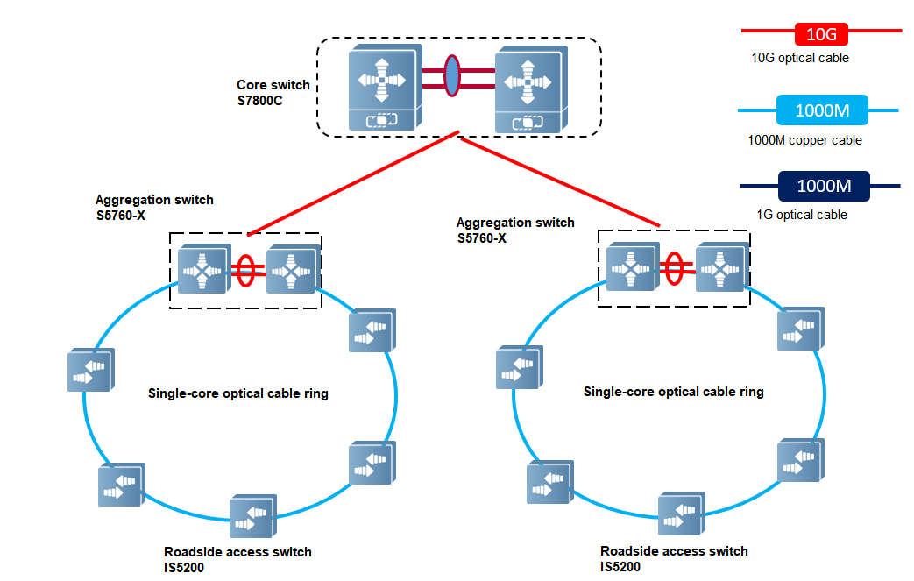

Intelligent Transportation
In intelligent transportation systems, industrial switches connect various traffic control devices, such as traffic lights, surveillance equipment, and display boards, forming a high-speed, stable, and reliable traffic management network. Through industrial switches, traffic management centers can monitor intelligent transportation systems, industrial switches connect various traffic devices, such as traffic signals, electronic monitoring equipment, and information display boards, forming a high-speed, stable, and reliable traffic management network. Through industrial switches, traffic management centers can monitor and control traffic flow in real-time, collect and analyze traffic data, optimize traffic signals, improve traffic efficiency, and reduce congestion. The high reliability and rapid fault recovery capabilities of industrial switches ensure the continuous and stable operation of traffic systems.

Ordering Guide
Follow the steps to order the RG-IS5200 series switches.
- Select a model of the RG-IS5200 series switches and its expansion modules based on port requirements.
- Select optical transceivers based on port requirements.
Models marked with asterisks (*) in the ordering information are available later.

Ordering Information

Switches and Power Modules
Order switches, expansion modules, power modules, and other components as needed. Before ordering an expansion module or power supply module, please contact our online customer service team for the latest support information about the modules.

Model | Description
RG-IS5200-8GT4XS | 8 x 10/100/1000BASE-T ports, 4 x 1GE/10GE SFP+ ports  Built-in AC power supply, single AC power input, fanless design, IP41 (supporting upgrade to IP55), DIN rail mounting
RG-IS5200-  8GT4XS-DC | 8 x 10/100/1000BASE-T ports, 4 x 1GE/10GE SFP+ ports  Dual DC power supplies, supporting 60 W power input through the IPA60 power adapter, fanless design, IP41 (supporting upgrade to IP55), DIN rail mounting
RG-IS5200-  8GT4XS-UP-DC | 8 x 10/100/1000BASE-T ports, PoE/PoE+/PoE++ power supply, 4 x 1GE/10GE SFP+ ports  Dual DC power supplies, supporting 240 W power input through the IPA240-P power adapter, fanless design, IP41 (supporting upgrade to IP55), DIN rail mounting  The first 4 Ethernet ports can be connected to PoE-REP, with a transmission rate of 1000M/100M/10M over a maximum transmission distance of 200 m (656.17 ft.).  The last 4 Ethernet ports can be connected to PoE-REP, with a transmission rate of 1000M/100/10M over a maximum transmission distance of 200 m (656.17 ft.), or of 100M over a maximum transmission distance of 400 m (1,312.34 ft.).
RG-IS5200-  24GT4XS-UP-DC | 24 x 10/100/1000BASE-T ports, PoE/PoE+/PoE++, 4 x 1GE/10GE SFP+ ports  Dual DC power supplies, supporting 60 W power input (without PoE) through the IPA60 power adapter or 240 W power input (with PoE) through the IPA240-P power adapter, fanless design, IP40, mounting in a 19-inch rack  The first 20 Ethernet ports can be connected to PoE-REP, with a transmission rate of 1000M/100M/10M over a maximum transmission distance of 200 m (656.17 ft.).  The last 4 Ethernet ports can be connected to PoE-REP, with a transmission rate of 1000M/100M/10M over a maximum transmission distance of 200 m (656.17 ft.), or of 100M over a maximum transmission distance of 400 m (1,312.34 ft.).
IPA240-P | 240 W AC PoE power module, applicable to RG-IS5200-8GT4XS-UP-DC and RG-IS5200-24GT4XS-UP-DC (PoE scenarios), supporting 1:1 hot standby (not simultaneous power supply), IP40, DIN rail mounting
IPA60 | 60 W AC power module, applicable to RG-IS5200-8GT4XS-DC and RG-IS5200-24GT4XS-UP-DC (non-PoE scenarios), supporting 1:1 hot standby (not simultaneous power supply), IP40, DIN rail mounting

Accessories
Model | Description
PoE-REP | PoE repeater. The IN port supports 100/1000BASE-T and LRE100-4. The OUT port supports 10/100/1000BASE-T.  The IN port supports PoE++ (PD Class 8) input while the OUT port supports PoE++ output and IP56
IS52-shield | IP55 protective enclosure, applicable to RG-IS5200-8GT4XS, RG-IS5200-8GT4XS-DC, and RG-IS5200-8GT4XS-UP-DC

Optical Transceivers and Cables

1GE
Model | Description
GE-SFP-SR-MM850-I | 1000BASE-SR, industrial SFP transceiver, 850 nm, Duplex LC, 550 m over MMF
GE-SFP-LR-SM1310-I | 1000BASE-LR, industrial SFP transceiver, 1310 nm, Duplex LC, 10 km over SMF

10GE
Model | Description
XG-SFP-SR-MM850-I | 10GBASE-SR，Industrial SFP+ transceiver, 850nm, Duplex LC, 300 m over MMF
XG-SFP-LR-SM1310-I | 10GBASE-LR，Industrial SFP+ transceiver, 1310nm, Duplex LC, 10 km over SMF

Package Contents

RG-IS5200-8GT4XS/RG-IS5200-8GT4XS-DC/RG-IS5200-8GT4XS-UP-DC
Item | Quantity
Switch | 1
Rail clip | 1
Rail | 1
M3x5 mm screw | 2
PWA4.2x20 mm tapping screw | 2
φ6.0x25 mm expansion anchor | 2
Power terminal connector | 1
10-Pin terminal block | 1
Grounding cable | 1
Installation Manual | 1
Safety Label and Certification Information Description | 1
Ruijie Networks product management software | 1

RG-IS5200-24GT4XS-UP-DC
Item | Quantity
Switch | 1
M4x7 mm screw | 8
2-Pin terminal block | 2
10-Pin terminal block | 1
Mounting bracket | 2
Grounding cable | 1
Installation Manual | 1
Safety Label and Certification Information Description | 1
Ruijie Networks product management software (Pre-installed) | 1

Warranty
For more information about warranty terms and period, contact your local sales agency:
- Warranty terms: https://www.ruijie.com/support/servicepolicy
- Warranty period: https://www.ruijie.com/support/servicepolicy/Service-Support-Summany/
Note: The warranty terms are subject to the terms of different countries and distributors.

More Information
For more information about Ruijie Networks, visit the official website or contact your local sales agency:
- Ruijie Networks official website: https://www.ruijie.com/
- Online support: https://www.ruijie.com/support
- Hotline support: https://www.ruijie.com/support/hotline
- Email support: EBGITSC@ruijie.com.cn

