RG-S5000-E Series
Simplified Gigabit Switch
Datasheet
V1.3

Ruijie Networks Co., Ltd.
All rights reserved.

Product Overview
RG-S5000-E series switches are next-generation cost-effective L2+ access switches released by Ruijie Networks for university, hospital, and enterprise campus scenarios. The series include PoE and non-PoE models and can meet requirements in wired network, wireless network, and other scenarios.

Product Appearance

RG-S5000-10GT2MS-E
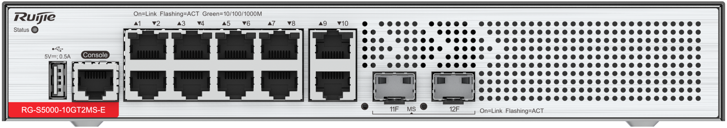
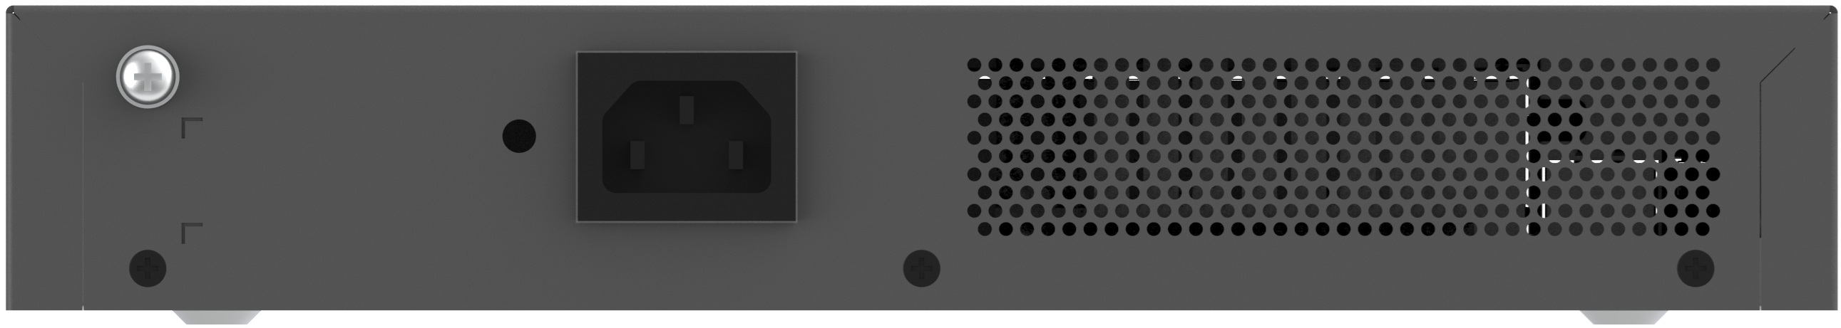

RG-S5000-24GT4MS-E
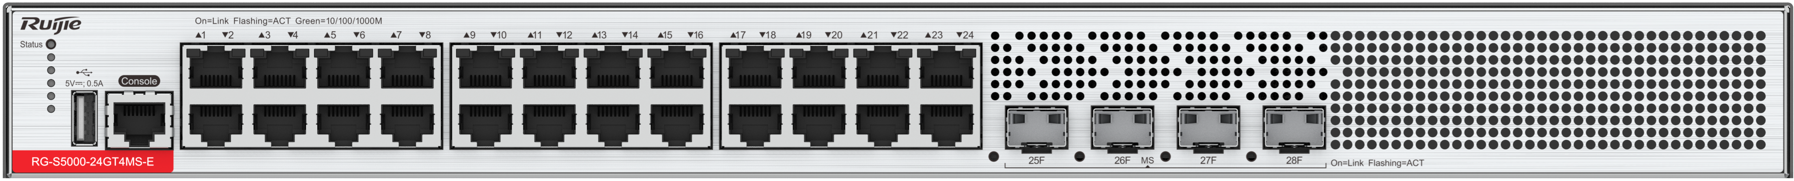
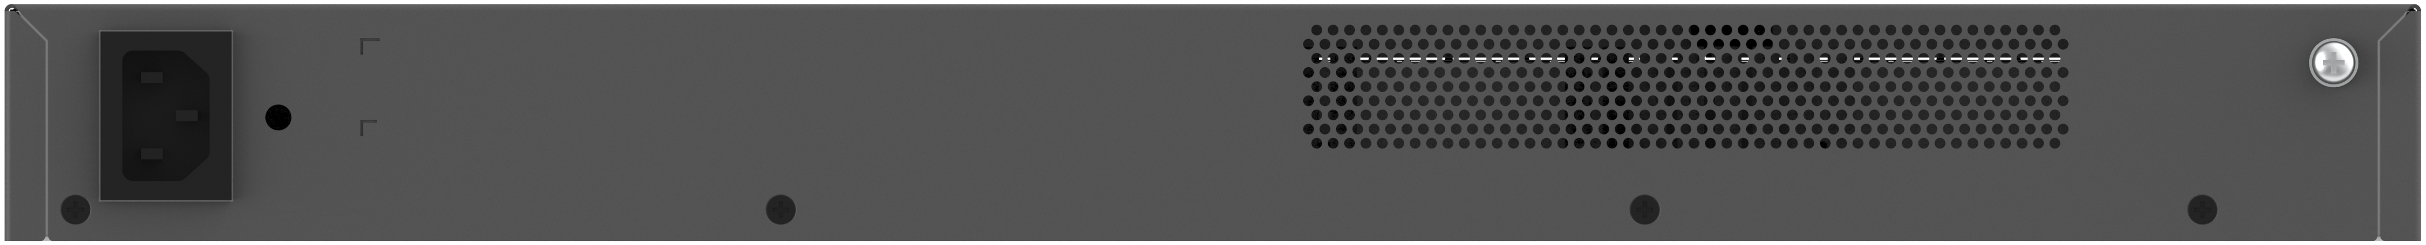

RG-S5000-48GT4MS-E
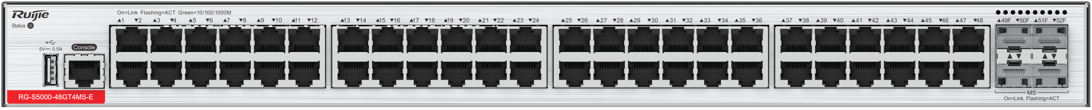
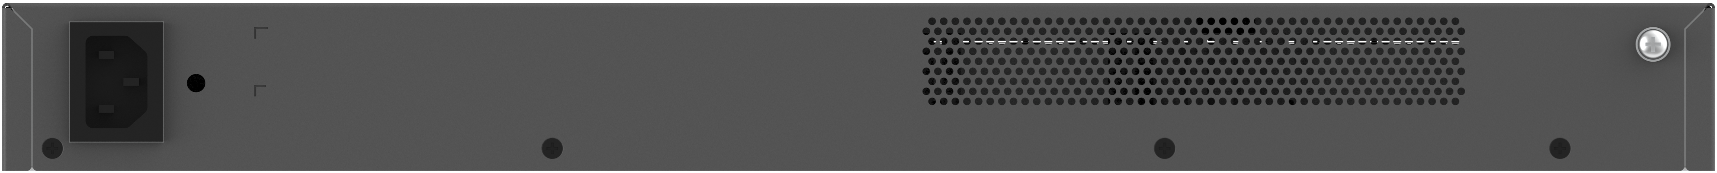

RG-S5000-10GT2MS-P-E
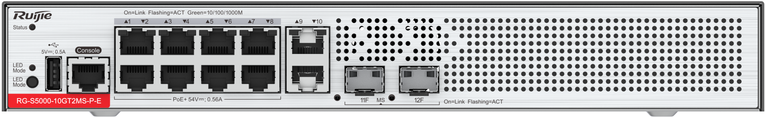
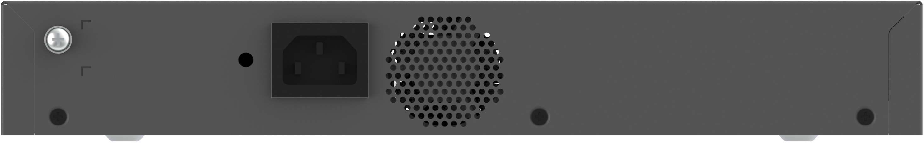

RG-S5000-24GT4MS-P-E
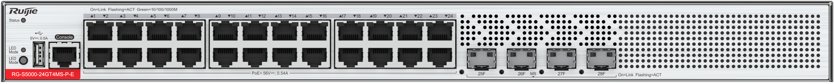
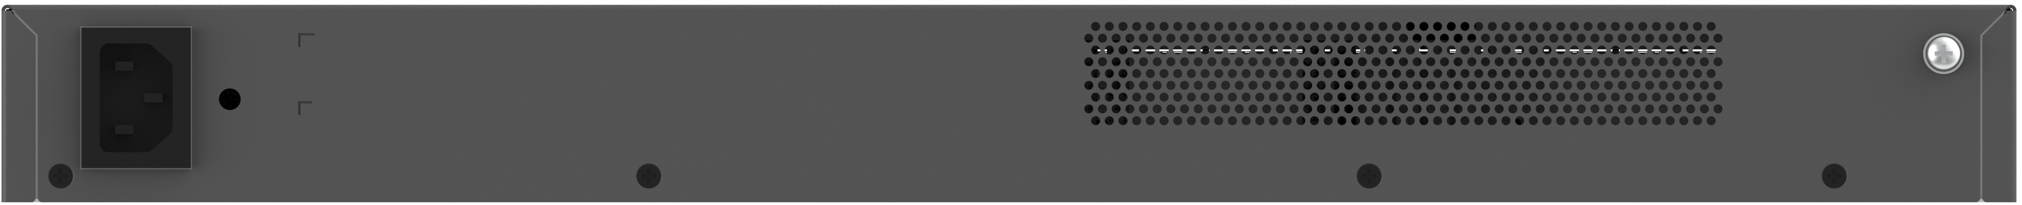

Product Highlights
- L2+ access switch, supporting static route and Routing Information Protocol (RIP)
- 2.5GE uplink ports, providing high bandwidth and better handling data bursts
- Port surge protection capability of up to 10 kV, reducing the probability of port damage caused by surges and improving network stability
- Rapid Link Detection Protocol (RLDP), which can quickly detect link connectivity and unidirectional communication over optical links, and can detect loops on interfaces to prevent network failures caused by loops when switch interfaces are connected to unauthorized devices such as hubs
- Energy Efficient Ethernet (EEE): When a port is idle for a given period of time, the system sets the port to energy-saving mode and wakes it up to transmit services by sending listening packets.
- SNMP, Syslog, and other features used for routine network diagnosis and maintenance, enabling easy O&M, simplified network management, and plug-and-play

Product Features

Strong Surge Protection Capability
The RG-S5000-E provides 10 kV surge protection for ports. The strong surge protection capability reduces the probability of ports damaged by surge and improves customers' network stability.

Uplink 2.5GE Ports
On the network of a video surveillance system, a large amount of continuous video data needs to be transmitted and mass burst data is generated instantaneously. To deal with the data, switches need to have stable data forwarding and bandwidth redundancy capability. More cameras connected to a switch indicate that a greater amount of data flows through the switch. If the amount of camera data forwarded by a switch exceeds the forwarding capability of an uplink port on the switch, packet loss occurs on the port and video freezing occurs. The uplink ports of the RG-S5000-E can work at a rate of 2.5 Gbps. Compared with the 1 Gbps uplink rate, the RG-S5000-E can connect to more terminals in HD monitoring scenarios and better cope with burst data.

High Reliability
The RG-S5000-E supports the Spanning Tree Protocol (STP), Rapid Spanning Tree Protocol (RSTP), and Multiple Spanning Tree Protocol (MSTP), achieving fast convergence, improving the fault tolerance capability, and ensuring stable network operation and link load balancing. It effectively uses network channels to improve the utilization of aggregate links.
The Rapid Link Detection Protocol (RLDP) enables the RG-S5000-E to quickly detect link connectivity and unidirectional optical links. The port loop detection function helps the RG-S5000-E to prevent network failures caused by loops due to unauthorized port connections with hubs.
The RG-S5000-E supports the Ethernet Ring Protection Switching (ERPS) technology, which is a Layer 2 link redundancy protocol designed for the core Ethernet. The control device blocks loops and restores links, and non-control devices directly report their link status to the control device, without processing from other non-control devices. Therefore, loop elimination and service recovery time of ERPS is faster than that of STP. ERPS implements link restoration within milliseconds.
The RG-S5000-E provides an advanced hardware CPU protection mechanism: CPU protect policy (CPP). It classifies data traffic sent to the CPU, processes the traffic by queue priority, and rate-limits the bandwidth as required. This protection mechanism also fully protects the CPU from being occupied by unauthorized traffic, defends against malicious attacks, and prevents resource consumption, thereby ensuring the security of the CPU and switch itself.
The RG-S5000-E adopts the Network Foundation Protection Policy (NFPP) technology to rate-limit ARP packets, ICMP request packets, DHCP Request messages, and other packets sent from users to networks. It discards packets of which the rate exceeds the threshold, identifies attack behaviors, and isolates users who launch attacks. This ensures network stability.

Fanless Design and Energy Saving
Ruijie integrates multiple energy-saving design ideas into the RG-S5000-E series switches, preventing loud noise and saving energy.
The RG-S5000-E provides Energy Efficient Ethernet (EEE). When a port is always idle in a given period of time, the system enables the port to enter the energy saving mode. When the port needs to receive or send a packet, the system resumes services on the port by periodically sending listening streams, saving energy.
Some models of RG-S5000-E series switches adopt the fanless design, which ensures no noise and no forced airflow, preventing dust and chemical pollutants in the air from entering the switch and causing corrosion and static electricity accumulation.
The RG-S5000-E supports intelligent fan speed regulating. It monitors the temperature in real time, reduces the fan speed, prolongs the fan service life, and reduces noise pollution.
The RG-S5000-E is tested in accordance with GB/T 18313-2001 and the noise meets the standard of sleeping in the living room at night.

Ease of Network Maintenance
When a fault occurs on software, the RG-S5000-E automatically restarts all processes for recovery.
It is equipped with standard USB ports and can be upgraded using the USB flash drive.
A network administrator can install network cables into the RG-S5000-E to manage and configure it in web mode without extra configuration.
It supports remote management, configuration backup and restoration, remote fault diagnosis, and historical log analysis.
It supports cloud management and delivers simplified O&M management and user experience:
Ease of networking: Only a PC or mobile phone available for Internet access is required to complete device deployment. The RG-S5000-E supports plug and play.
Ease of O&M: Network O&M is simple. You can manage the network anytime and anywhere.
Ease of monitoring: You can view the network health and device details including the system status, traffic trend, connectivity, and power supply status) at any time. Faults and user network experience are visible, alarms are pushed once they are generated, and logs are generated to facilitate event traceback.
Ease of authentication: Based on Ruijie Cloud, it provides authentication for Internet access, without any additional software and servers.

Intelligent O&M
The RG-S5000-E supports plug and play during network deployment and O&M, allowing users to conduct O&M independently without professional after-sale intervention. It also supports loop detection and zero touch replacement to improve O&M efficiency.

Cloud Management
The RG-S5000-E can be added or imported to WIS in batches. WIS can remotely manage the RG-S5000-E, including online status monitoring, configuration delivery, upgrade, restart, configuration backup, and restoration.

Product Specifications

Hardware Specifications

Port Specifications
Port specifications | RG-S5000-10GT2MS-E | RG-S5000-24GT4MS-E | RG-S5000-48GT4MS-E | RG-S5000-10GT2MS-P-E | RG-S5000-24GT4MS-P-E
Fixed service port | 10 x 10/100/1000BASE-T ports  2 x 1GE/2.5GE SFP ports | 24 x 10/100/1000BASE-T ports  4 x 1GE/2.5GE SFP ports | 48 x 10/100/1000BASE-T ports  4 x 1GE/2.5GE SFP ports | 10 x 10/100/1000BASE-T ports, ports 1 to 8 supporting PoE/PoE+  2 x 1GE/2.5GE SFP ports | 24 x 10/100/1000BASE-T ports, supporting PoE/PoE+  4 x 1GE/2.5GE SFP ports
Fixed management port | 1 x RJ45 console port
USB | 1 x USB port

System Specifications
Port specifications | RG-S5000-10GT2MS-E | RG-S5000-24GT4MS-E | RG-S5000-48GT4MS-E | RG-S5000-10GT2MS-P-E | RG-S5000-24GT4MS-P-E
System packet forwarding rate ^{*1} | 27 Mpps | 61 Mpps | 104 Mpps | 27 Mpps | 61 Mpps
System switching capacity ^{*2} | 36 Gbps | 82 Gbps | 139 Gbps | 36 Gbps | 82 Gbps
CPU | Single-core CPU, with the clock speed of 1.2 GHz
Flash memory | 64 MB | 64 MB | 64 MB | 64 MB | 64 MB
Memory | 512 MB DDR4 | 512 MB DDR4 | 512 MB DDR4 | 512 MB DDR4 | 512 MB DDR4
Switch buffer | 512 KB | 512 KB | 512 KB | 512 KB | 512 KB
MAC address | 16000
ARP table size | 512
ND table size | 256
Number of IPv4 unicast routes | 64
Number of IPv6 unicast routes | 64
Number of ACEs | 500
^{*1} means the system's packet forwarding rate.
^{*2} means the system's switching capacity.

Dimensions and Weight
Dimensions and weight | RG-S5000-10GT2MS-E | RG-S5000-24GT4MS-E | RG-S5000-48GT4MS-E | RG-S5000-10GT2MS-P-E | RG-S5000-24GT4MS-P-E
Unit dimensions (W x D x H) | 260.0 mm x 170.0 mm x 43.6 mm (10.24 in. x 6.69 in. x 1.72 in.) | 440.0 mm x 220.0 mm x 43.6 mm (17.32 in. x 8.66 in. x 1.72 in.) | 440.0 mm x 220.0 mm x 43.6 mm (17.32 in. x 8.66 in. x 1.72 in.) | 297.0 mm x 170.0 mm x 43.6 mm (11.69 in. x 6.69 in. x 1.72 in.) | 440.0 mm x 220.0 mm x 43.6 mm (17.32 in. x 8.66 in. x 1.72 in.)
Shipping dimensions (W x D x H) | 485 mm x 410 mm x 390 mm (19.04 in. x 16.14 in. x 15.35 in.) | 570 mm x 490 mm x 390 mm (22.44 in. x 19.29 in. x 15.35 in.) | 570 mm x 490 mm x 390 mm (22.44 in. x 19.29 in. x 15.35 in.) | 580 mm x 450 mm x 380 mm (22.83 in. x 17.72 in. x 14.96 in.) | 570 mm x 490 mm x 390 mm (22.44 in. x 19.29 in. x 15.35 in.)
Rack height | 1 RU | 1 RU | 1 RU | 1 RU | 1 RU
Unit weight | 2.0 kg (4.41 lbs) | 2.5 kg (5.51 lbs) | 2.8 kg (6.17 lbs) | 2.5 kg (5.51 lbs) | 2.8 kg (6.17 lbs)
Shipping weight | 2.40 kg (5.25 lbs) | 3.70 kg (8.15 lbs) | 3.60 kg (7.94 lbs) | 3.18 kg (7.01 lbs) | 4.13 kg (9.11 lbs)
Mounting | Mounting on a workbench/wall or in a rack (cabinet)

Power Supply and Consumption
Power supply and consumption | RG-S5000-10GT2MS-E | RG-S5000-24GT4MS-E | RG-S5000-48GT4MS-E | RG-S5000-10GT2MS-P-E | RG-S5000-24GT4MS-P-E
Power supply | 1 x fixed power supply
Power input | AC input  - Rated input voltage: 100 V AC to 240 V AC, 50/60 Hz  - Maximum input voltage: 90 V AC to 264 V AC, 47 Hz to 63 Hz  - Maximum input current: 0.6 A | AC input  - Rated input voltage: 100 V AC to 240 V AC, 50/60 Hz  - Maximum input voltage: 90 V AC to 264 V AC, 47 Hz to 63 Hz  - Maximum input current: 0.6 A | AC input  - Rated input voltage: 100 V AC to 240 V AC, 50/60 Hz  - Maximum input voltage: 90 V AC to 264 V AC, 47 Hz to 63 Hz  - Maximum input current: 1.5 A | AC input  - Rated input voltage: 100 V AC to 240 V AC, 50/60 Hz  - Maximum input voltage: 90 V AC to 264 V AC, 47 Hz to 63 Hz  - Maximum input current: 3 A | AC input  - Rated input voltage: 100 V AC to 240 V AC, 50/60 Hz  - Maximum input voltage: 90 V AC to 264 V AC, 47 Hz to 63 Hz  - Maximum input current: 6 A
Maximum output power | Fixed power supply: 16 W | Fixed power supply: 15.6 W | Fixed power supply: 30 W | Fixed power supply: 141 W | Fixed power supply: 430 W
PoE port | Not supported | Not supported | Not supported | Ports 1 to 8 support PoE/PoE+ (IEEE802.3af/at) power supply | Ports 1 to 24 support PoE/PoE+ (IEEE802.3af/at) power supply
PoE power cable pairs | Not supported | Not supported | Not supported | Mode A (1-2, 3-6 pairs) | Mode A (1-2, 3-6 pairs)
PoE output power | Not supported | Not supported | Not supported | Each port of ports 1 to 8 provides up to 30 W of power  The maximum power is 125 W | Each PoE port provides up to 30 W of power  The maximum power is 370 W
Maximum power consumption | 16 W | 15.6 W | 30 W | 16 W (without PoE load)  141 W (full PoE load) | 33 W (without PoE load)  403 W (full PoE load)
Energy saving | Energy Efficient Ethernet (EEE)
Note: The maximum number of powered devices supported by the switch is determined by the available power of the switch and the actual power consumption of each device.

Environment and Reliability
Environment and reliability | RG-S5000-10GT2MS-E | RG-S5000-24GT4MS-E | RG-S5000-48GT4MS-E | RG-S5000-10GT2MS-P-E | RG-S5000-24GT4MS-P-E
Temperature | Operating temperature: 0°C to 45°C (32°F to 113°F)  Storage temperature: –40°C to +70°C (–40°F to +158°F)  Note: At an altitude between 1,800 m (5,905.51 ft.) and 5,000 m (16,404.20 ft.), every time the altitude increases by 220 m (721.78 ft.), the maximum temperature decreases by 1°C (1.8°F).
Humidity | Operating humidity: 10% to 90% RH (non-condensing)  Storage humidity: 5% to 95% RH (non-condensing)
Altitude | Operating altitude: –500 m to +5,000 m (–1640.42 ft. to +16404.20 ft.)  Storage altitude: –500 m to +5,000 m (–1640.42 ft. to +16404.20 ft.)
Mean time between failure (MTBF) | 200,000 hours (about 22 years)
Fan | Fanless | Fanless | 2 x fixed fan modules | 1 x fixed fan module | 2 x fixed fan modules
Heat dissipation | Fanless design, natural heat dissipation | Fanless design, natural heat dissipation | Forced air cooling | Forced air cooling | Forced air cooling
Acoustic noise | Fanless | Fanless | 27℃ (80.6°F): 40 dB | 27℃ (80.6°F): 40 dB | 27℃ (80.6°F): 40 dB
USB hot swapping | Supported | Supported | Supported | Supported | Supported
Cable hot swapping | Supported by all ports | Supported by all ports | Supported by all ports | Supported by all ports | Supported by all ports
Fan monitoring | Fanless design | Fanless design | Fan speed control and fan failure alarming | Fan speed control and fan failure alarming | Fan speed control and fan failure alarming
Temperature monitoring | Temperature monitoring, over-temperature alarming  If the ambient temperature exceeds a certain value, the device will be reset.
ESD | Air discharge: 8 kV/15 kV  Contact discharge: 6 kV/8 kV
Surge protection | Service port: 10 kV  Power port: common mode 6 kV, differential mode 2 kV

Certifications and Regulatory Compliance
Certifications and regulatory compliance | RG-S5000-10GT2MS-E | RG-S5000-24GT4MS-E | RG-S5000-48GT4MS-E | RG-S5000-10GT2MS-P-E | RG-S5000-24GT4MS-P-E
Safety regulation | IEC 62368-1
EMC regulation | EN 300386, EN 55032 Class A, EN 55035, EN IEC 61000-3-2, EN 61000-3-3, EN 61000-4-2, EN 61000-4-3, EN 61000-4-4, EN 61000-4-5, EN 61000-4-6, EN 61000-4-11
RoHS | European RoHS Directive 2011/65/EU & Amendment(EU) 2015/863

Software Specifications
Feature | RG-S5000-E Series
Ethernet switching | Jumbo frame (maximum length: 9216 bytes)
Ethernet switching | 802.3az EEE
Ethernet switching | IEEE 802.1Q (4K VLANs)
Ethernet switching | Voice VLAN
Ethernet switching | Port-based VLAN assignment
Ethernet switching | Basic QinQ and selective QinQ
Ethernet switching | STP (IEEE 802.1.d), RSTP (IEEE 802.1w), and MSTP (IEEE 802.1s)
Ethernet switching | ERPS (G.8032)
Ethernet switching | LLDP/LLDP-MED
IP service | Static and dynamic ARP
IP service | DHCP client
IP service | DHCP relay
IP service | DHCP server
IP service | DHCP snooping
IP service | DNS client
IP service | Neighbor Discovery (ND)
IP routing | Static routing
IP routing | RIP and RIPng
IP routing | OSPFv2
Multicast | IGMP snooping v1/v2
Multicast | IGMP fast leave
ACL and QoS | Standard IP ACLs (IP-based hardware ACLs)
ACL and QoS | Extended IP ACLs (hardware ACLs based on IP addresses or TCP/UDP port numbers)
ACL and QoS | MAC-based extended ACLs (ACLs based on source or destination MAC addresses)
ACL and QoS | Expert ACLs
ACL and QoS | IPv6 ACL
ACL and QoS | ACL 80
ACL and QoS | Global ACLs
ACL and QoS | ACL redirection
ACL and QoS | Flow-based rate limiting at the ingress
ACL and QoS | Port rate limiting
ACL and QoS | Traffic classification based on 802.1p or DSCP priorities
ACL and QoS | Traffic classification based on 802.1p priorities, DSCP priorities, and IP precedences
ACL and QoS | Congestion management: SP, WRR, DRR, WFQ, SP+WRR, SP+DRR, and SP+WFQ
ACL and QoS | Congestion avoidance: tail drop
ACL and QoS | Eight queues on each port
ACL and QoS | Rate limiting in each queue
Security | Filtering of invalid MAC addresses
Security | RADIUS authentication and authorization
Security | RADIUS and TACACS+
Security | IEEE 802.1X authentication
Security | MAC address bypass (MAB) authentication, and interface-based and MAC address-based 802.1X authentication
Security | Web authentication
Security | Hypertext Transfer Protocol Secure (HTTPS)
Security | SSHv1.5 and SSHv2.0
Security | ICMPv6
Security | IP source guard
Security | Proxy ARP and ARP entry aging
Security | Hardware CPP and NFPP
Security | Various attack defense functions including NFPP, ARP anti-spoofing, DHCP/DHCPv6 attack defense, ICMP attack defense, ND attack defense, IP scanning attack defense, and customizing attack defense packet types
Reliability | RLDP
Reliability | LACP
Reliability | Load balancing modes
Reliability | Rapid Link Detection Protocol (RLDP), Layer 2 link connectivity detection, and unidirectional link detection
NMS and maintenance | RSPAN
NMS and maintenance | sFlow (sFlow is a network detection technology based on packet sampling, which is mainly used for traffic statistics analysis in super-heavy network traffic scenarios)
NMS and maintenance | NTP (NTP client and NTP server)
NMS and maintenance | TFTP (TFTP client)
NMS and maintenance | SNMPv1/v2c/v3
NMS and maintenance | CWMP
NMS and maintenance | SSH v1.5/v2.0
PoE | RG-S5000-10GT2MS-P-E and RG-S5000-24GT4MS-P-E:  - IEEE 802.3af and 802.3at  - Automatic and energy-saving power supply management mode  - Uninterrupted power supply in hot start mode  - Scheduled powering on or off PoE ports  - Port priority
Cloud | WIS

Product Compliance
Organization | Standards and Protocol
IETF | RFC 1058 Routing Information Protocol (RIP)  RFC 1157 A Simple Network Management Protocol (SNMP)  RFC 1305 Network Time Protocol Version 3 (NTP)  RFC 1349 Internet Protocol (IP)  RFC 1350 TFTP Protocol (revision 2)  RFC 1519 CIDR  RFC 1583 OSPF Version 2  RFC 1591 Domain Name System Structure and Delegation  RFC 1643 Ethernet Interface MIB  RFC 1757 Remote Network Monitoring (RMON)  RFC 1812 Requirements for IP Version 4 Router  RFC 1901 Introduction to Community-based SNMPv2  RFC 1902-1907 SNMP v2  RFC 1918 Address Allocation for Private Internet  RFC 1981 Path MTU Discovery for IP version 6  RFC 2131 Dynamic Host Configuration Protocol (DHCP)  RFC 2132 DHCP Options and BOOTP Vendor Extensions  RFC 2328 OSPF Version 2  RFC 2460 Internet Protocol, Version 6 (IPv6)  RFC 2461 Neighbor Discovery for IP Version 6 (IPv6)  RFC 2462 IPv6 Stateless Address Auto configuration  RFC 2463 Internet Control Message Protocol for IPv6 (ICMPv6)  RFC 2571 SNMP Management Frameworks  RFC 2711 IPv6 Router Alert Option  RFC 2863 The Interfaces Group MIB  RFC 2865 Remote Authentication Dial In User Service (RADIUS)  RFC 2925 Definitions of Managed Objects for Remote Ping, Traceroute, and Lookup Operations (Ping only)  RFC 3046 DHCP Option82  RFC 3101 OSPF Not-So-Stubby Area Option  RFC 3137 OSPF Stub Router Advertisment sFlow  RFC 3417 (SNMP Transport Mappings)  RFC 3418 Management Information Base (MIB) for the Simple Network Management Protocol (SNMP)  RFC 3509 Alternative Implementations of OSPF Area Border Routers  RFC 3513 IP Version 6 Addressing Architecture  RFC 3575 IANA Considerations for RADIUS  RFC 3579 RADIUS Support For EAP  RFC 3623 Graceful OSPF Restart  RFC 4022 MIB for TCP  RFC 4552 Authentication/Confidentiality for OSPFv3  RFC 4750 OSPFv2 MIB partial support no SetMIB  RFC 4940 IANA Considerations for OSPF  RFC 5187 OSPFv3 Graceful Restart  RFC 5340 OSPFv3 for IPv6  RFC 768 User Datagram Protocol (UDP)  RFC 783 TFTP Protocol (revision 2)  RFC 792 Internet Control Message Protocol (ICMP)  RFC 793 Transmission Control Protocol (TCP)  RFC 813 Window and Acknowledgement Strategy in TCP  RFC 815 IP datagram reassembly algorithms  RFC 826 Ethernet Address Resolution Protocol (ARP)  RFC 854 Telnet Protocol  RFC 959 File Transfer Protocol (FTP)
IEEE | IEEE 802.2 Logical Link Control  IEEE 802.1ab Link Layer Discovery Protocol  IEEE 802.1ad Provider Bridges  IEEE 802.1ax/IEEE802.3ad Link Aggregation  IEEE 802.1D Media Access Control (MAC) Bridges  IEEE 802.1D Spanning Tree Protocol  IEEE 802.1Q Virtual Bridged Local Area Networks (VLAN)  IEEE 802.1s Multiple Spanning Tree Protocol  IEEE 802.1w Rapid Spanning Tree Protocol  IEEE 802.3ad Link Aggregation Control Protocol (LACP)  IEEE Std 802.3x Full Duplex and flow control

Typical Applications

Serving as an Access Device on a Small- or Medium-sized Network
The RG-S5000-E is suitable for various scenarios, including medium-sized enterprises, medium-sized universities, primary and middle schools, and government institutions. In these scenarios, the RG-S5000-E functions as an access switch to provide high-performance and large-capacity switching services. It also provides 2.5GE uplink ports and high bandwidth for terminals.
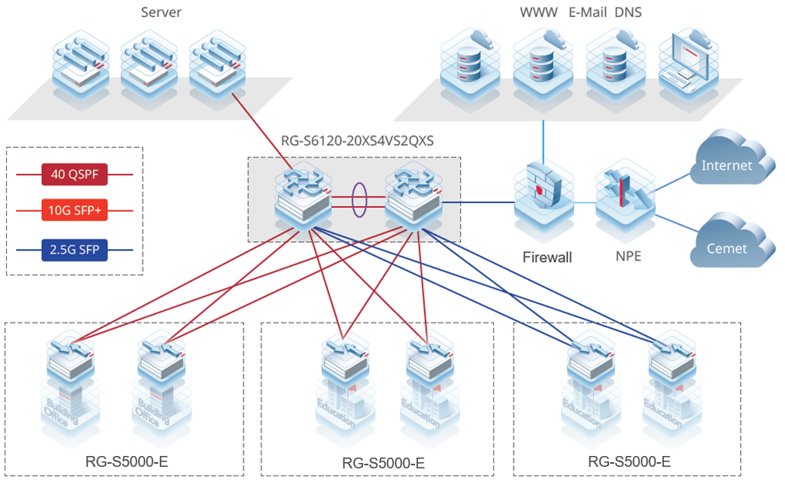

Ordering Information

Switches
Model | Description
RG-S5000-10GT2MS-E | 10 x 10/100/1000BASE-T ports with auto-negotiation, 2 x 1GE/2.5GE SFP ports, fixed single AC power supply
RG-S5000-24GT4MS-E | 24 x 10/100/1000BASE-T ports with auto-negotiation, 4 x 1GE/2.5GE SFP ports, fixed single AC power supply
RG-S5000-48GT4MS-E | 48 x 10/100/1000BASE-T ports with auto-negotiation, 4 x 1GE/2.5GE SFP ports, fixed single AC power supply
RG-S5000-10GT2MS-P-E | 10 x 10/100/1000BASE-T ports with auto-negotiation, 2 x 1GE/2.5GE SFP ports, fixed single AC power supply, ports 1 to 8 supporting PoE/PoE+ power supply, and maximum PoE output power of 125 W
RG-S5000-24GT4MS-P-E | 24 x 10/100/1000BASE-T ports with auto-negotiation, 4 x 1GE/2.5GE SFP ports, fixed single AC power supply, PoE/PoE+ power supply, and maximum PoE output power of 370 W
Note:
- 1 x 1GE/2.5GE SFP port supports 1GE SFP transceivers, 2.5GE SFP transceivers.

Optical Transceivers and Cables

1GE
Model | Description
Mini-GBIC-GT | 1000BASE-X to 1000BASE-T, copper SFP transceiver, RJ45, 100 m over Cat 5e/6/6a  The port needs to be configured with auto-negotiation
MINI-GBIC-SX-MM850 | 1000BASE-SX, SFP transceiver, 850 nm, Duplex LC, 500 m over MMF
MINI-GBIC-LX-SM1310 | 1000BASE-LX, SFP transceiver, 1310 nm, Duplex LC, 10 km over SMF
MINI-GBIC-LH40-SM1310 | 1000BASE-LH, SFP transceiver, 1310 nm, Duplex LC, 40 km over SMF
MINI-GBIC-ZX80-SM1550 | 1000BASE-ZX, SFP transceiver, 1550 nm, Duplex LC, 80 km over SMF
GE-SFP-LX20-SM1310-BIDI | 1000BASE-LX, SFP transceiver, TX1310/RX1550, BiDi LC, 20 km over SMF
GE-SFP-LX20-SM1550-BIDI | 1000BASE-LX, SFP transceiver, TX1550/RX1310, BiDi LC, 20 km over SMF
GE-SFP-LH40-SM1310-BIDI | 1000BASE-LH, SFP transceiver, TX1310/RX1550, BiDi LC, 40 km over SMF
GE-SFP-LH40-SM1550-BIDI | 1000BASE-LH, SFP transceiver, TX1550/RX1310, BiDi LC, 40 km over SMF
GE-SFP-LX03-SM1310-BIDI-I | 1000BASE-LX, SFP transceiver, TX1310/RX1550, BiDi LC, 3 km over SMF
GE-SFP-LX03-SM1550-BIDI-I | 1000BASE-LX, SFP transceiver, TX1550/RX1310, BiDi LC, 3 km over SMF
Note: BiDi transceivers must be used in pairs. If one end uses GE-SFP-LX20-SM1310-BIDI, the other end must use GE-SFP-LX20-SM1550-BIDI.

2.5GE
Model | Description
2.5G-SFP-LX03-SM1310-BIDI-I | 2.5GBASE-LX, SFP transceiver, TX1310/RX1550, BiDi LC, 3 km over SMF
2.5G-SFP-LX03-SM1550-BIDI-I | 2.5GBASE-LX, SFP transceiver, TX1550/RX1310, BiDi LC, 3 km over SMF

Package Contents
Item | RG-S5000-10GT2MS-E  RG-S5000-10GT2MS-P-E | RG-S5000-24GT4MS-E  RG-S5000-48GT4MS-E  RG-S5000-24GT4MS-P-E
Chassis | 1 | 1
Power cord | 1 | 1
Grounding wire | 1 | 1
Nylon buckle | 1 | 1
Mounting bracket | 2 | 2
Rubber pad | / | 4
M4x8 cross recessed countersunk head screw, GB819-85 | 8 | 8
Mounting Bracket Installation Guide | 1 | 1
Network Product Warranty Manual and Hazardous Substance Statement | 1 | 1
Ruijie Networks Access Product Management Software | 1 (pre-installed) | 1 (pre-installed)

Warranty
For more information about warranty terms and period, contact your local sales agency:
- Warranty terms: https://www.ruijienetworks.com/support/servicepolicy
- Warranty period: https://www.ruijienetworks.com/support/servicepolicy/Service-Support-Summany/
Note: The warranty terms are subject to the terms of different countries and distributors.

More Information
For more information about Ruijie Networks, visit the official Ruijie website or contact your local sales agency:
- Ruijie Networks official website: https://www.ruijienetworks.com/
- Online support: https://www.ruijienetworks.com/support
- Hotline support: https://www.ruijienetworks.com/support/hotline
- Email support: service_rj@ruijienetworks.com

