RG-AP1920
Wi-Fi 7 Dual-Radio
Wall Plate Access Point
Datasheet
V1.5

Ruijie Networks Co., Ltd.
All rights reserved.

Product Overview
The RG-AP1920 is a dual-radio Wi-Fi 7 access point (AP) launched by Ruijie Networks for indoor scenarios in various sectors covering higher education, government, general education, finance, and business.
The RG-AP1920 complies with the IEEE 802.11be, IEEE 802.11ax, IEEE 802.11ac Wave2, IEEE 802.11ac Wave1, and IEEE 802.11n standards. With a hardware-independent dual-radio design, the RG-AP1920 delivers a combined data rate of up to 3.570 Gbps, eliminating the performance bottleneck.
The RG-AP1920 is designed considering factors such as wireless network security, radio control, mobile access, QoS, and seamless roaming. The RG-AP1920 can be used together with Ruijie access controllers (ACs) and WIS to implement wireless user data forwarding, security, and access control.
The RG-AP1920 can be installed on an 86 mm junction box. It also provides Ethernet ports for wired connections. An attractive design enables the RG-AP1920 to smoothly blend into any indoor scenarios. This makes it ideal for wireless network deployment in dormitories, small offices, and guest rooms.

Product Appearance
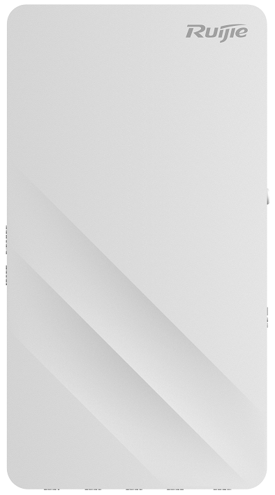

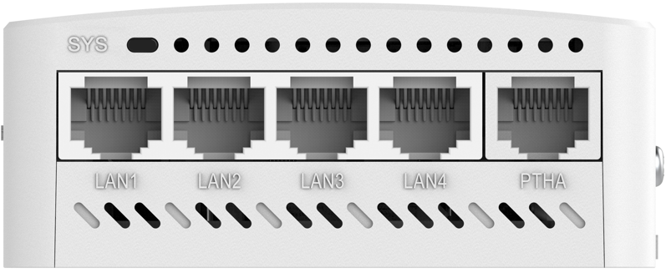
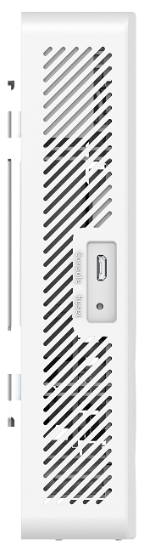
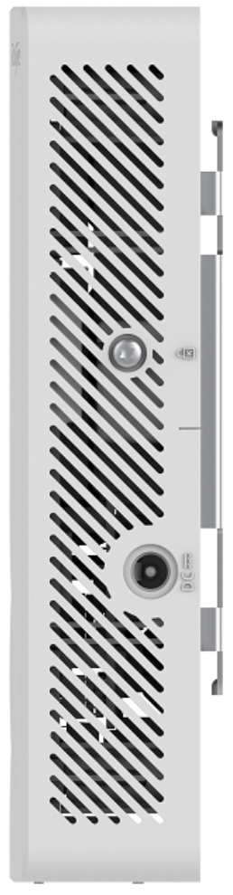

Product Highlights

Ultra-High Performance
- Dual-radio design with support for the latest IEEE 802.11be standard, providing 3.570 Gbps peak data rate for high-speed wireless access.
- Advanced 4096-QAM technology, delivering higher data rates and enhanced user experiences in demanding scenarios.
- Orthogonal Frequency-Division Multiple Access (OFDMA) improves network efficiency and reduces latency, enabling seamless access for high-density deployments.
- Dynamic Frequency Selection (DFS) optimizes RF spectrum usage and minimizes radar interference, ensuring stable and efficient network performance.

High Security and Reliability
- Comprehensive wireless security features, including Wi-Fi Protected Access 3 (WPA3), 802.1X, and Private Pre-Shared Key (PPSK), delivering robust data protection.
- Multicast-to-unicast conversion and intelligent monitoring enhance the stability of multimedia services and overall network reliability.

Ease of Management
- Flexible deployment options with support for Fat, Fit, and Cloud modes, offering simplified provisioning and comprehensive remote management.
- Integration with WIS Cloud for centralized management, including device configuration, real-time monitoring, and one-click optimization for end-to-end network lifecycle management.

Applicable Scenarios

Typical Scenarios
The RG-AP1920 is fit for wireless network deployment in areas with simple building structures, no special obstructions, a small number of users, and a small capacity demand, including hotel rooms, small offices, dormitories, and residential buildings.
The following figure shows the typical network topology of the RG-AP1920.
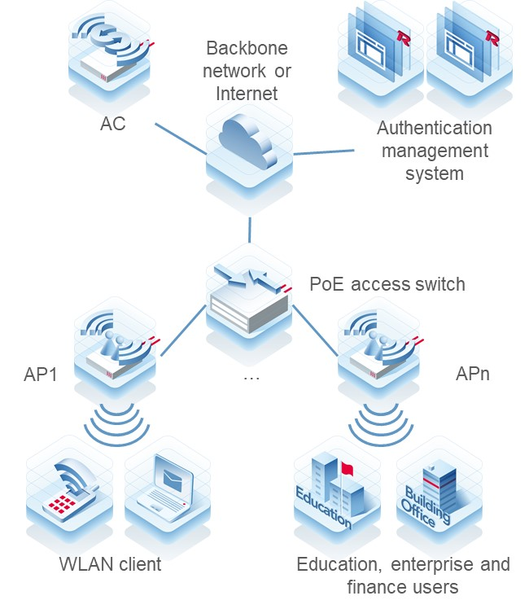

Higher Education

Classroom and Lab
Deploying Wi-Fi in classrooms and labs enables students and teachers to access network resources with ease, thereby enhancing the quality of teaching and learning. Students can engage in online learning, access course materials, and collaborate with classmates, while teachers can access teaching resources and deliver multimedia lessons.


Library
Wi-Fi deployment in libraries facilitates quick access to online resources such as e-books and academic papers for research and study by students and teachers.


Healthcare

Outpatient Service
The Wi-Fi network provides a mobile office environment for medical staff. Medical staff can use mobile devices to view patient information in real time, which significantly improves treatment efficiency. Patients can access relevant medical information through smart devices online, resulting in improved satisfaction.


Remote Monitoring and Management of Medical Devices
With Wi-Fi deployment, remote monitoring and management of medical devices become possible. Wireless medical devices such as ECG monitors and blood pressure monitors can transmit patient data in real time, thereby improving information security. Additionally, these wireless medical devices can be easily maintained and upgraded, resulting in cost reductions.
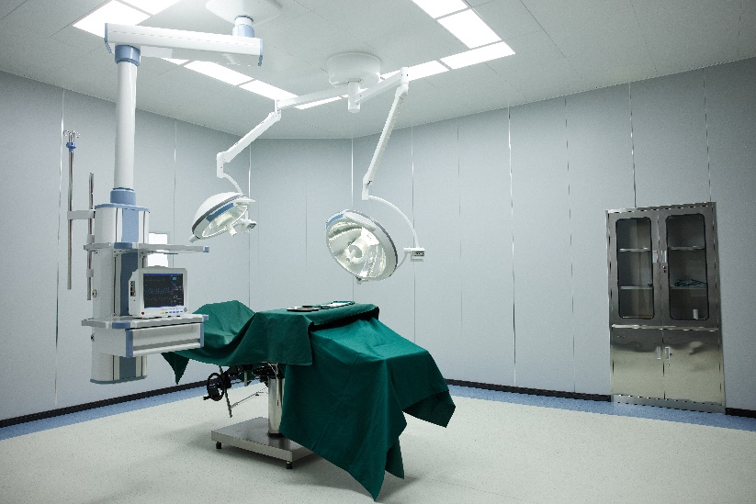

Government and Commerce

Large Conference Center
Deploying Wi-Fi in conference centers enables high-definition conference broadcasting, remote conferencing, and allows all attendees to simultaneously access wireless networks, thereby improving conference efficiency.
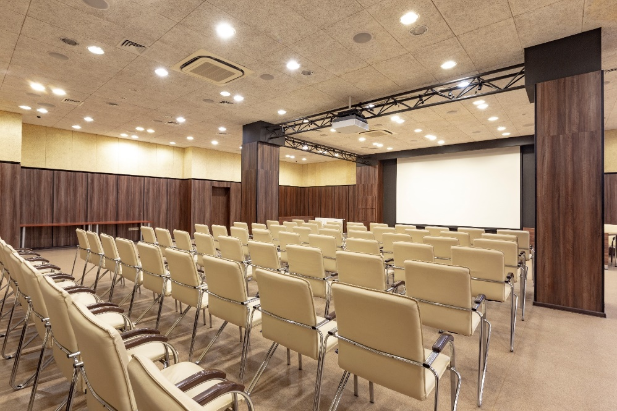
Note: For more applicable scenarios, contact Ruijie pre-sales engineers.

Product Features

Multi-Service Ports
In compliance with IEEE 802.3af/at standard, the RG-AP1920 provides one 10/100/1000/2.5GBASE-T port with a maximum wired data rate of 2.5 Gbps to implement high-speed transmission and conversion between wireless networks and wired networks.
The RG-AP1920 also offers four downlink 10/100/1000BASE-T ports for wired connections, which caters for the demands in diverse scenarios.

High-Speed Wireless Access, High Energy Efficiency and Reliability

4096-QAM for High Data Rate
The RG-AP1920 adopts a dual-radio design and complies with IEEE 802.11be standard. When two radios are enabled, the RG-AP1920 can provide a combined peak data rate of 3.570 Gbps, delivering high-speed access experience.

OFDMA for High-Density Client Access
The Orthogonal Frequency Division Multiple Access (OFDMA) feature in IEEE 802.11be enables the RG-AP1920 to divide a Wireless Local Area Network (WLAN) channel into multiple sub-channels, with each client consuming one or more sub-channels. The RG-AP1920 can implement scheduling for multiple clients to receive and send packets concurrently. This reduces contention for air interface resources and backoff, shortens network latency, and boosts network efficiency. In a high-density deployment and access scenario, the average rate per client can be increased compared to IEEE 802.11ax.

Advanced Wi-Fi Technologies
The RG-AP1920 supports the following radio transmission technologies:
- Dynamic frequency selection (DFS) optimizes the use of available radio spectrum to prevent radar channel interference.
- Cyclic delay/shift diversity (CDD/CSD) improves downlink radio frequency (RF) performance, and converts spatial diversity to frequency diversity to avoid intersymbol interference, thus decreasing the bit error rate (BER) and effectively reducing signal distortion.
- Maximum ratio combining (MRC) improves the signal quality at the receiver end and enhances reliability and performance of received signals.
The RG-AP1920 supports the following radio channel coding technologies:
- Space-time block coding (STBC) increases the range and improves the signal reception, and enhances the reliability of data transmission.
- Low-density parity check (LDPC) corrects errors efficiently and improves the throughput.
- Transmit beam-forming (TxBF) expands the signal coverage and enhances the reliability of specific devices, thereby improving the data rate.

Intelligent Identification
The RG-AP1920 is capable of identifying smart mobile terminals (such as iOS and Android terminals) and PCs. The RG-AP1920 can be interconnected with WIS Cloud to implement visualized wireless network management based on wireless endpoint types and perform network optimization with one click.

Intelligent Local Forwarding
The RG-AP1920 integrates the intelligent local forwarding technology of Ruijie Networks, eliminating the traffic bottleneck of ACs. The data forwarding mode of the RG-AP1920 can be pre-configured through a Ruijie AC. The RG-AP1920 determines whether data needs to be forwarded by the AC or be sent to a wired network for data exchange based on SSIDs or user VLANs.
The local forwarding technology enables the RG-AP1920 to forward delay-sensitive data that requires real-time high-performance transmission over a wired network. This greatly reduces the traffic forwarding burden of the AC to better adapt to high-throughput transmission on 802.11be networks.

Abundant QoS Policies
The RG-AP1920 provides abundant QoS policies. It supports WLAN/AP/STA-based bandwidth limiting as well as Wi-Fi Multimedia (WMM) that defines priorities for different service data. Therefore, the RG-AP1920 can implement timely and quantitative transmission of audio and video data, ensuring smooth application of multimedia services.
The multicast-to-unicast conversion technology supported by the RG-AP1920 addresses the problem of video freezing caused by packet loss or high latency in Video on Demand (VoD) and other multicast applications on wireless networks, improving the user experience in multicast video services.

Comprehensive Security Protection and Ease of Use

Comprehensive Wireless Security Protection
Working with Ruijie RG-INC network management system and RG-WS series ACs, the RG-AP1920 can provide a wide range of wireless security protection features, including Wireless Intrusion Detection System (WIDS), radio interference positioning, rogue AP containment, ARP anti-spoofing, and DHCP snooping, to build a secure and reliable wireless network for users.

Multiple Easy-to-Use Authentication Modes
When used together with Ruijie authentication system or multi-service ACs, the RG-AP1920 supports multiple efficient and convenient authentication modes including MAC address bypass (MAB) authentication. MAB authentication eliminates the need for a client to enter the username and password repeatedly after the first login.

Flexible Device Management

Flexible Fit/Fat/Cloud Mode Switching
The RG-AP1920 supports flexible switching among Fat, Fit, and Cloud modes. In Fit mode, the RG-AP1920 allows for quick provisioning and installation. Comprehensive remote management greatly improves the operation and maintenance (O&M) and management efficiency for wireless networks.

Eweb-based Management
The RG-AP1920 provides the Eweb for AC and AP management. O&M personnel can implement wireless configurations easily and manage a wireless network in an all-round manner. On the Eweb of ACs, O&M personnel can manage APs as well as clients connected to the APs and limit the rates and network access behaviors of clients. Through the Eweb, O&M personnel can plan, manage, and maintain wireless networks conveniently.

Association with Network Management Software
The RG-AP1920 can be associated with RG-INC, which can manage all ACs and APs on a network, including device configuration backup and device status query. RG-INC provides a wireless heat map to display the wireless signal distribution of APs in the actual environment.

Solution Scalability Capabilities
Ruijie WIS Cloud Management Network Solution (WIS Cloud for short, https://wis.ruijienetworks.com/) provides full-lifecycle cloud management network services covering network procurement, planning, deployment, acceptance, and O&M. When the RG-AP1920 is connected to WIS Cloud, it can meet various needs in multiple scenarios including planning, deployment, acceptance, and operation through cloud management, cloud O&M, cloud authentication, and other value-added services provided by WIS Cloud.

Network-Wide Cloud Management
WIS Cloud supports integrated management and control of various types of devices including APs, ACs, switches, gateways, and routers. It supports remote O&M management operations such as adding or batch importing of multi-branch network devices, online status monitoring, configuration delivery, upgrade, restart, configuration backup, and restoration. It supports network-wide topology auto-discovery and topology status monitoring.

Wireless Network Visualization
The overview function module of WIS Cloud provides a comprehensive view of the network running status from the perspective of overview, experience, users, devices, and environment. The network running information includes the following items:
- Network basic information: device stability, device health, user stability, network signal coverage, and network association.
- User usage: user activity (network dependency), and user online experience and analysis
- Network saturation: network capacity usage and channel usage
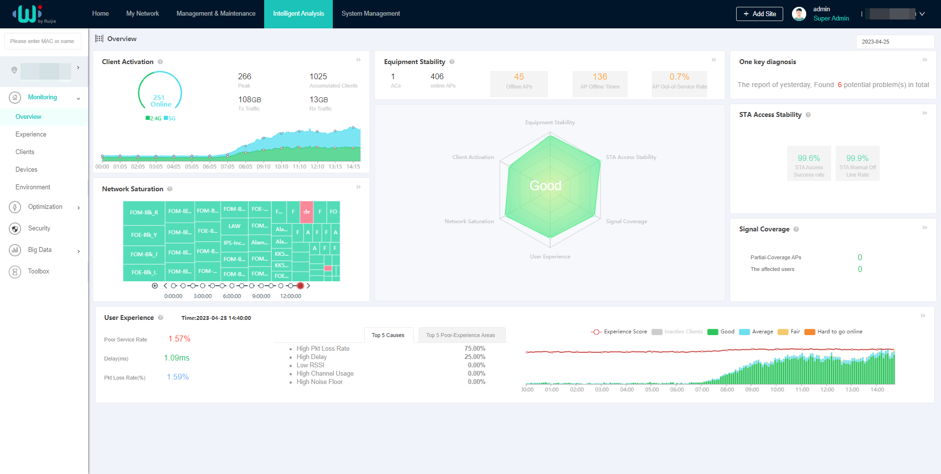

Intelligent Network Diagnosis
With WIS Cloud, wireless network diagnosis and health index assessment can be completed in just one click, providing test results for each item. The health index provided by WIS Cloud enables you to rapidly assess the state of your live network. WIS Cloud can locate faulty areas, APs, and STAs, and provides potential risks and corresponding optimization suggestions.
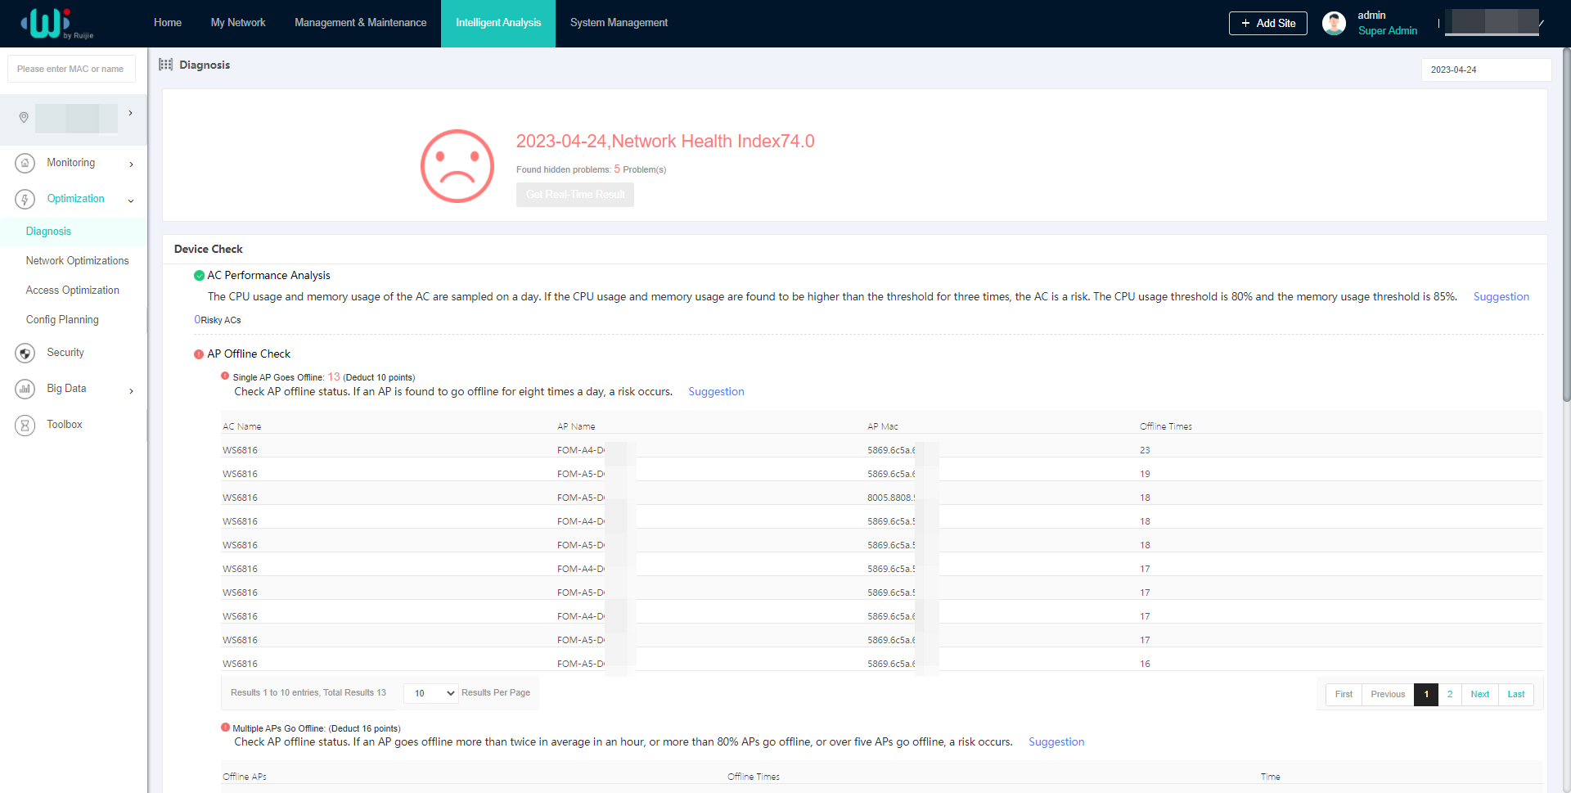

Specifications

Hardware Specifications
Hardware Specifications | RG-AP1920
802.11n | 4 spatial streams  - Radio 1 – 2.4 GHz: 2x2 MIMO, two spatial streams  - Radio 2 – 5 GHz: 2x2 MIMO, two spatial streams  Channel:  - Radio 1 – 2.4 GHz: 20 MHz and 40 MHz  - Radio 2 – 5 GHz: 20 MHz and 40 MHz  Combined peak data rate: 600 Mbps  - Radio 1 – 2.4 GHz: 6.5 Mbps to 300 Mbps (MCS0 to MCS15)  - Radio 2 – 5 GHz: 6.5 Mbps to 300 Mbps (MCS0 to MCS15)  Radio technologies: Orthogonal Frequency-Division Multiplexing (OFDM)  Modulation types: BPSK, QPSK, 16-QAM and 64-QAM  Packet aggregation:  - Aggregate MAC Protocol Data Unit (A-MPDU)  - Aggregate MAC Service Data Unit (A-MSDU)  Dynamic Frequency Selection (DFS)  Cyclic Delay/Shift Diversity (CDD/CSD)  Maximum Ratio Combining (MRC)  Space-Time Block Coding (STBC)  Low-Density Parity Check (LDPC)  Transmit beam-forming (TxBF)
802.11ac | 2 spatial streams  - Radio 2 – 5 GHz: 2x2 MIMO, two spatial streams  Channel:  - Radio 2 – 5 GHz: 20 MHz, 40 MHz, 80 MHz and 160 MHz  Combined peak data rate: 1.733 Gbps  - Radio 2 – 5 GHz: 6.5 Mbps to 1.733 Gbps (MCS0 to MCS9)  Radio technologies: Orthogonal Frequency-Division Multiplexing (OFDM)  Modulation types: BPSK, QPSK, 16-QAM, 64-QAM and 256-QAM  Packet aggregation:  - Aggregate MAC Protocol Data Unit (A-MPDU)  - Aggregate MAC Service Data Unit (A-MSDU)  Dynamic Frequency Selection (DFS)  Cyclic Delay/Shift Diversity (CDD/CSD)  Maximum Ratio Combining (MRC)  Space-Time Block Coding (STBC)  Low-Density Parity Check (LDPC)  Transmit beam-forming (TxBF)
802.11ax | 4 spatial streams  - Radio 1 – 2.4 GHz: 2x2 MIMO, two spatial streams  - Radio 2 – 5 GHz: 2x2 MIMO, two spatial streams  Channel:  - Radio 1 – 2.4 GHz: 20 MHz and 40 MHz  - Radio 2 – 5 GHz: 20 MHz, 40 MHz, 80 MHz and 160 MHz  Combined peak data rate: 2.976 Gbps  - Radio 1 – 2.4 GHz: 7.3 Mbps to 0.574 Gbps (MCS0 to MCS11)  - Radio 2 – 5 GHz: 7.3 Mbps to 2.402 Gbps (MCS0 to MCS11)  Radio technologies: uplink/downlink Orthogonal Frequency-Division Multiple Access (OFDMA)  Modulation types: BPSK, QPSK, 16-QAM, 64-QAM, 256-QAM and 1024-QAM  Packet aggregation:  - Aggregate MAC Protocol Data Unit (A-MPDU)  - Aggregate MAC Service Data Unit (A-MSDU)  Dynamic Frequency Selection (DFS)  Cyclic Delay/Shift Diversity (CDD/CSD)  Maximum Ratio Combining (MRC)  Space-Time Block Coding (STBC)  Low-Density Parity Check (LDPC)  Transmit beam-forming (TxBF)  WPA3
802.11be | 4 spatial streams  - Radio 1 – 2.4 GHz: 2x2 MIMO, two spatial streams  - Radio 2 – 5 GHz: 2x2 MIMO, two spatial streams  Channel:  - Radio 1 – 2.4 GHz: 20 MHz and 40 MHz  - Radio 2 – 5 GHz: 20 MHz, 40 MHz, 80 MHz and 160 MHz  Combined peak data rate: 3.570 Gbps  - Radio 1 – 2.4 GHz: 7.3 Mbps to 0.688 Gbps (MCS0 to MCS13)  - Radio 2 – 5 GHz: 7.3 Mbps to 2.882 Gbps (MCS0 to MCS13)  Radio technologies: uplink/downlink Orthogonal Frequency-Division Multiple Access (OFDMA)  Modulation types: BPSK, QPSK, 16-QAM, 64-QAM, 256-QAM, 1024-QAM and 4096-QAM  Packet aggregation:  - Aggregate MAC Protocol Data Unit (A-MPDU)  - Aggregate MAC Service Data Unit (A-MSDU)  Dynamic Frequency Selection (DFS)  Cyclic Delay/Shift Diversity (CDD/CSD)  Maximum Ratio Combining (MRC)  Space-Time Block Coding (STBC)  Low-Density Parity Check (LDPC)  Transmit beam-forming (TxBF)  WPA3
Antenna | Wi-Fi  - 2.4 GHz: two built-in omnidirectional smart antennas, with peak antenna gain of 3 dBi.  - 5 GHz: two built-in omnidirectional smart antennas, with peak antenna gain of 3 dBi.  Bluetooth  - One built-in omnidirectional antenna, with peak antenna gain of 2.5 dBi.
Port | 1 x 100/1000/2.5GBASE-T port  4 x 10/100/1000BASE-T ports  1 x micro USB console port  1 x a pair of pass-through ports  1 x Bluetooth 5.3
Status LED | 1 x system status LED  - AP power-on status  - Software initialization status and upgrade status  - Uplink service interface status  - Wireless user online status  - CAPWAP tunnel timeout  - Specific AP locating
Button | 1 x Reset button  - Press the button for shorter than 2 seconds. Then the device restarts.  - Press the button for longer than 5 seconds. Then the device restores to factory settings.
Dimensions (W x H x D) | Main unit: 86 mm x 160 mm x 35 mm (3.39 in. x 6.30 in. x 1.38 in.)  Shipping: 347 mm x 383 mm x 270 mm (13.66 in. x 15.08 in. x 10.63 in.)
Weight | Main unit: 0.3 kg (0.66 lbs)  Mounting bracket: 0.05 kg (0.11 lbs)  Shipping: 9.73 kg (21.45 lbs)
Mounting | 86 mm junction box-mount or wall-mount
Lock option | Kensington lock
Input power supply | The AP supports the following power supply modes:  - 54 V DC/0.35 A power input over DC connector  - PoE/PoE+ input, in compliance with IEEE 802.3af/at standard  Note:  - If both DC power and PoE are available, DC power is preferred.  - When the AP adopts DC power supply, an adapter with a power of less than 100 W should be used.
Maximum power consumption | Maximum power consumption: 16.8 W  - DC power: 16.8 W, 2.4 GHz radio 2x2, 5 GHz radio 2x2  - 802.3at (PoE+): 16.8 W, 2.4 GHz radio 2x2, 5 GHz radio 2x2  - 802.3af (PoE): 12.68 W, 2.4 GHz radio 2x2, 5 GHz radio 2x2 (Note: The maximum channel widths in the 2.4 GHz and 5 GHz frequency bands are reduced to 20 MHz and 40 MHz respectively.)  - Idle mode: 7.2 W
Environment | Storage temperature: –40°C to +70°C (–40°F to +158°F)  Storage humidity: 5% RH to 95% RH (non-condensing)  Storage altitude: –500 m to +5,000 m (–1640.42 ft. to +16,404.20 ft.)  Operating temperature: –10°C to +40°C (14°F to 104°F)  Operating humidity: 5% RH to 95% RH (non-condensing)  Operating altitude: –500 m to +5,000 m (–1640.42 ft. to +16,404.20 ft.)  Note: At an altitude in the range of 1,800–5,000 m (5,905.51–16,404.20 ft.), every time the altitude increases by 220 m (721.78 ft.), the maximum temperature decreases by 1°C (1.8°F).
Mean Time Between Failure (MTBF) | 200,000 hours (22 years) at the operating temperature of 25°C (77°F)
System memory | 512 MB, 256 MB flash
Transmit power | 2.4 GHz  - Maximum transmit power: 20 dBm (100 mW)  - Minimum transmit power: 0 dBm (1 mW)  5 GHz  - Maximum transmit power: 20 dBm (100 mW)  - Minimum transmit power: 0 dBm (1 mW)  Note:  - Adjusting the transmit power by percentage (recommended) and in 1dBm increments.  - The transmit power is limited by local regulatory requirements. For details, see WLAN Country or Region Codes and Channel Compliance.

The following table lists the radio frequency performance of Wi-Fi including different frequency bands, protocols, and data rates. It is country-specific, and Ruijie Networks reserves the right of interpretation.
Wi-Fi Radio Performance | RG-AP1920
Frequency Band and Protocol | Data Rate | Maximum Transmit Power per Transmit Chain | Maximum Receive Sensitivity per Receive Chain
2.4 GHz 802.11g | 6 Mbps | 20 dBm | -91 dBm
2.4 GHz 802.11g | 24 Mbps | 17 dBm | -85 dBm
2.4 GHz 802.11g | 36 Mbps | 17 dBm | -80 dBm
2.4 GHz 802.11g | 54 Mbps | 16 dBm | -74 dBm
2.4 GHz 802.11n (HT20) | MCS0 | 18 dBm | -85 dBm
2.4 GHz 802.11n (HT20) | MCS7 | 16 dBm | -67 dBm
2.4 GHz 802.11n (HT40) | MCS0 | 18 dBm | -82 dBm
2.4 GHz 802.11n (HT40) | MCS7 | 16 dBm | -64 dBm
2.4 GHz 802.11ax (HE20) | MCS0 | 18 dBm | -85 dBm
2.4 GHz 802.11ax (HE20) | MCS11 | 14 dBm | -58 dBm
2.4 GHz 802.11ax (HE40) | MCS0 | 18 dBm | -82 dBm
2.4 GHz 802.11ax (HE40) | MCS11 | 14 dBm | -54 dBm
2.4 GHz 802.11be (EHT40) | MCS0 | 18 dBm | -82 dBm
2.4 GHz 802.11be (EHT40) | MCS11 | 14 dBm | -54 dBm
5 GHz 802.11a | 6 Mbps | 20 dBm | -91 dBm
5 GHz 802.11a | 24 Mbps | 17 dBm | -85 dBm
5 GHz 802.11a | 36 Mbps | 17 dBm | -80 dBm
5 GHz 802.11a | 54 Mbps | 16 dBm | -74 dBm
5 GHz 802.11n (HT20) | MCS0 | 18 dBm | -85 dBm
5 GHz 802.11n (HT20) | MCS7 | 16 dBm | -67 dBm
5 GHz 802.11n (HT40) | MCS0 | 18 dBm | -82 dBm
5 GHz 802.11n (HT40) | MCS7 | 16 dBm | -64 dBm
5 GHz 802.11ac (VHT20) | MCS0 | 18 dBm | -85 dBm
5 GHz 802.11ac (VHT20) | MCS7 | 16 dBm | -67 dBm
5 GHz 802.11ac (VHT40) | MCS0 | 18 dBm | -82 dBm
5 GHz 802.11ac (VHT40) | MCS9 | 15 dBm | -57 dBm
5 GHz 802.11ac (VHT80) | MCS0 | 18 dBm | -82 dBm
5 GHz 802.11ac (VHT80) | MCS9 | 15 dBm | -56 dBm
5 GHz 802.11ax (HE20) | MCS0 | 18 dBm | -85 dBm
5 GHz 802.11ax (HE20) | MCS11 | 14 dBm | -58 dBm
5 GHz 802.11ax (HE40) | MCS0 | 18 dBm | -82 dBm
5 GHz 802.11ax (HE40) | MCS11 | 14 dBm | -54 dBm
5 GHz 802.11ax (HE80) | MCS0 | 18 dBm | -82 dBm
5 GHz 802.11ax (HE80) | MCS9 | 15 dBm | -56 dBm
5 GHz 802.11ax (HE80) | MCS11 | 14 dBm | -52 dBm
5 GHz 802.11ax (HE160) | MCS0 | 18 dBm | -79 dBm
5 GHz 802.11ax (HE160) | MCS9 | 15 dBm | -53 dBm
5 GHz 802.11ax (HE160) | MCS11 | 14 dBm | -50 dBm
5 GHz 802.11be (EHT80) | MCS0 | 18 dBm | -82 dBm
5 GHz 802.11be (EHT80) | MCS9 | 15 dBm | -56 dBm
5 GHz 802.11be (EHT80) | MCS11 | 14 dBm | -52 dBm
5 GHz 802.11be (EHT80) | MCS13 | 12 dBm | -46 dBm
5 GHz 802.11be (EHT160) | MCS0 | 18 dBm | -79 dBm
5 GHz 802.11be (EHT160) | MCS9 | 15 dBm | -53 dBm
5 GHz 802.11be (EHT160) | MCS11 | 14 dBm | -50 dBm
5 GHz 802.11be (EHT160) | MCS13 | 10 dBm | -44 dBm

Note: Available frequency bands may vary with countries or regions. To use the above-mentioned frequency bands, ensure that they are supported in your country or region. For details, see WLAN Country or Region Codes and Channel Compliance.

Software Specifications
Basic Function | RG-AP1920
Applicable software version | RGOS11.9(6)W3B19 or later
WLAN
Maximum number of associated STAs | 256 (up to 128 STAs per radio)
Practical maximum client count indication (per device) | 64
Maximum number of BSSIDs | 32 (up to 16 BSSIDs per radio)
Maximum number of WLAN IDs | 16
STA management | SSID hiding  Band steering (preferential access to the 5 GHz radio)  Each SSID can be configured with the authentication mode, encryption mechanism, and VLAN attributes independently.  Remote intelligent perception technology (RIPT)  Intelligent load balancing based on the STA quantity or traffic
STA limiting | SSID-based STA limiting  Radio-based STA limiting
Bandwidth limiting | STA/SSID/AP-based rate limiting
CAPWAP | IPv4/IPv6 CAPWAP  Layer 2 and Layer 3 topology between an AP and an AC  An AP can automatically discover the accessible AC.  An AP can be automatically upgraded through the AC.  An AP can automatically download the configuration file from the AC.  CAPWAP through NAT  MTU setting and fragmentation over CAPWAP tunnels  Encryption over CAPWAP data tunnels  Encryption over CAPWAP control tunnels
Data forwarding | Centralized and local forwarding
Wireless roaming | Layer 2 and Layer 3 roaming
Wireless locating | Mobile unit (MU) location
Application management | Application identification
Security and Authentication
Authentication and encryption | Remote Authentication Dial-In User Service (RADIUS)  EXEC authorization, specifying source IP addresses of RADIUS packets, supporting authentication of other vendors, and built-in authentication server  PSK, Web, 802.1X, WPA, WPA2, and WPA3 authentication  MAB authentication  Data encryption: WEP (64/128 bits), WPA-Personal, WPA-Enterprise, WPA2-Personal (PSK, TKIP, CCMP), WPA2-Enterprise, WPA3-Personal (SAE, WPA2/WPA3 transition mode), WPA3-Enterprise (CCMP, GCMP), WPA3-OWE
Data frame filtering | Allowlist, static blocklist, and dynamic blocklist
WIDS | Wireless Intrusion Detection System (WIDS)  User isolation  Rogue AP detection and containment
Dynamic Policy | IP standard ACL, MAC extended ACL, IP extended ACL, expert ACL, and IPv6 ACL  Time range-based ACL  ACL based on a Layer 2 interface  ACL based on a Layer 3 interface  Ingress ACL based on a wireless interface  Dynamic ACL assignment based on 802.1X authentication (used with an AC)
CPP | CPU Protect Policy (CPP)
NFPP | Network Foundation Protection Policy (NFPP)  ARP attack defense, ICMP attack defense, and DHCP attack defense
Routing and Switching
MAC | Static MAC address, MAC address filtering, MAC address limiting  MAC address table size: 1,024  Maximum number of static MAC addresses: 1,024  Maximum number of filtered MAC addresses: 1,024
Ethernet | Jumbo frame length: 1,518  Full-duplex and half-duplex modes of interfaces  Optical module information display, alarms about faults, and diagnosis parameter measurement (QSFP+/SFP+/SFP)
VLAN | Interface-based VLAN assignment  Maximum number of SVIs: 200  Maximum number of VLANs: 4,094  VLAN ID range: 1–4,094
ARP | ARP entry aging, gratuitous ARP learning, and proxy ARP  Identification of IP address conflict among downlink users  Maximum number of ARP entries: 1,024  ARP check
IPv4 services | Static IPv4 address and DHCP-assigned IPv4 address  Maximum number of IPv4 addresses configured on each Layer 3 interface: 200  NAT, FTP ALG, and DNS ALG
IPv6 services | IPv6 addressing, Neighbor Discovery (ND), IPv6 ND proxy, ICMPv6, and IPv6 ping  IPv6 DHCP client  Maximum number of IPv6 addresses configured on each Layer 3 interface: 400
IP routing | IPv4/IPv6 static route  Maximum number of static IPv4 routes: 1,024  Maximum number of static IPv6 routes: 1,000
Multicast | Multicast-to-unicast conversion
VPN | PPPoE client  IPsec VPN
Network Management and Monitoring
Network management | NTP server and NTP client  SNTP client  SNMP v1/v2c/v3  Fault detection and alarming  Information statistics collection and logging
Network management platform | Web management (Eweb)
User access management | Console, Telnet, SSH, FTP client, FTP server, and TFTP client
Switchover among Fat, Fit, and cloud modes | When the AP works in Fit mode, it can be switched to Fat mode through an AC.  When the AP works in Fat mode, it can be switched to Fit mode through the console port or Telnet.  When the AP works in Cloud mode, it can be managed through WIS Cloud.

Regulatory Compliance
Regulatory Compliance | RG-AP1920
Regulatory compliance | EN 55032, EN 55035, EN IEC 61000-3-2, EN 61000-3-3, EN 301 489-1, EN 301 489-3, EN 301 489-17, EN 300 328, EN 301 893, EN 300 440, EN IEC 62311, FCC Part 15, IEC 62368-1, EN 62368-1, EN 18031-1, and EN 18031-2
* For more country-specific regulatory information and approvals, contact your local sales agency.
Note：
- EU simplified DoC: Hereby, [Ruijie Networks Co., Ltd.] declares that the radio equipment type [RG-AP1920] is in compliance with Directive 2014/53/EU. The full text of the EU declaration of conformity is available at the following internet address: https://www.ruijie.com/.
- UK simplified DoC: Hereby, [Ruijie Networks Co., Ltd.] declares that the radio equipment type [RG-AP1920] is in compliance with UK Radio Equipment Regulation 2017. The full text of the UK declaration of conformity is available at the following internet address: https://www.ruijie.com/.
- The functions of Wireless Access Systems including Radio Local Area Networks(WAS/RLANs) within the band 5150-5350 MHz for this device are restricted to indoor use only within all European Union countries (BE/BG/CZ/DK/DE/EE/IE/EL/ES/FR/HR/IT/CY/LV/LT/LU/HU/MT/NL/ AT/PL/PT/RO/SI/SK/FI/SE/TR/NO/CH/IS/LI/UK(NI)
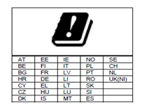

- Ruijie wireless products provide only secure and reliable network protocols and communication ports by default. For details, see Ruijie Default Protocols and Ports for Wireless Products. Proper firewall and security policies can be implemented based on this document to ensure the normal operation of wireless services.

Antenna Pattern Plots

Horizontal Planes (Top View)
2.4 GHz Elevation Antenna Pattern
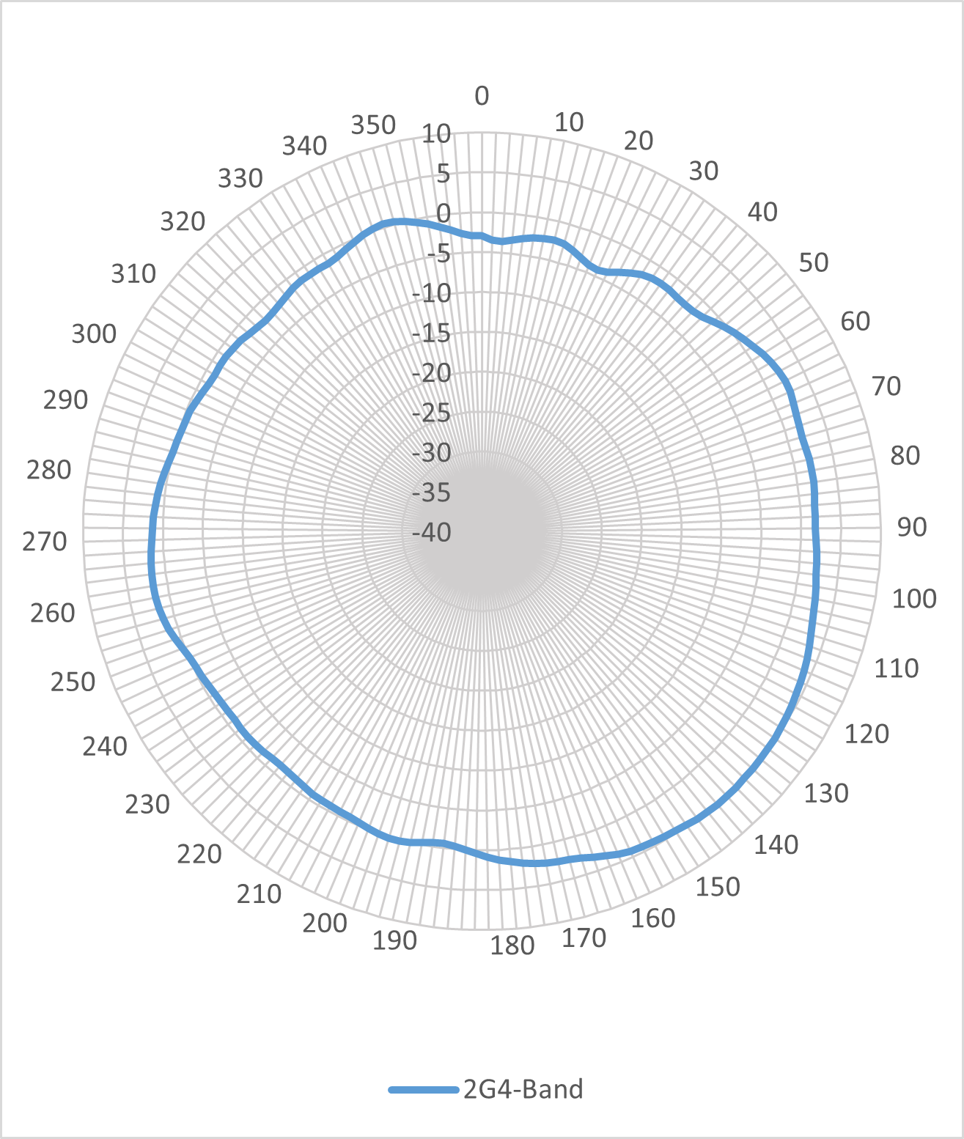
5 GHz Elevation Antenna Pattern
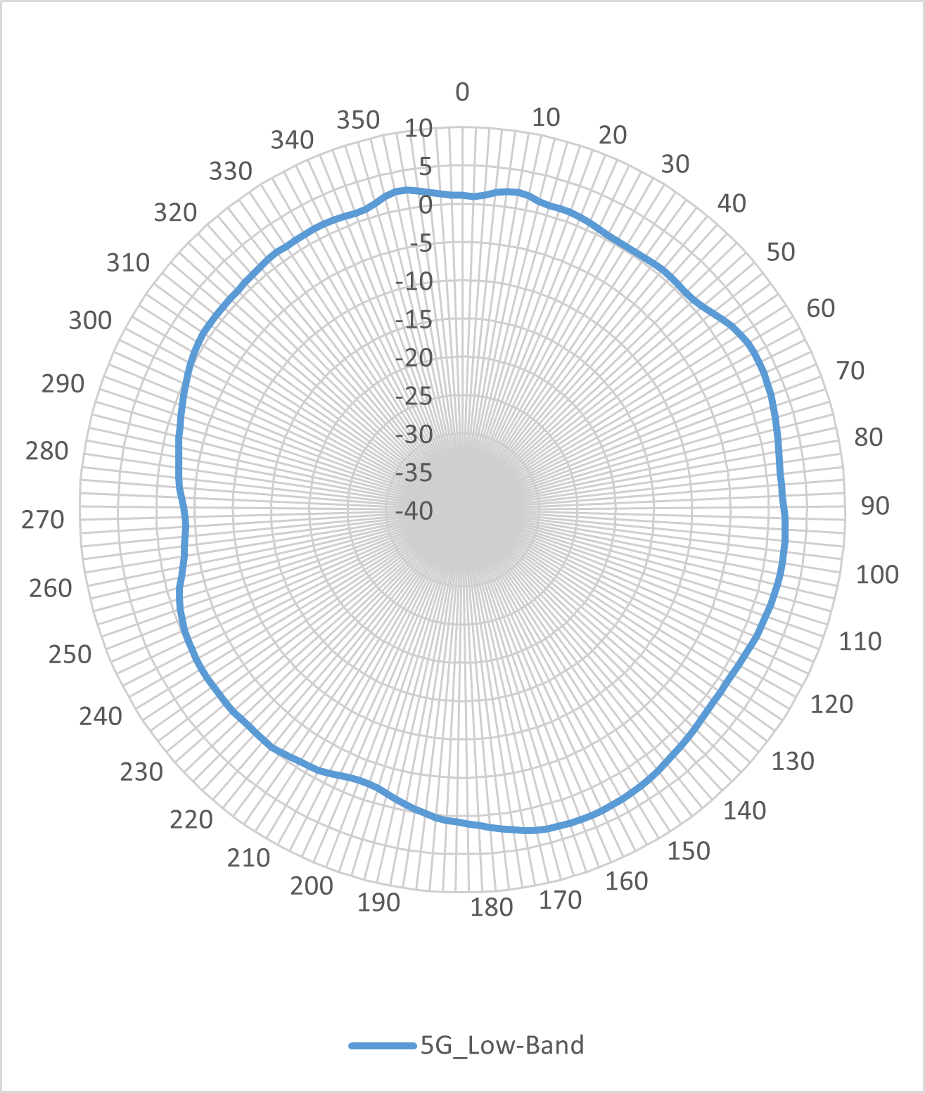
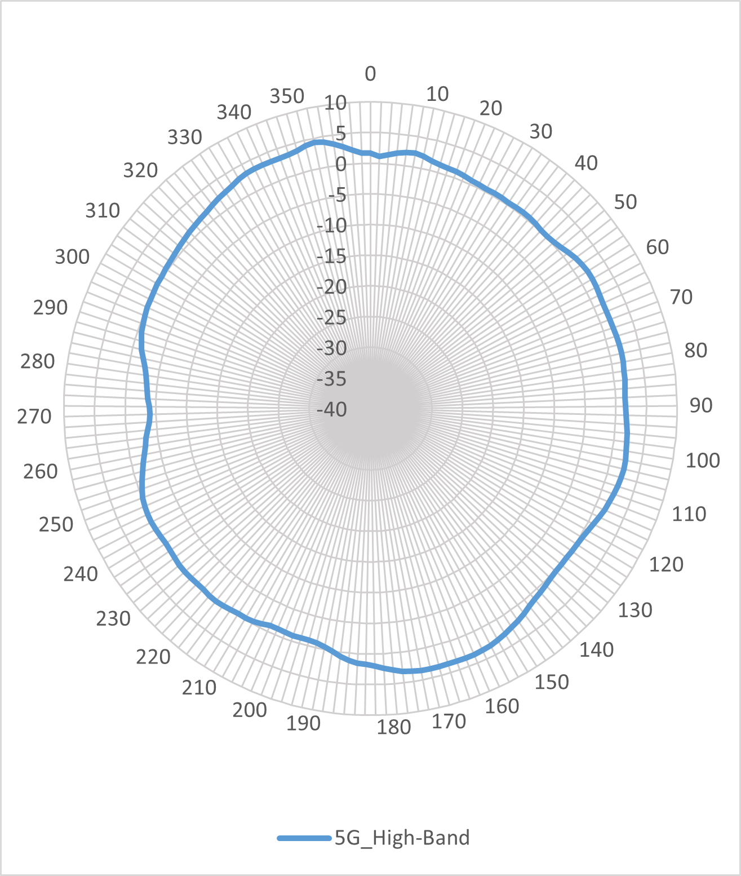

Vertical Planes (Front View)
2.4 GHz Elevation Antenna Pattern
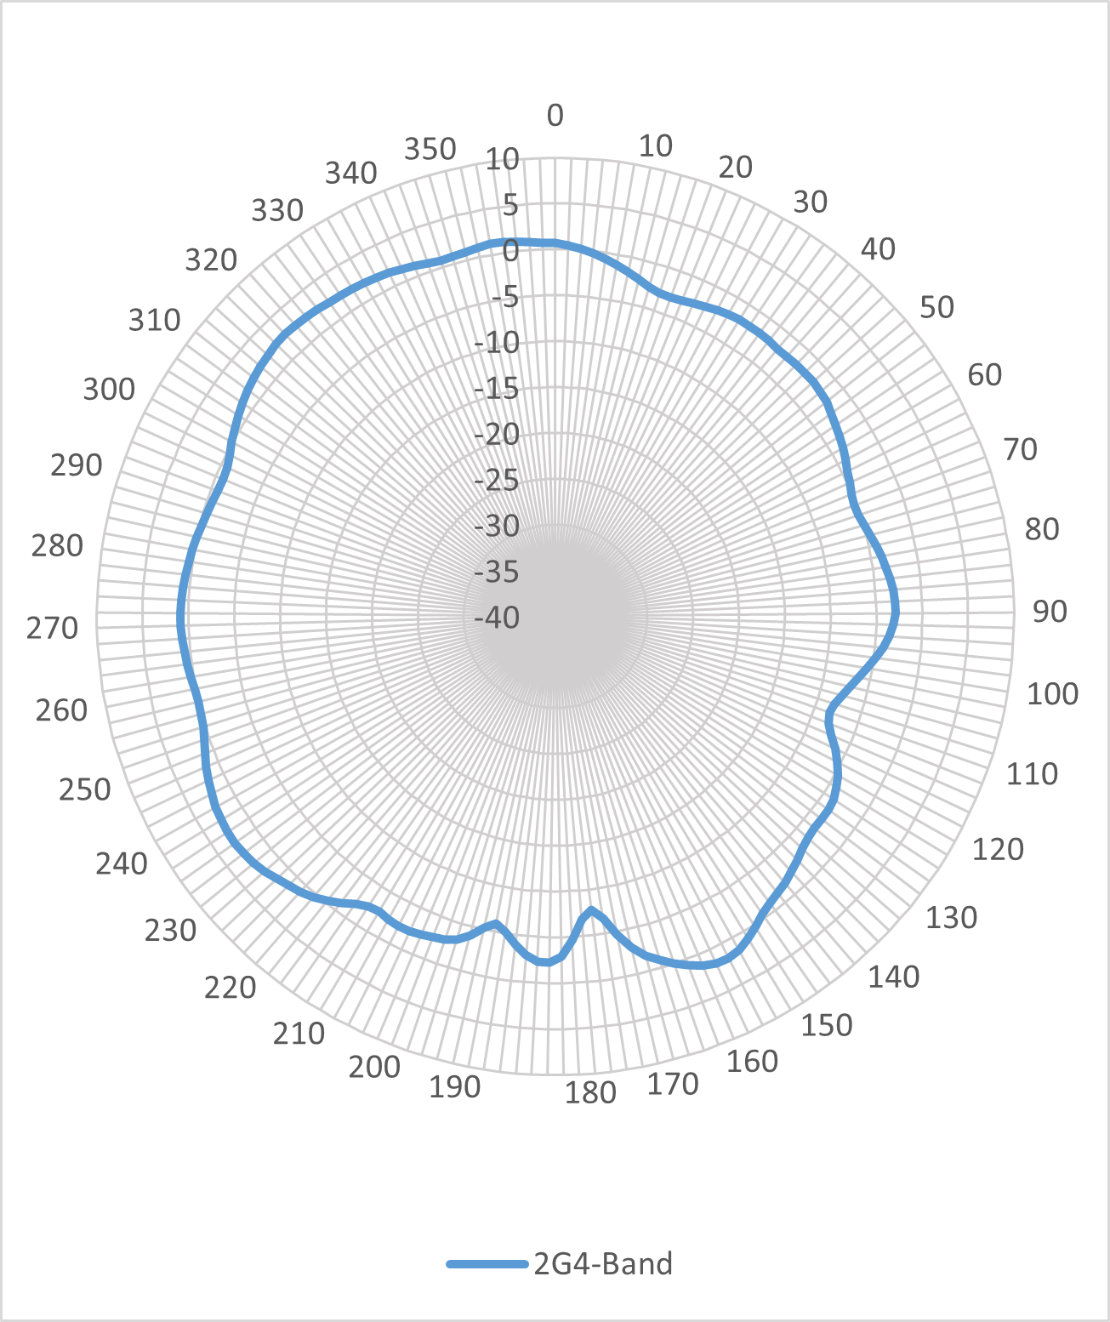
5 GHz Elevation Antenna Pattern
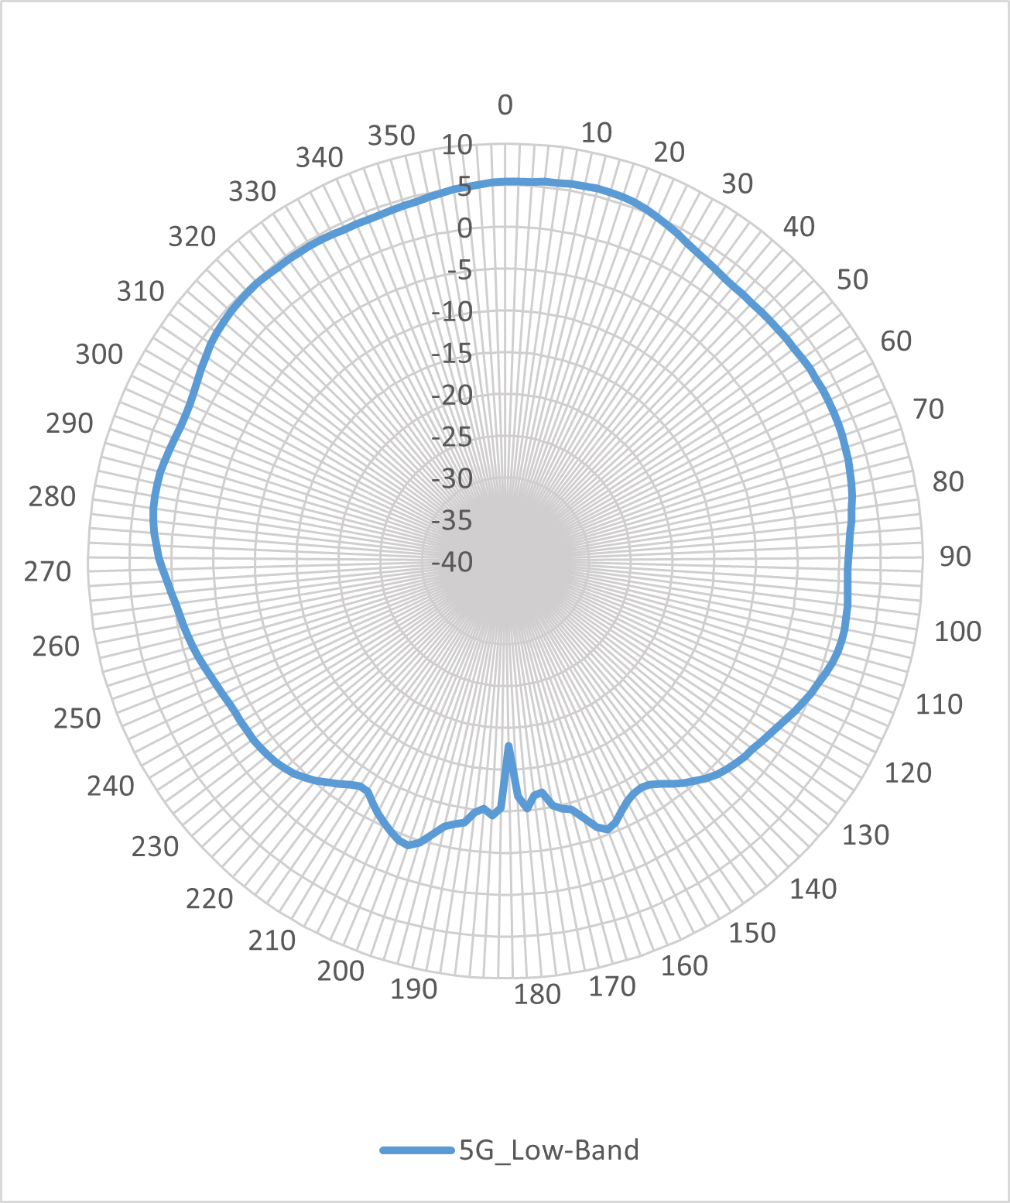
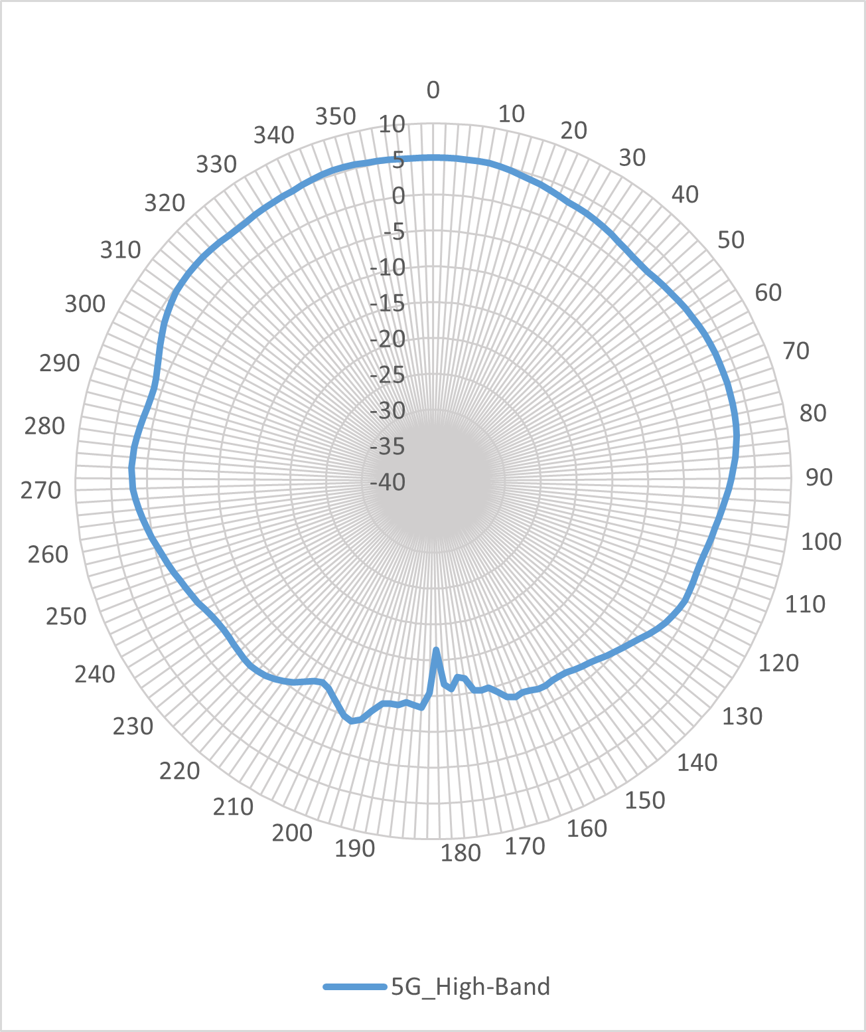

Ordering Information
Model | Description | Mandatory/Optional
RG-AP1920 | Wi-Fi 7 dual-radio wall plate access point  Up to four spatial streams, peak data rate of 3.570 Gbps  - Radio 1: 2.4 GHz: two spatial streams, 2x2 MIMO, peak data rate of 0.688 Gbps  - Radio 2: 5 GHz: two spatial streams,2x2 MIMO, peak data rate of 2.882 Gbps  The AP consumes 0.5 licenses of an AC. 802.11a/b/g/n/ac/ax/be, switching between Fat, Fit, and cloud modes, and 802.3af/at-compliant (PoE/PoE+) and local power supply  Note:  - The DC power supply needs to be purchased separately, and the output voltage/current must be 50 V/0.35 A.  - When the AP adopts DC power supply, an adapter with a power of less than 100 W should be used. | Mandatory

Package Contents
Item | Quantity
RG-AP1920 AP | 1
Mounting bracket | 1
M4 x 25 mm Phillips pan head screw | 2
PM3 x 5 mm Torx screw | 1
Quick Installation Guide | 1
Warranty Card and Hazardous Substance Table | 1
Ruijie wireless product management software (pre-installed on the AP) | 1

Warranty
For more information about warranty terms and period, contact your local sales agency.
- Warranty terms: https://www.ruijie.com/support/servicepolicy
- Warranty period: https://www.ruijie.com/support/servicepolicy/Service-Support-Summany/
Note: The warranty terms are subject to the terms of different countries and distributors.

More Information
For more information about Ruijie Networks, visit the official website of Ruijie Networks or contact your local sales agency:
- Ruijie Networks official website: https://www.ruijie.com/
- Online support: https://www.ruijie.com/support
- Hotline support: https://www.ruijie.com/support/hotline
- Email support: EBGITSC@ruijie.com.cn
- WLAN Country or Region Codes and Channel Compliance: https://www.ruijie.com/support/documents/slide_wlan-country-codes-overview
- Ruijie Default Protocols and Ports for Wireless Products: https://www.ruijie.com/en-global/support/documents/slide_wlan-network-protocol-port/

