RG-AP850-AR(V3)
Wi-Fi 6 Quad-radio Access Point
Datasheet
V1.9

Ruijie Networks Co, Ltd.
All rights reserved.

Product Overview
The RG-AP850-AR(V3) is a Wi-Fi 6 wireless access point that delivers quad radios, AI radio design, high performance, and enterprise-grade encryption. Its hybrid cloud management mode and high-density access design allow the RG-AP850-AR(V3) to be flexibly deployed in high-quality network scenarios, such as classrooms, meeting rooms, offices, dormitories, and large venues in the education industry, production workshops and warehouses in the manufacturing industry, and outpatient clinics and mobile ward rounds in the medical industry.
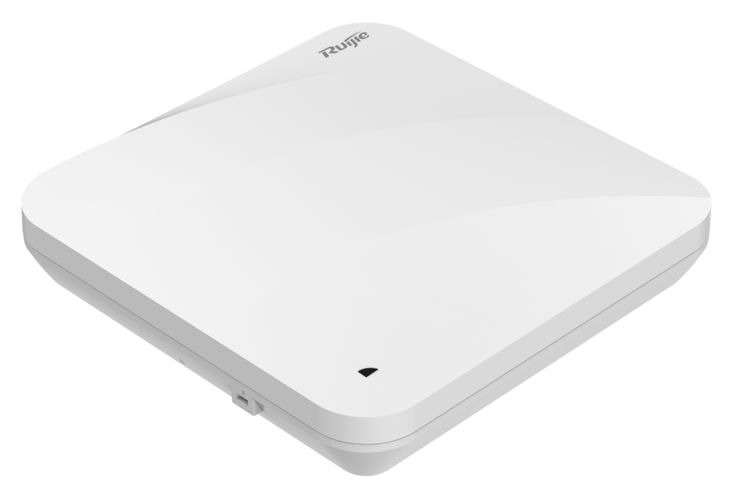
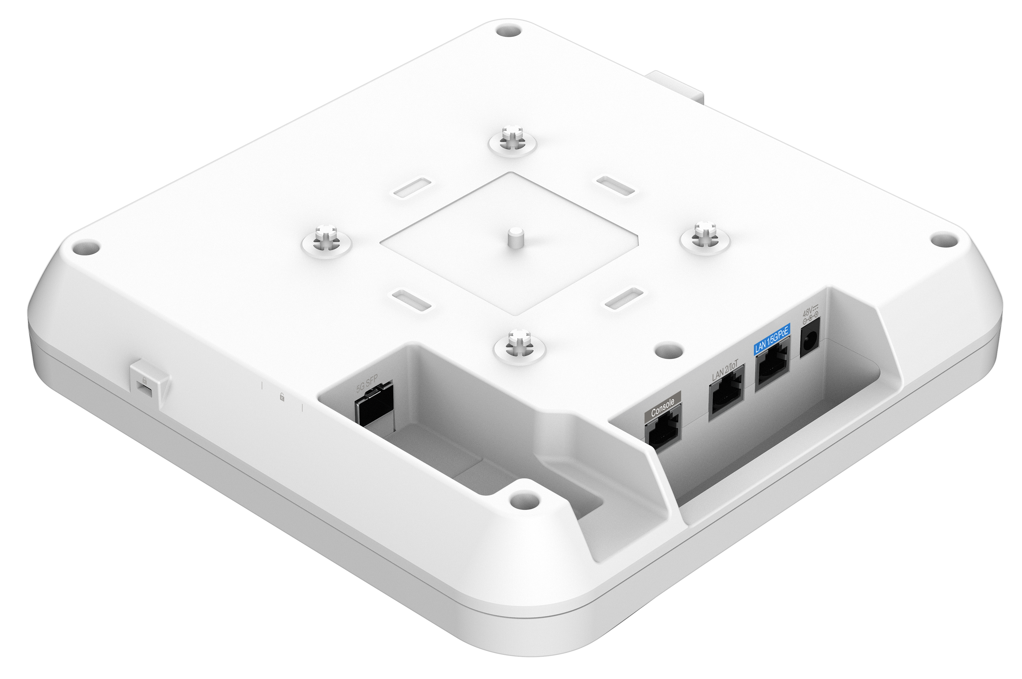

Product Highlights


Ultra-High Performance
- Quad-radio design (2.4GHz + 5GHz + 5 GHz + AI Radio), eight spatial streams, 1024-Quadrature Amplitude Modulation (QAM) high-speed access, and up to 5.378 Gbps peak data rate, realizing high-speed wireless access experience
- Hardware-independent AI radio card to implement better roaming policies through real-time client scanning, thereby providing optimal roaming experience for mobile office, mobile video conferencing, or network courses
- Orthogonal Frequency-Division Multiple Access (OFDMA), Multi-User Multiple-Input Multiple-Output (MU-MIMO), and Wi-Fi Multimedia (WMM), increasing the average rate per user in high-density deployment environments
- RF power adjustment and intelligent channel allocation to solve the problems such as co-channel interference and adjacent channel interference, thereby improving network transmission efficiency and stability

Flexible Networking
- Local and cloud management modes, and intelligent wireless network optimization, reducing TCO and maximizing ROI
- Access through optical and Ethernet cables for flexible networking and high-speed backhaul over 5 Gbps optical links
- IEEE 802.11k/v/r support and roaming stickiness optimization, achieving seamless user roaming
- Rich IoT features: PoE output, Bluetooth 5.1, and wireless locating

High Security and Reliability
- Encryption and authentication technologies including Wi-Fi Protected Access 3 (WPA3), enhanced open security, 802.1X, and Private Pre-shared Key (PPSK), enhancing data security
- Hardware-independent AI radio card, safeguarding the security of 2.4 GHz/5 GHz radio in 24/7 mode and carrying out radar scanning on wireless networks to eliminate potential risks
- Dynamic Frequency Selection (DFS), optimizing the use of available RF spectrum to prevent radar channel interference
- Cyclic Delay/Shift Diversity (CDD/CSD), Maximum Ratio Combining (MRC), Space-Time Block Coding (STBC), and Low-Density Parity Check (LDPC), improving the signal quality, signal receiving, and reliability and performance of data transmission
- Transmit beam-forming (TxBF) expands the signal coverage and enhances the reliability of specific devices, thereby improving the data rate
- Intelligent identification and monitoring, multicast-to-unicast conversion, and other features, enhancing network security and reliability

Applicable Scenarios

Manufacturing Industry

Production Workshop
In the era of Industry 4.0, deploying roaming-free Wi-Fi enables automated and intelligent production workshops.


Higher Education

Classroom and Lab
Deploying Wi-Fi in classrooms and labs enables students and teachers to access network resources with ease, thereby enhancing the quality of teaching and learning. Students can engage in online learning, access course materials, and collaborate with classmates, while teachers can access teaching resources and deliver multimedia lessons.


Library
Wi-Fi deployment in libraries facilitates quick access to online resources such as e-books and academic papers for research and study by students and teachers.


Healthcare

Outpatient Service
The Wi-Fi network provides a mobile office environment for medical staff. Medical staff can use mobile devices to view patient information in real time, which significantly improves treatment efficiency. Patients can access relevant medical information through smart devices online, resulting in improved satisfaction.


Remote Monitoring and Management of Medical Devices
With Wi-Fi deployment, remote monitoring and management of medical devices become possible. Wireless medical devices such as ECG monitors and blood pressure monitors can transmit patient data in real time, thereby improving information security. Additionally, these wireless medical devices can be easily maintained and upgraded, resulting in cost reductions.

Note: For more applicable scenarios, contact Ruijie pre-sales engineers.

Product Features

Multi-scenario Adaptability
The RG-AP850-AR(V3), a quad-radio wall-mounted wireless access point, is ideal for a wide range of applications, including higher education, government, general education, finance, and business sectors, providing flexible solutions to meet diverse service needs.

High-speed Access and Compatibility
The RG-AP850-AR(V3) supports various wireless protocols, such as 802.11ax, 802.11ac Wave2, 802.11ac Wave1, and 802.11n. It features a hardware-independent quad-radio design to deliver a data rate of up to 5.378 Gbps, effectively eliminating wireless performance bottlenecks. Additionally, it is compatible with an extensive array of devices, promoting seamless interconnectivity among employees and customers.

Independent AI Radio Design
The hardware-independent AI radio card can safeguard the security of 2.4 GHz/5 GHz radio in 24/7 mode and carry out radar scanning on wireless networks to eliminate potential risks. Better roaming policies are implemented through real-time client scanning, providing optimal roaming experience for mobile office, mobile video conferencing, or network courses.

Security and Scalability
The RG-AP850-AR(V3) stands out with its exceptional wireless network security, RF control, mobile access, QoS guarantee, seamless roaming, and IoT module expansion. With Ruijie's wireless access controller (AC), it enables wireless user data forwarding, security, access control, and IoT application expansion to cope with diverse service needs.

Flexible Deployment and Power Supply
The RG-AP850-AR(V3) supports both local power supply and Power over Ethernet (PoE), providing you with the flexibility to choose the power supply mode. In addition, the RG-AP850-AR(V3) can be mounted against a wall or ceiling, making space deployment and environmental requirements less challenging. This makes the RG-AP850-AR(V3) particularly suitable for scenarios such as large campuses, conference centers, enterprise offices, and operation hotspots.

Solution Scalability Capabilities
Ruijie WIS Cloud Management Network Solution (WIS for short, https://wis.ruijienetworks.com/) provides full-lifecycle cloud management network services covering network procurement, planning, deployment, acceptance, and O&M. When the AP connects to WIS, it can meet various needs in multiple scenarios including planning, deployment, acceptance, and operation through cloud management, cloud O&M, cloud authentication, and other value-added services provided by WIS.

Network-wide Cloud Management
WIS supports integrated management and control of various types of devices including APs, ACs, switches, gateways, and routers. It supports remote O&M management operations such as adding or batch importing of multi-branch network devices, online status monitoring, configuration delivery, upgrade, restart, configuration backup, and restoration. It supports network-wide topology auto-discovery and topology status monitoring.
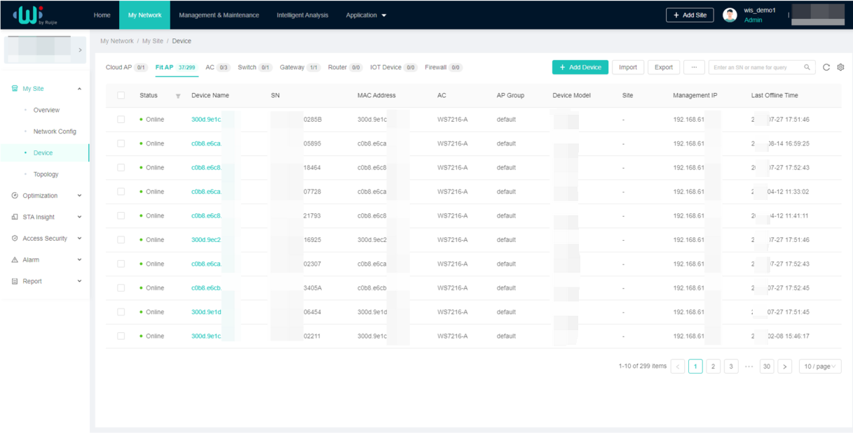

Wireless Network Visualization
The overview function module of WIS provides a comprehensive view of the network running status from the perspective of overview, experience, users, devices, and environment. The network running information includes the following items:
- Network basic information: device stability, device health, user stability, network signal coverage, and network association.
- User usage: user activity (network dependency), and user online experience and analysis
- Network saturation: network capacity usage and channel usage
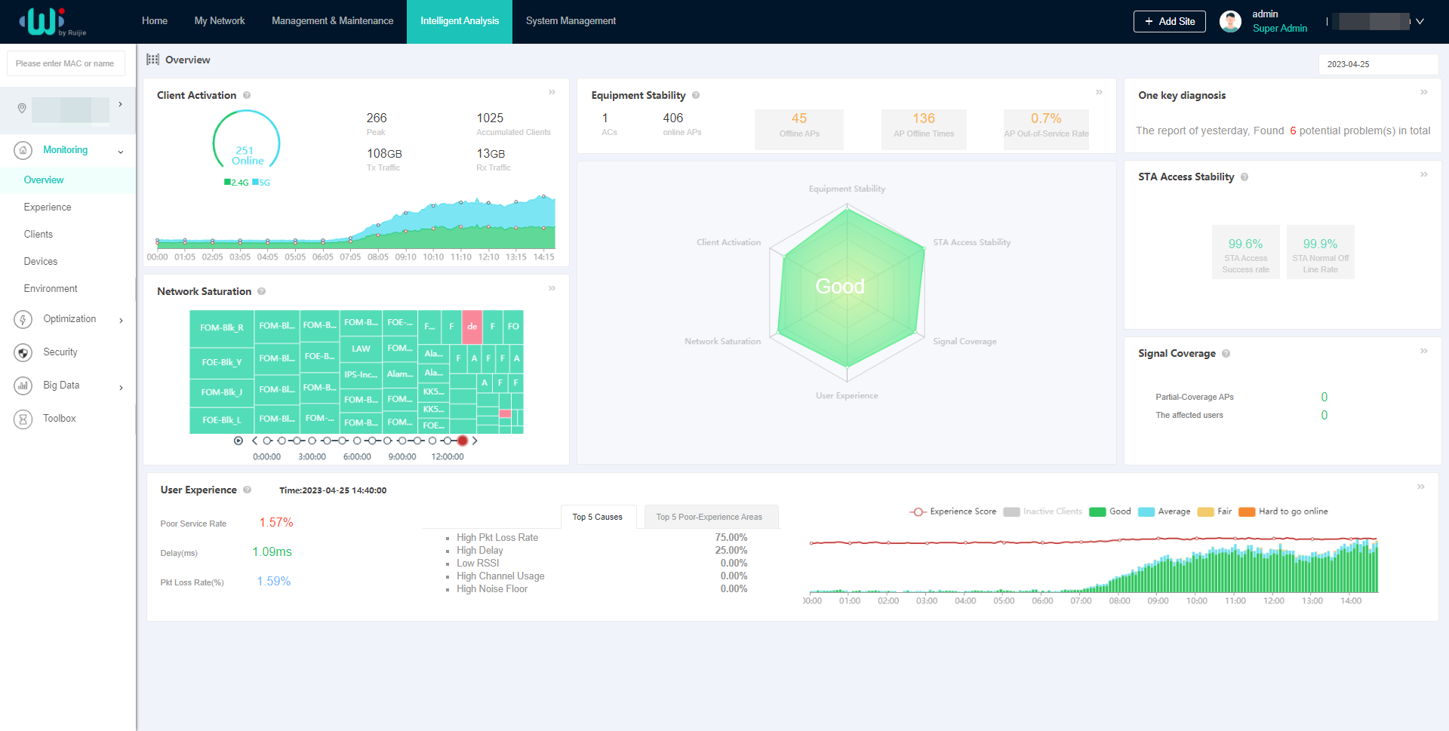

Intelligent Network Diagnosis
With WIS, wireless network diagnosis and health index assessment can be completed in just one click, providing test results for each item. The health index provided by WIS enables you to rapidly assess the state of your live network. WIS can locate faulty areas, APs, and STAs, and provides potential risks and corresponding optimization suggestions.
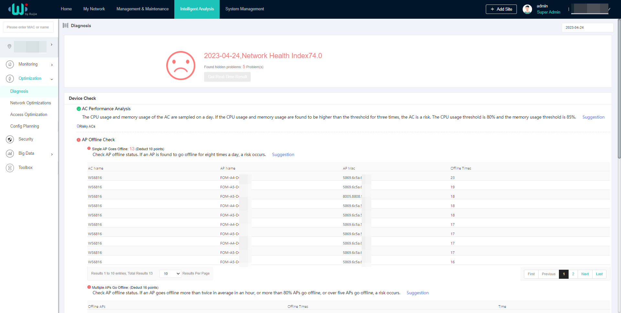

Specifications

Hardware Specifications
Hardware Specifications | RG-AP850-AR(V3)
802.11n | Eight spatial streams  - Radio 1 – 2.4 GHz: 2x2 MIMO, two spatial streams  - Radio 2 – 5 GHz: 2x2 MIMO, two spatial streams  - Radio 3 – 5 GHz: 2x2 MIMO, two spatial streams  - Radio 4 – AI Radio, 2.4 GHz/5 GHz: 2x2 MIMO, two spatial streams  Channels:  - Radio 1 – 2.4 GHz: 20 MHz and 40 MHz  - Radio 2 – 5 GHz: 20 MHz and 40 MHz  - Radio 3 – 5 GHz: 20 MHz and 40 MHz  - Radio 4 – AI Radio, 2.4 GHz/5 GHz: 20 MHz and 40 MHz  Combined peak data rate: 900 Mbps  - Radio 1 – 2.4 GHz: 6.5 Mbps to 300 Mbps (MCS0 to MCS15 )  - Radio 2 – 5 GHz: 6.5 Mbps to 300 Mbps (MCS0 to MCS15)  - Radio 3 – 5 GHz: 6.5 Mbps to 300 Mbps (MCS0 to MCS15)  - Radio 4 – AI Radio, 2.4 GHz/5 GHz: AI Radio for scanning only  Radio technologies: Orthogonal Frequency-Division Multiplexing (OFDM)  Modulation types: BPSK, QPSK, 16-QAM, 64-QAM  Packet aggregation:  - Aggregate MAC Protocol Data Unit (A-MPDU)  - Aggregate MAC Service Data Unit (A-MSDU)  Dynamic Frequency Selection (DFS)  Cyclic Delay/Shift Diversity (CDD/CSD)  Maximum Ratio Combining (MRC)  Space-Time Block Coding (STBC)  Low-Density Parity Check (LDPC)  Transmit beam-forming (TxBF)
802.11ac | Six spatial streams  - Radio 2 – 5 GHz: 2x2 MIMO, two spatial streams  - Radio 3 – 5 GHz: 2x2 MIMO, two spatial streams  - Radio 4 – AI Radio, 5 GHz: 2x2 MIMO, two spatial streams  Channels:  - Radio 2 – 5 GHz: 20 MHz, 40 MHz, 80 MHz, and 160 MHz  - Radio 3 – 5 GHz: 20 MHz, 40 MHz, 80 MHz, and 160 MHz  - Radio 4 – AI Radio, 5 GHz: 20 MHz, 40 MHz, and 80 MHz  Combined peak data rate: 3.466 Gbps  - Radio 2 – 5 GHz: 6.5 Mbps to 1.733 Gbps (MCS0 to MCS9)  - Radio 3 – 5 GHz: 6.5 Mbps to 1.733 Gbps (MCS0 to MCS9)  - Radio 4 – AI Radio, 5 GHz: AI Radio for scanning only  Radio technologies: Orthogonal Frequency-Division Multiplexing (OFDM)  Modulation types: BPSK, QPSK, 16-QAM, 64-QAM, 256-QAM  Packet aggregation:  - Aggregate MAC Protocol Data Unit (A-MPDU)  - Aggregate MAC Service Data Unit (A-MSDU)  Dynamic Frequency Selection (DFS)  Cyclic Delay/Shift Diversity (CDD/CSD)  Maximum Ratio Combining (MRC)  Space-Time Block Coding (STBC)  Low-Density Parity Check (LDPC)  Transmit beam-forming (TxBF)
802.11ax | Six spatial streams  - Radio 1 – 2.4 GHz: 2x2 uplink/downlink MU-MIMO, two spatial streams  - Radio 2 – 5 GHz: 2x2 uplink/downlink MU-MIMO, two spatial streams  - Radio 3 – 5 GHz: 2x2 uplink/downlink MU-MIMO, two spatial streams  Channels:  - Radio 1 – 2.4 GHz: 20 MHz and 40 MHz  - Radio 2 – 5 GHz: 20 MHz, 40 MHz, 80 MHz, and 160 MHz  - Radio 3 – 5 GHz: 20 MHz, 40 MHz, 80 MHz, and 160 MHz  Combined peak data rate: 5.378 Gbps:  - Radio 1 – 2.4 GHz: 8.6 Mbps to 0.574 Gbps (MCS0 to MCS11)  - Radio 2 – 5 GHz: 8.6 Mbps to 2.402 Gbps (MCS0 to MCS11)  - Radio 3 – 5 GHz: 8.6 Mbps to 2.402 Gbps (MCS0 to MCS11)  Radio technologies: uplink/downlink Orthogonal Frequency-Division Multiple Access (OFDMA)  Modulation types: BPSK, QPSK, 16-QAM, 64-QAM, 256-QAM, 1024-QAM  Packet aggregation:  - Aggregate MAC Protocol Data Unit (A-MPDU)  - Aggregate MAC Service Data Unit (A-MSDU)  Dynamic Frequency Selection (DFS)  Cyclic Delay/Shift Diversity (CDD/CSD)  Maximum Ratio Combining (MRC)  Space-Time Block Coding (STBC)  Low-Density Parity Check (LDPC)  Transmit beam-forming (TxBF)  WPA3
Antenna | Wi-Fi  - 2.4 GHz: two built-in omnidirectional antennas, with peak antenna gain of 5.4 dBi.  - 5 GHz: six built-in omnidirectional antennas, with peak antenna gain of 5.2 dBi.  Bluetooth  - One integrated vertically polarized omnidirectional antenna, with peak antenna gain of 4.6 dBi.
Port | 1 x 100/1000/2.5G/5GBASE-T port  1 x 5GE SFP/RJ45 combo port, compatibility with 1GE and 2.5GE modules, shared with one 100/1000/2.5G/5GBASE-T port  1 x 10/100/1000BASE-T port  1 x RJ45 console port (serial console port)  1 x USB 3.0 (Type-A connector)  1 x Bluetooth 5.1
Status LED | 1 x multi-color system status LED  - AP power-on status  - Software initialization status and upgrade status  - Uplink service interface status  - Wireless user online status  - CAPWAP tunnel timeout  - Specific AP locating
Button | 1 x Reset button  - Press the button for shorter than 2 seconds. Then the device restarts.  - Press the button for longer than 5 seconds. Then the device restores to factory settings.
Dimensions (W x D x H) | Main unit: 230 mm x 230 mm x 51 mm (9.06 in. x 9.06 in. x 2.01 in.)  Shipping: 618 mm x 450 mm x 350 mm (24.33 in. x 17.72 in. x 13.78 in.)
Weight | Main unit: 1.0 kg (2.2 lbs)  Mounting bracket: 0.1 kg (0.22 lbs)  Shipping: 1.42 kg (3.13 lbs)
Mounting | Wall/Ceiling-mount (a mounting bracket is delivered with the main unit)
Lock option | Kensington lock and securing latch
Input power supply | The AP supports the following two power supply modes:  - 54 V DC/1.1 A power input over DC connector: The DC connector accepts the center-positive circular plug with the inner diameter of 2.1 mm (0.08 in.) or outer diameter of 5.5 mm (0.22 in.) and the length of 9.5 mm (0.37 in.). A DC power supply needs to be purchased independently.  - PoE input over LAN 1: The power source equipment (PSE) complies with IEEE 802.3af/at/bt standard (PoE/PoE+/PoE++).  Note: If both DC power and PoE are available, DC power is preferred.
Maximum power consumption | Maximum power consumption: 40 W  - DC power: 40 W, 2.4 GHz radio 2x2, 5 GHz radio1 2x2, 5 GHz radio2 2x2, AI Radio enabled, LAN 2 for PoE supply, and USB port enabled  - 802.3bt (PoE++): 40 W, 2.4 GHz radio 2x2, 5 GHz radio1 2x2, 5 GHz radio2 2x2, AI Radio enabled, LAN 2 for PoE supply, and USB port enabled  - 802.3at (PoE+): 23 W, 2.4 GHz radio 2x2, 5 GHz radio1 2x2, 5 GHz radio2 2x2, AI Radio enabled , LAN 2 and USB port that fail to provide power for external devices (PoE out disabled of LAN 2 and USB port disabled)  - 802.3af (PoE): 12.95 W, 2.4 GHz radio 1x1, 5 GHz radio1 1x1, 5 GHz radio2 1x1, AI Radio is disabled, LAN 2 and USB port that fail to provide power for external devices (PoE out disabled of LAN 2 and USB port disabled)  - Idle mode: 10.3 W
External power supply | When powered by 802.3bt (PoE++), the AP can supply power to an external device.  - The USB port can source 1 A/5 W power to an attached device.  - The LAN 2 port can source 48 V/12.95 W power to an IoT unit.
Environment | Storage temperature: –40°C to +70°C (–40°F to +158°F)  Storage humidity: 5% RH to 95% RH (non-condensing)  Storage altitude: –500 m to +5,000 m (–1640.42 ft. to +16,404.20 ft.)  Operating temperature: –10°C to +50°C (14°F to 122°F)  Operating humidity: 5% RH to 95% RH (non-condensing)  Operating altitude: –500 m to +5,000 m (–1640.42 ft. to +16,404.20 ft.)  Note: At an altitude in the range of 2,000–5,000 m (6,561.68–16,404.20 ft.), every time the altitude increases by 220 m (721.78 ft.), the maximum temperature decreases by 1°C (1.8°F).
Mean Time Between Failure (MTBF) | 200,000 hours (22 years) at the operating temperature of 25°C (77°F)
System memory | 1 GB DRAM, 256 MB flash
Transmit power | 2.4 GHz  - Maximum transmit power: 27 dBm (501.19 mW)  - Minimum transmit power: 19 dBm (79.43 mW)  5 GHz  - Maximum transmit power: 26 dBm (398.11 mW)  - Minimum transmit power: 21 dBm (125.89 mW)  Note:  - Adjusting the transmit power by percentage (recommended) and in 1dBm increments.  - The transmit power adjusted in percentage. The transmit power is limited by local regulatory requirements. For details, see WLAN Country or Region Codes and Channel Compliance.

The following table lists the radio frequency performance of Wi-Fi including different frequency bands, protocols, and date rates. It is country-specific, and Ruijie Networks reserves the right of interpretation.
Radio Frequency Performance | RG-AP850-AR(V3)
Frequency Band and Protocol | Data Rate | Maximum Transmit Power per Transmit Chain | Maximum Receive Sensitivity per Receive Chain
2.4 GHz, 802.11b | 1 Mbps | 24 dBm | –91 dBm
2.4 GHz, 802.11b | 2 Mbps | 24 dBm | –91 dBm
2.4 GHz, 802.11b | 5.5 Mbps | 23 dBm | –90 dBm
2.4 GHz, 802.11b | 11 Mbps | 22 dBm | –87 dBm
2.4 GHz, 802.11g | 6 Mbps | 24 dBm | –89 dBm
2.4 GHz, 802.11g | 24 Mbps | 23 dBm | –82 dBm
2.4 GHz, 802.11g | 36 Mbps | 23 dBm | –78 dBm
2.4 GHz, 802.11g | 54 Mbps | 21 dBm | –72 dBm
2.4 GHz, 802.11n (HT20) | MCS0 | 24 dBm | –85 dBm
2.4 GHz, 802.11n (HT20) | MCS7 | 20 dBm | –67 dBm
2.4 GHz, 802.11n (HT40) | MCS0 | 24 dBm | –82 dBm
2.4 GHz, 802.11n (HT40) | MCS7 | 20 dBm | –64 dBm
2.4 GHz, 802.11ax (HE20) | MCS0 | 24 dBm | –85 dBm
2.4 GHz, 802.11ax (HE20) | MCS11 | 16 dBm | –58 dBm
2.4 GHz, 802.11ax (HE40) | MCS0 | 24 dBm | –82 dBm
2.4 GHz, 802.11ax (HE40) | MCS11 | 16 dBm | –54 dBm
5 GHz, 802.11a | 6 Mbps | 24 dBm | –89 dBm
5 GHz, 802.11a | 24 Mbps | 23 dBm | –82 dBm
5 GHz, 802.11a | 36 Mbps | 23 dBm | –78 dBm
5 GHz, 802.11a | 54 Mbps | 21 dBm | –72 dBm
5 GHz, 802.11n (HT20) | MCS0 | 24 dBm | –85 dBm
5 GHz, 802.11n (HT20) | MCS7 | 20 dBm | –67 dBm
5 GHz, 802.11n (HT40) | MCS0 | 24 dBm | –82 dBm
5 GHz, 802.11n (HT40) | MCS7 | 20 dBm | –64 dBm
5 GHz, 802.11ac (VHT20) | MCS0 | 24 dBm | –85 dBm
5 GHz, 802.11ac (VHT20) | MCS9 | 18.5 dBm | –60 dBm
5 GHz, 802.11ac (VHT40) | MCS0 | 24 dBm | –82 dBm
5 GHz, 802.11ac (VHT40) | MCS9 | 18.5 dBm | –57 dBm
5 GHz, 802.11ac (VHT80) | MCS0 | 24 dBm | –79 dBm
5 GHz, 802.11ac (VHT80) | MCS9 | 18.5 dBm | –53 dBm
5 GHz, 802.11ax (HE20) | MCS0 | 24 dBm | –85 dBm
5 GHz, 802.11ax (HE20) | MCS11 | 16 dBm | –58 dBm
5 GHz, 802.11ax (HE40) | MCS0 | 24 dBm | –82 dBm
5 GHz, 802.11ax (HE40) | MCS11 | 16 dBm | –54 dBm
5 GHz, 802.11ax (HE80) | MCS0 | 24 dBm | –79 dBm
5 GHz, 802.11ax (HE80) | MCS11 | 16 dBm | –52 dBm
5 GHz, 802.11ax (HE160) | MCS0 | 24 dBm | –76 dBm
5 GHz, 802.11ax (HE160) | MCS11 | 16 dBm | –49 dBm

Note: Available frequency bands may vary with countries or regions. To use the above-mentioned frequency bands, ensure that they are supported in your country or region. For details, see WLAN Country or Region Codes and Channel Compliance.

Software Specifications

Basic Functions
Basic Function | RG-AP850-AR(V3)
Applicable software version | RGOS11.9(6)W2B7 or later
WLAN
Maximum number of associated STAs | 1,536 (up to 512 STAs per radio)
Maximum number of BSSIDs | 48 (up to 16 BSSIDs per radio)
Maximum number of WLAN IDs | 16
STA management | SSID hiding  Each SSID can be configured with the authentication mode, encryption mechanism, and VLAN attributes independently.  Remote Intelligent Perception Technology (RIPT)  Intelligent STA identification technology  Intelligent load balancing based on the STA quantity or traffic  Rate set settings
STA limiting | SSID-based STA limiting  Radio-based STA limiting
Bandwidth limiting | STA/SSID/AP-based rate limiting
CAPWAP | IPv4/IPv6 CAPWAP  Layer 2 and Layer 3 topology between an AP and an AC  An AP can automatically discover the accessible AC.  An AP can be automatically upgraded through the AC.  An AP can automatically download the configuration file from the AC.  CAPWAP through NAT  MTU setting and fragmentation over CAPWAP tunnels  Encryption over CAPWAP data channels  Encryption over CAPWAP control channels
Data forwarding | Centralized and local forwarding
Wireless roaming | Layer 2 and Layer 3 roaming
Wireless locating | MU and TAG device locating
Application management | Application identification
Security and Authentication
Authentication and encryption | Remote Authentication Dial-In User Service (RADIUS)  PSK and web authentication  QR code-based guest authentication, SMS authentication, and MAC address bypass (MAB) authentication  Data encryption: WEP (64/128 bits), WPA-Personal, WPA-Enterprise, WPA2-Personal (PSK, TKIP, CCMP), WPA2-Enterprise, WPA3-Personal (SAE, WPA2/WPA3 transition mode), WPA3-Enterprise (CCMP, GCMP)
Data frame filtering | Allowlist, static blocklist, and dynamic blocklist
WIDS | Wireless Intrusion Detection System(WIDS)  User isolation  Rogue AP detection and containment
ACL | IP standard ACL, MAC extended ACL, IP extended ACL, and expert-level ACL  IPv6 ACL  Time range-based ACL  ACL based on a Layer 2 interface  ACL based on a Layer 3 interface  Ingress ACL based on a wireless interface  ACL Remark  Dynamic ACL assignment based on 802.1X authentication (used with the AC)
CPP | CPU Protect Policy (CPP)
NFPP | Network Foundation Protection Policy (NFPP)
Routing and Switching
MAC | Static and filtered MAC addresses  MAC address table size: 2,048  Maximum number of static MAC addresses: 2,048  Maximum number of filtered MAC addresses: 2,048
Ethernet | Jumbo frame length: 1,518  Full-duplex and half-duplex modes of interfaces  IEEE802.1p and IEEE802.1Q  Optical module information display, alarms about faults, and diagnosis parameter measurement (QSFP+/SFP+/SFP)
VLAN | Interface-based VLAN assignment  Maximum number of SVIs: 200  Maximum number of VLANs: 4,094  VLAN ID range: 1–4,094
ARP | ARP entry aging, gratuitous ARP learning, and proxy ARP  Maximum number of ARP entries: 2,048  ARP check
IPv4 services | Static and DHCP-assigned IPv4 addresses  NAT, FTP ALG and DNS ALG
IPv6 services | IPv6 addressing, Neighbor Discovery (ND), IPv6 ND proxy, ICMPv6, IPv6 ping  IPv6 DHCP client
IP routing | IPv4/IPv6 static route  Maximum number of static IPv4 routes: 1,024  Maximum number of static IPv6 routes: 1,000
Multicast | Multicast-to-unicast conversion
VPN | PPPoE client  IPsec VPN
Network Management and Monitoring
Network management | NTP server and NTP client  SNTP client  SNMPv1/v2C/v3  Fault detection and alarm  Information statistics and logging
Network management platform | Web management (Eweb)
User access management | Telnet, SSH, FTP client, FTP server, and TFTP client
Switchover among Fat, Fit, and cloud modes | When the AP works in Fit mode, it can be switched to Fat mode through an AC.  When the AP works in Fat mode, it can be switched to Fit mode through the console port or Telnet mode.  When the AP works in cloud mode, it can be managed through WIS Cloud.

Value-added Software
The following value-added software functions can be achieved with the WIS solution (used with RG-iData-WIS and wireless controller).
Value-added Software | RG-AP850-AR(V3)
Intelligent O&M
Experience | Network operation analysis, such as device stability and signal coverage  Measuring users' network experience based on indicators such as the latency, packet loss, signal strength, and channel utilization, and visualizing results of the network experience  Statistics on the number of online and offline failures of STAs associated with different APs, average signal strength, and other parameters  VIP monitoring and alarm, and custom alarm thresholds  STA global experience map and experience coverage evaluation based on the time range  STA access protocol replay and fine-grained STA fault diagnosis  Note: To support the preceding functions, ensure that the AP works in Fit mode.
Network optimization | Network performance optimization, including one-click network optimization and scenario-based optimization  Client steering to cope with roaming stickiness, and experience indicator comparison  Client steering to cope with remote association, and experience indicator comparison  One-click diagnosis – analyzing problems and providing suggestions
Big data | Baseline analysis – recording the configuration, version, and other changes, and tracking network KPI changes  Time capsule – analyzing the device version and configuration change history
Regional analysis | Batch generation of building floor information – uploading floor plans, and dragging and dropping AP positions
One-click report | One-click health report – generating a report on the overall operation of a network
Security radar | Unauthorized Wi-Fi signal location, presentation by category, and containment
Cloud Management
Management and maintenance | Uniformly connecting, managing, and maintaining APs, ACs, and other devices, batch device configuration and upgrade, and other functions  Deployment through Zero Touch Provisioning (ZTP) – creating configuration templates and automatically applying configured templates  One-click discovery of the wired and wireless network topology and topology generation
Cloud Authentication
Authentication mode | SMS authentication, fixed account authentication, one-click authentication, Facebook authentication, Instagram authentication, voucher authentication, and other authentication modes  Authentication implemented in the cloud, without the need to deploy the local authentication server
Customized portal | Customized Portal authentication page for mobile phones and PCs
SMS gateway | Interconnection with SMS gateways of GUODULINK and Alibaba Cloud
Platform Capabilities
Big data capabilities | Mainstream persistence solutions based on Hadoop, MongoDB, and MySQL, providing distributed storage capabilities  Spark-based big data computing capabilities  Data warehouse building based on Hive, and data model conversion, integration, and other functions
Hierarchy and decentralization | Authorizing different applications for different users to meet service needs of different departments  Granting operation permissions to administrators in different scenarios
System management | Account operation, authorization configuration, email configuration, configuration backup, exception alarms, and other system management functions
Note: For details, refer to the latest hybrid cloud management solution.

Regulatory Compliance
Regulatory Compliance | RG-AP850-AR(V3)
Regulatory compliance | EN 55032, EN 55035, EN 61000-3-3, EN IEC 61000-3-2, EN 301 489-1, EN 301 489-3, EN 301 489-17, EN 300 328, EN 301 893, EN 300 440, FCC Part 15, EN IEC 62311, IEC 62368-1, EN 62368-1, EN 18031-1, and EN 18031-2
* For more country-specific regulatory information and approvals, contact your local sales agency.
Note：
- EU simplified DoC: Hereby, [Ruijie Networks Co., Ltd.] declares that the radio equipment type [RG-AP850-AR(V3)] is in compliance with Directive 2014/53/EU. The full text of the EU declaration of conformity is available at the following internet address: https://www.ruijie.com/.
- UK simplified DoC: Hereby, [Ruijie Networks Co., Ltd.] declares that the radio equipment type [RG-AP850-AR(V3)] is in compliance with UK Radio Equipment Regulation 2017. The full text of the UK declaration of conformity is available at the following internet address: https://www.ruijie.com/.
- The functions of Wireless Access Systems including Radio Local Area Networks(WAS/RLANs) within the band 5150-5350 MHz for this device are restricted to indoor use only within all European Union countries (BE/BG/CZ/DK/DE/EE/IE/EL/ES/FR/HR/IT/CY/LV/LT/LU/HU/MT/NL/ AT/PL/PT/RO/SI/SK/FI/SE/TR/NO/CH/IS/LI/UK(NI)
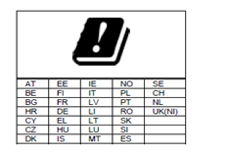

- Ruijie wireless products provide only secure and reliable network protocols and communication ports by default. For details, see Ruijie Default Protocols and Ports for Wireless Products. Proper firewall and security policies can be implemented based on this document to ensure the normal operation of wireless services.

Antenna Pattern Plots

Horizontal Planes (Top View)
The following figures show the azimuth antenna pattern at 2.4 GHz and 5 GHz radios.
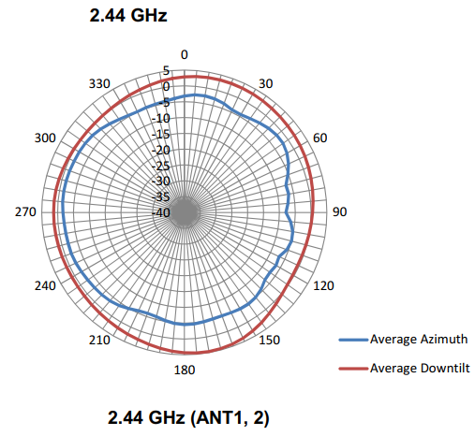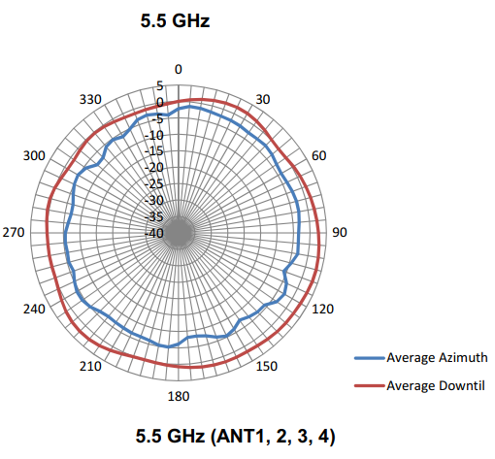

Vertical Planes (Side View, AP Facing Down)
The following figures shows the elevation antenna pattern at 2.4 GHz and 5 GHz radios.
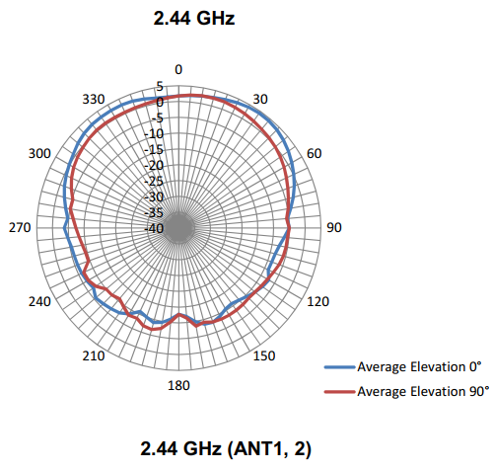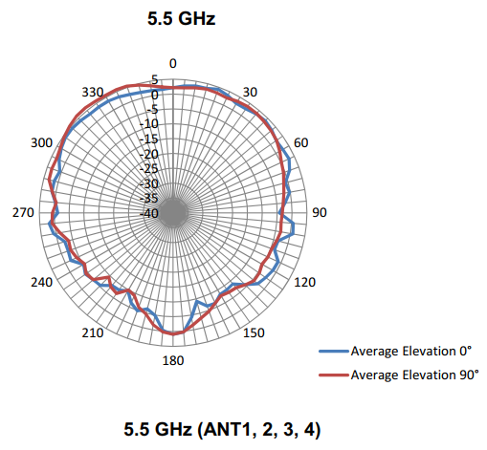
Note: Operating frequency bands are country-specific.

Ordering Information
Model | Description
RG-AP850-AR(V3) | 802.11ax-compliant indoor high-density wireless access point  Quad-radio, eight spatial streams, peak data rate of 5.378 Gbps  - Radio 1: 2.4 GHz: two spatial streams, 2x2 MU-MIMO, peak data rate of 574 Mbps  - Radio 2: 5 GHz: two spatial streams, 2x2 MU-MIMO, peak data rate of 2.402 Gbps  - Radio 3: 5 GHz: two spatial streams, 2x2 MU-MIMO, peak data rate of 2.402 Gbps  - Radio 4: AI Radio, 2.4 GHz/5 GHz: two spatial streams, 2x2 MIMO, AI Radio for scanning only  802.11a/b/g/n/ac/ax, switching between Fat, Fit, and cloud modes, and 802.3af/at/bt PoE and local DC power supply  Note:  - The power source equipment (PSE) needs to be purchased separately.  - The DC power supply needs to be purchased separately, and the output voltage/current must be 54 V/1.1 A.

Package Contents
Item | Quantity
RG-AP850-AR(V3) AP | 1
Mounting bracket | 1
Key to security lock | 1
Wall anchor | 4
4.2 mm x 20 mm Phillips pan head self-tapping screw | 4
Warranty Card and Hazardous Substance Table | 1
Quick Installation Guide | 1
Ruijie wireless product management software (pre-installed on the AP) | 1

Warranty
For more information about warranty terms and period, contact your local sales agency:
- Warranty terms: https://www.ruijie.com/support/servicepolicy
- Warranty period: https://www.ruijie.com/support/servicepolicy/Service-Support-Summany/
Note: The warranty terms are subject to the terms of different countries and distributors.

More Information
For more information about Ruijie Networks, visit the official Ruijie website or contact your local sales agency:
- Ruijie Networks official website: https://www.ruijie.com/
- Online support: https://www.ruijie.com/support
- Hotline support: https://www.ruijie.com/support/hotline
- Email support: EBGITSC@ruijie.com.cn
- WLAN Country or Region Codes and Channel Compliance: https://www.ruijie.com/support/documents/slide_wlan-country-codes-overview
- Ruijie Default Protocols and Ports for Wireless Products: https://www.ruijie.com/en-global/support/documents/slide_wlan-network-protocol-port/

